Nurse and Midwife registrant data: September 2015
Published December 2015

Introduction
This report contains registration information about nurses and midwives registered with the Nursing and Midwifery Board of Australia (NMBA).
The functions of the NMBA are defined under the National Law, and include:
- Registering nurses, midwives and students of nursing and midwifery
- Determining national registration requirements
- Developing professional codes, standards, guidelines and position statements to guide the practice of nurses and midwives
- Managing notifications, investigations and panel hearings
- Overseeing the assessment of internationally qualified nurses and midwives who wish to register in Australia
- Approving national accreditation standards and accredited programs of study leading to registration and endorsement
- Delegating to state and territory boards and committees of the NMBA, and AHPRA staff, the power to determine individual applications for registration and notification of a nurse’s or midwife’s health, performance and/or conduct, and a student’s health or criminal history
*Co-regulatory models apply in New South Wales (NSW) and Queensland (QLD). In NSW, notifications are managed separately by the Nursing and Midwifery Council of NSW; the NSW Board of the NMBA only manages registration matters. In QLD, notifications are received by the Office of the Health Ombudsman (OHO), who determines which notifications should be managed by the NMBA.
The NMBA’s functions are supported by the Australian Health Practitioner Regulation Agency (AHPRA). For information about legislation governing the NMBA and AHPRA, see AHPRA's Legislation & Publications at www.ahpra.gov.au/Legislation-and-Publications.aspx
AHPRA has analysed the NMBA’s registration data and produced a number of statistical tables about registrants to share with the professions and community. This report is updated on a quarterly basis.
For more information on nursing and midwifery registration, please see the NMBA’s website:www.nursingmidwiferyboard.gov.au/Registration-and-Endorsement.aspx

Contents
Nurse and midwife – registration type by state or territory 3
Totals for practitioners with general registration as Nurse and/or Midwife 4
Totals for practitioners with non-practising registration as Nurse and/or Midwife 5
Registered Nurse and Midwife – endorsements by type 6
Registered Nurse Notation 6
Nurse and Midwife – general registration by age group 8
Nurse and Midwife – general registration by age group 8
Nurse and Midwife – non-practising registration by age group 9
Nurse and Midwife – non-practising registration by age group 9
Nurse and Midwife – general registration by gender 10
Nurse and Midwife – total general registration by gender 11
Nurse and Midwife – general registration by gender percentages 11
Nurse and Midwife – non-practising registration by gender 12
Nurse and Midwife – total non-practising totals by gender 13
Nurse and Midwife – non-practising registration by gender percentages 13
Nurse and midwife – registration type by state or territory
The NMBA recognises three nursing and midwifery registration types: general registration, non-practising registration and student registration. A nurse may be either a Registered Nurse or an Enrolled Nurse, or both.
 |  |  | Principal Place of practice
Profession | Registration Type | Divisions | ACT | NSW | NT | QLD | SA | TAS | VIC | WA | No PPP | Total
Nurse | General | Enrolled Nurse (EN) | 657 | 13,026 | 385 | 11,801 | 7,648 | 1,398 | 19,637 | 5,182 | 84 | 59,818
 |  | Registered Nurse (RN) | 4,327 | 74,976 | 3,143 | 50,408 | 21,226 | 6,330 | 65,006 | 27,646 | 8,520 | 261,582
 |  | Enrolled Nurse & Registered Nurse | 53 | 940 | 55 | 1,006 | 531 | 45 | 1,813 | 442 | 25 | 4,910
 | Total General Nurse |  | 5,037 | 88,942 | 3,583 | 63,215 | 29,405 | 7,773 | 86,456 | 33,270 | 8,629 | 326,310
 | Non-practising | Enrolled Nurse (EN) | 16 | 302 | 9 | 162 | 104 | 18 | 218 | 72 | 8 | 909
 |  | Registered Nurse (RN) | 51 | 1,427 | 27 | 503 | 260 | 86 | 592 | 284 | 316 | 3,546
 |  | Enrolled Nurse & Registered Nurse |  | 3 |  | 3 | 3 |  | 5 | 1 | 1 | 16
 | Total Non-practising Nurse |  | 67 | 1,732 | 36 | 668 | 367 | 104 | 815 | 357 | 325 | 4,471
Total Nurse |  |  | 5,104 | 90,674 | 3,619 | 63,883 | 29,772 | 7,877 | 87,271 | 33,627 | 8,954 | 330,781
Nurse & Midwife | General | Enrolled Nurse (EN) & Midwife | 3 | 4 |  | 12 | 1 |  | 35 |  |  | 55
 |  | Registered Nurse (RN) & Midwife | 547 | 8,328 | 521 | 5,780 | 2,067 | 626 | 7,453 | 2,902 | 294 | 28,518
 |  | Enrolled Nurse & Registered Nurse & Midwife | 1 | 10 | 1 | 3 | 2 |  | 27 | 9 |  | 53
 | Total General Nurse & Midwife |  | 551 | 8,342 | 522 | 5,795 | 2,070 | 626 | 7,515 | 2,911 | 294 | 28,626
 | Non-practising | Enrolled Nurse (EN) & Midwife |  |  |  |  |  |  | 1 |  |  | 1
 |  | Registered Nurse (RN) & Midwife | 15 | 309 | 1 | 79 | 32 | 7 | 85 | 37 | 27 | 592
 |  | Enrolled Nurse & Registered Nurse and Midwife
 | Total Non-practising Nurse & Midwife |  | 15 | 309 | 1 | 79 | 32 | 7 | 86 | 37 | 27 | 593
Total Nurse & Midwife |  |  | 566 | 8,651 | 523 | 5,874 | 2,102 | 633 | 7,601 | 2,948 | 321 | 29,219
Midwife | General |  | 99 | 782 | 60 | 642 | 472 | 20 | 1,049 | 333 | 104 | 3,561
 | Non-practising |  |  | 14 |  | 6 | 10 | 1 | 15 | 6 | 7 | 59
Midwife Total |  |  | 99 | 796 | 60 | 648 | 482 | 21 | 1,064 | 339 | 111 | 3,620
Grand Total |  |  | 5,769 | 100,121 | 4,202 | 70,405 | 32,356 | 8,531 | 95,936 | 36,914 | 9,386 | 363,620
Totals for practitioners with general registration as Nurse and/or Midwife
The following table and charts show totals for General Registration
 | Principal place of practice
 | ACT | NSW | NT | QLD | SA | TAS | VIC | WA | No PPP | Total
Enrolled Nurse (EN) | 657 | 13,026 | 385 | 11,801 | 7,648 | 1,398 | 19,637 | 5,182 | 84 | 59,818
Registered Nurse (RN) | 4,327 | 74,976 | 3,143 | 50,408 | 21,226 | 6,330 | 65,006 | 27,646 | 8,520 | 261,582
Enrolled Nurse & Registered Nurse | 53 | 940 | 55 | 1,006 | 531 | 45 | 1,813 | 442 | 25 | 4,910
Nurse (EN & RN) and Midwife | 551 | 8,342 | 522 | 5,795 | 2,070 | 626 | 7,515 | 2,911 | 294 | 28,626
Midwife | 99 | 782 | 60 | 642 | 472 | 20 | 1,049 | 333 | 104 | 3,561
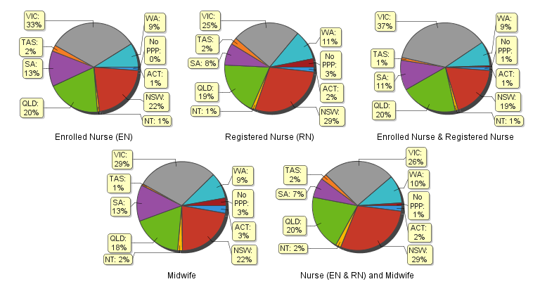
Totals for practitioners with non-practising registration as Nurse and/or Midwife
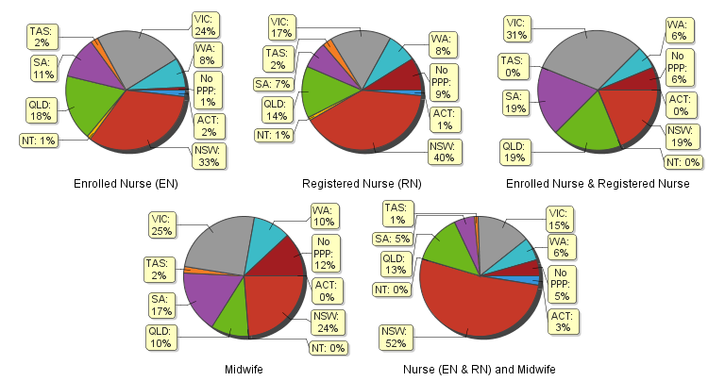
The following table and charts show totals for Non-Practising Registration
 | Principal place of practice
 | ACT | NSW | NT | QLD | SA | TAS | VIC | WA | No PPP | Total
Enrolled Nurse (EN) | 16 | 302 | 9 | 162 | 104 | 18 | 218 | 72 | 8 | 909
Registered Nurse (RN) | 51 | 1,427 | 27 | 503 | 260 | 86 | 592 | 284 | 316 | 3,546
Enrolled Nurse & Registered Nurse |  | 3 |  | 3 | 3 |  | 5 | 1 | 1 | 16
Nurse (EN & RN) and Midwife | 15 | 309 | 1 | 79 | 32 | 7 | 86 | 37 | 27 | 593
Midwife |  | 14 |  | 6 | 10 | 1 | 15 | 6 | 7 | 59

Registered Nurse and Midwife – endorsements by type
The NMBA endorsements for registered nurses are:
- Nurse Practitioner – includes prescribing scheduled medicines
- Registered Nurse - supply scheduled medicines (rural and isolated practice)
The NMBA endorsements for midwives are:
- Midwife – scheduled medicines
- Midwife Practitioner – refer Position-Statement Midwife Practitioners (7 April 2011)

 |  | Principal place of practice
Profession | Endorsement type | ACT | NSW | NT | QLD |  | SA |  | TAS |  | VIC |  | WA |  | No PPP |  | Total
Nurse | Nurse Practitioner | 37 | 279 | 20 | 339 |  | 113 |  | 27 |  | 240 |  | 218 |  | 14 |  | 1,287
 | Scheduled Medicines - Rural and isolated practice | 5 | 39 | 15 | 794 |  | 6 |  | 6 |  | 123 |  | 13 |  | 9 |  | 1,010
Midwife | Scheduled Medicines | 2 | 32 | 2 | 73 |  | 19 |  | 3 |  | 39 |  | 32 |  |  |  | 202
 | Midwife Practitioner |  | 1 |  |  |  |  |  |  |  |  |  |  |  |  |  | 1
The above numbers under ‘Midwife Scheduled Medicines’ reflect those midwives who have met the NMBA Registration standard for endorsement for scheduled medicines for midwives they are also eligible for the Eligible midwife notation.
Registered Nurse Notation
Registered nurses with a sole qualification in mental health nursing or paediatric nursing or disability nursing - rather than a qualification in general nursing - are identified on the national register with a notation, which states: Solely qualified in the area of Disability Nursing / Mental Health Nursing / Paediatric Nursing.
Registered Nurse |  | Principal place of practice
Notation | ACT |  | NSW | NT | QLD | SA | TAS | VIC | WA | No PPP | Total
Disability Nursing | 1 |  | 24 | 2 | 9 | 6 |  | 14 | 17 | 5 | 78
Mental Health nursing | 7 |  | 219 | 29 | 135 | 243 | 10 | 230 | 1,115 | 91 | 2,079
Paediatric Nursing | 4 |  | 127 | 3 | 52 | 18 | 1 | 55 | 148 | 37 | 445
Total | 12 |  | 370 | 34 | 196 | 267 | 11 | 299 | 1,280 | 133 | 2,602

The NMBA also recognises midwives that meet the requirements of the Eligible Midwife registration standard with a notation on their registration.
The notation states:
Eligible midwife competent to provide pregnancy, labour, birth and post natal care and qualified to provide the associated services and order diagnostic investigations required for midwifery practice, in accordance with relevant State and Territory legislation.
Midwife | Principal place of practice
Notation | ACT | NSW | NT | QLD | SA | TAS | VIC | WA | Total
Eligible midwife | 1 | 23 | 2 | 53 | 6 | 4 | 25 | 9 | 123
The above numbers reflect those midwives with the Eligible midwife notation only. An Eligible midwife, may be qualified to apply for endorsement for scheduled medicines for midwives under section 94 to prescribe Schedule 2, 3, 4 & 8 medicines when they have completed a NMBA-approved program of study and meet the requirements of the NMBA Registration standard for endorsement for scheduled medicines for midwives.
Nurse and Midwife – general registration by age group
Nurse and Midwife | Nurse |  |  | Nurse & Midwife |  |  | Midwife
Age group | Enrolled Nurse (EN) | Registered Nurse (RN) | Enrolled Nurse & Registered Nurse | Enrolled Nurse (EN) | Registered Nurse (RN) | Enrolled Nurse & Registered Nurse |  | Total |  | % by Age Group
U - 25 | 4,355 | 12,237 | 331 | 2 | 437 | 7 | 316 | 17,685 |  | 4.93%
25 - 29 | 5,072 | 31,997 | 1,207 | 18 | 1,496 | 14 | 648 | 40,452 |  | 11.28%
30 - 34 | 4,904 | 32,879 | 807 | 5 | 1,834 | 9 | 549 | 40,987 |  | 11.43%
35 - 39 | 4,461 | 28,982 | 572 | 6 | 1,769 | 3 | 467 | 36,260 |  | 10.11%
40 - 44 | 5,693 | 33,595 | 512 | 13 | 2,424 | 6 | 508 | 42,751 |  | 11.93%
45 - 49 | 7,603 | 30,941 | 567 | 4 | 3,355 | 5 | 440 | 42,915 |  | 11.97%
50 - 54 | 9,576 | 30,581 | 510 | 3 | 5,310 | 7 | 256 | 46,243 |  | 12.90%
55 - 59 | 9,970 | 30,404 | 277 | 3 | 6,049 | 1 | 195 | 46,899 |  | 13.08%
60 - 64 | 5,983 | 19,873 | 102 | 1 | 4,042 | 1 | 117 | 30,119 |  | 8.40%
65 - 69 | 1,859 | 7,984 | 23 |  | 1,423 |  | 52 | 11,341 |  | 3.16%
70 - 74 | 303 | 1,719 | 1 |  | 317 |  | 10 | 2,350 |  | 0.66%
75 - 79 | 35 | 338 | 1 |  | 54 |  | 3 | 431 |  | 0.12%
80+ | 4 | 52 |  |  | 8 |  |  | 64 |  | 0.02%
Total | 59,818 | 261,582 | 4,910 | 55 | 28,518 | 53 | 3,561 | 358,497 |  | 100.00%
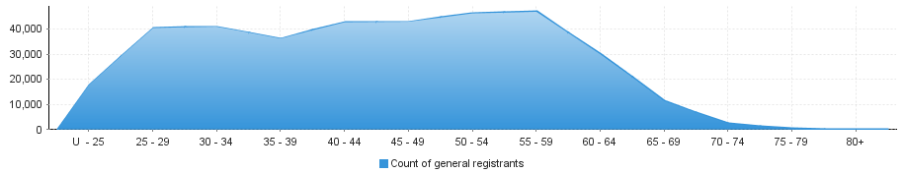
Nurse and Midwife – general registration by age group

Nurse and Midwife – non-practising registration by age group
Nurse and Midwife | Nurse |  |  | Nurse & Midwife |  |  | Midwife
Age group | Enrolled Nurse (EN) | Registered Nurse (RN) | Enrolled Nurse & Registered Nurse | Enrolled Nurse (EN) | Registered Nurse (RN) | Enrolled Nurse & Registered Nurse |  | Total |  | % by Age Group
U - 25 | 28 | 55 | 1 |  | 1 |  |  | 85 |  | 1.66%
25 - 29 | 60 | 205 | 5 |  | 7 | 10 |  | 287 |  | 5.60%
30 - 34 | 57 | 336 | 1 | 1 | 17 | 10 |  | 422 |  | 8.24%
35 - 39 | 61 | 345 |  |  | 16 | 10 |  | 432 |  | 8.43%
40 - 44 | 82 | 373 |  |  | 42 | 4 |  | 501 |  | 9.78%
45 - 49 | 109 | 365 | 1 |  | 41 | 7 |  | 523 |  | 10.21%
50 - 54 | 147 | 396 | 5 |  | 79 | 5 |  | 632 |  | 12.34%
55 - 59 | 187 | 503 | 2 |  | 108 | 5 |  | 805 |  | 15.71%
60 - 64 | 128 | 501 |  |  | 138 | 5 |  | 772 |  | 15.07%
65 - 69 | 42 | 315 |  |  | 94 | 1 |  | 452 |  | 8.82%
70 - 74 | 8 | 108 |  |  | 37 | 2 |  | 155 |  | 3.03%
75 - 79 |  | 35 | 1 |  | 6 |  |  | 42 |  | 0.82%
80+ |  | 9 |  |  | 6 |  |  | 15 |  | 0.29%
Total | 909 | 3,546 | 16 | 1 | 592 | 59 | 909 | 5,123 |  | 100.00%
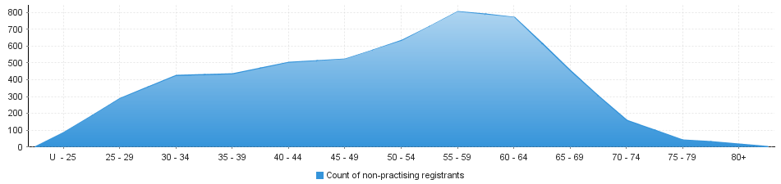
Nurse and Midwife – non-practising registration by age group

Nurse and Midwife – general registration by gender
Nurse and Midwife |  |  | Principal place of practice
Profession | Gender | Divisions | ACT | NSW | NT | QLD | SA | TAS | VIC | WA | No PPP | Total
Nurse | Female | Enrolled Nurse (EN) | 597 | 11,549 | 317 | 10,643 | 6,961 | 1,273 | 17,890 | 4,837 | 68 | 54,135
 |  | Registered Nurse (RN) | 3,787 | 65,127 | 2,656 | 44,657 | 18,676 | 5,547 | 57,850 | 24,937 | 7,319 | 230,556
 |  | Enrolled Nurse & Registered Nurse | 44 | 784 | 50 | 873 | 449 | 43 | 1,540 | 401 | 25 | 4,209
 | Female Nurse Total |  | 4,428 | 77,460 | 3,023 | 56,173 | 26,086 | 6,863 | 77,280 | 30,175 | 7,412 | 288,900
 | Male | Enrolled Nurse (EN) | 60 | 1,477 | 68 | 1,158 | 687 | 125 | 1,747 | 345 | 16 | 5,683
 |  | Registered Nurse (RN) | 540 | 9,849 | 487 | 5,751 | 2,550 | 783 | 7,156 | 2,709 | 1,201 | 31,026
 |  | Enrolled Nurse & Registered Nurse | 9 | 156 | 5 | 133 | 82 | 2 | 273 | 41 |  | 701
 | Male Nurse Total |  | 609 | 11,482 | 560 | 7,042 | 3,319 | 910 | 9,176 | 3,095 | 1,217 | 37,410
Nurse Total |  |  | 5,037 | 88,942 | 3,583 | 63,215 | 29,405 | 7,773 | 86,456 | 33,270 | 8,629 | 326,310
Nurse & Midwife | Female | Enrolled Nurse (EN) & Midwife | 3 | 4 |  | 11 | 1 |  | 35 |  |  | 54
 |  | Registered Nurse (RN) & Midwife | 535 | 8,151 | 496 | 5,682 | 2,021 | 611 | 7,375 | 2,859 | 286 | 28,016
 |  | Enrolled Nurse & Registered Nurse & Midwife | 1 | 9 | 1 | 3 | 2 |  | 27 | 9 |  | 52
 | Female Nurse & Midwife Total |  | 539 | 8,164 | 497 | 5,696 | 2,024 | 611 | 7,437 | 2,868 | 286 | 28,122
 |  | Enrolled Nurse (EN) & Midwife |  |  |  | 1 |  |  |  |  |  | 1
 | Male | Registered Nurse (RN) & Midwife | 12 | 177 | 25 | 98 | 46 | 15 | 78 | 43 | 8 | 502
 |  | Enrolled Nurse & Registered Nurse & Midwife |  | 1 |  |  |  |  |  |  |  | 1
 | Male Nurse & Midwife Total |  | 12 | 178 | 25 | 99 | 46 | 15 | 78 | 43 | 8 | 504
Nurse & Midwife Total |  |  | 551 | 8,342 | 522 | 5,795 | 2,070 | 626 | 7,515 | 2,911 | 294 | 28,626
Midwife | Female |  | 98 | 777 | 59 | 640 | 471 | 19 | 1,046 | 333 | 103 | 3,546
 | Male |  | 1 | 5 | 1 | 2 | 1 | 1 | 3 |  | 1 | 15
Midwife Total |  |  | 99 | 782 | 60 | 642 | 472 | 20 | 1,049 | 333 | 104 | 3,561
Grand Total |  |  | 5,687 | 98,066 | 4,165 | 69,652 | 31,947 | 8,419 | 95,020 | 36,514 | 9,027 | 358,497

Nurse and Midwife – total general registration by gender
 | Principal place of practice
General | ACT | NSW | NT | QLD | SA | TAS | VIC | WA | No PPP | Total
Female | 5,065 | 86,401 | 3,579 | 62,509 | 28,581 | 7,493 | 85,763 | 33,376 | 7,801 | 320,568
Male | 622 | 11,665 | 586 | 7,143 | 3,366 | 926 | 9,257 | 3,138 | 1,226 | 37,929

Nurse and Midwife – general registration by gender percentages
 | Principal place of practice
General | ACT | NSW | NT | QLD | SA | TAS | VIC | WA | No PPP | Total
Female | 89.06% | 88.10% | 85.93% | 89.74% | 89.46% | 89.00% | 90.26% | 91.41% | 86.42% | 89.47%
Male | 10.94% | 11.90% | 14.07% | 10.26% | 10.54% | 11.00% | 9.74% | 8.59% | 13.58% | 10.53%

Nurse and Midwife – non-practising registration by gender
Nurse and Midwife |  |  | Principal place of practice
Profession | Gender | Divisions | ACT | NSW | NT | QLD | SA | TAS | VIC | WA | No PPP | Total
Nurse | Female | Enrolled Nurse (EN) | 15 | 279 | 9 | 156 | 98 | 16 | 203 | 72 | 6 | 854
 |  | Registered Nurse (RN) | 44 | 1,294 | 27 | 463 | 229 | 77 | 549 | 264 | 290 | 3,237
 |  | Enrolled Nurse & Registered Nurse |  | 3 |  | 2 | 2 |  | 5 | 1 | 1 | 14
 | Female Nurse Total |  | 59 | 1,576 | 36 | 621 | 329 | 93 | 757 | 337 | 297 | 4,105
 | Male | Enrolled Nurse (EN) | 1 | 23 |  | 6 | 6 | 2 | 15 |  | 2 | 55
 |  | Registered Nurse (RN) | 7 | 133 |  | 40 | 31 | 9 | 43 | 20 | 26 | 309
 |  | Enrolled Nurse & Registered Nurse |  |  |  | 1 | 1 |  |  |  |  | 2
 | Male Nurse Total |  | 8 | 156 |  | 47 | 38 | 11 | 58 | 20 | 28 | 366
Nurse Total |  |  | 67 | 1,732 | 36 | 668 | 367 | 104 | 815 | 357 | 325 | 4,471
Nurse & Midwife | Female | Enrolled Nurse (EN) & Midwife |  |  |  |  |  |  | 1 |  |  | 1
 |  | Registered Nurse (RN) & Midwife | 15 | 304 | 1 | 78 | 32 | 6 | 85 | 36 | 26 | 583
 |  | Enrolled Nurse & Registered Nurse & Midwife
 | Female Nurse & Midwife Total |  | 15 | 304 | 1 | 78 | 32 | 6 | 86 | 36 | 26 | 584
 |  | Enrolled Nurse (EN) & Midwife
 | Male | Registered Nurse (RN) & Midwife |  | 5 |  | 1 |  | 1 |  | 1 | 1 | 9
 |  | Enrolled Nurse & Registered Nurse & Midwife
 | Male Nurse & Midwife Total |  |  | 5 |  | 1 |  | 1 |  | 1 | 1 | 9
Nurse & Midwife Total |  |  | 15 | 309 | 1 | 79 | 32 | 7 | 86 | 37 | 27 | 593
Midwife | Female |  |  | 14 |  | 6 | 10 | 1 | 15 | 6 | 7 | 59
 | Male
Midwife Total |  |  |  | 14 |  | 6 | 10 | 1 | 15 | 6 | 7 | 59
Grand Total |  |  | 82 | 2,055 | 37 | 753 | 409 | 112 | 916 | 400 | 359 | 5,123

Nurse and Midwife – total non-practising totals by gender
 | Principal place of practice
General | ACT | NSW | NT | QLD | SA | TAS | VIC | WA | No PPP | Total
Female | 74 | 1,894 | 37 | 705 | 371 | 100 | 858 | 379 | 330 | 4,748
Male | 8 | 161 | 0 | 48 | 38 | 12 | 58 | 21 | 29 | 375

Nurse and Midwife – non-practising registration by gender percentages
 | Principal place of practice
General | ACT | NSW | NT | QLD | SA | TAS | VIC | WA | No PPP | Total
Female | 90.24% | 92.17% | 100.00% | 93.63% | 90.71% | 89.29% | 93.67% | 94.75% | 91.92% | 89.47%
Male | 9.76% | 7.83% | 0.00% | 6.37% | 9.29% | 10.71% | 6.33% | 5.25% | 8.08% | 10.53%

Note that the data for dual registration in the tables and diagrams includes where a nurse or a midwife may be non-practising in one category, for example enrolled nurse (non-practising) & registered nurse (practising) or nurse (non-practising) & midwife (practising).
Note that No principal place of practice (PPP) will include nurses and midwives with an overseas address.

