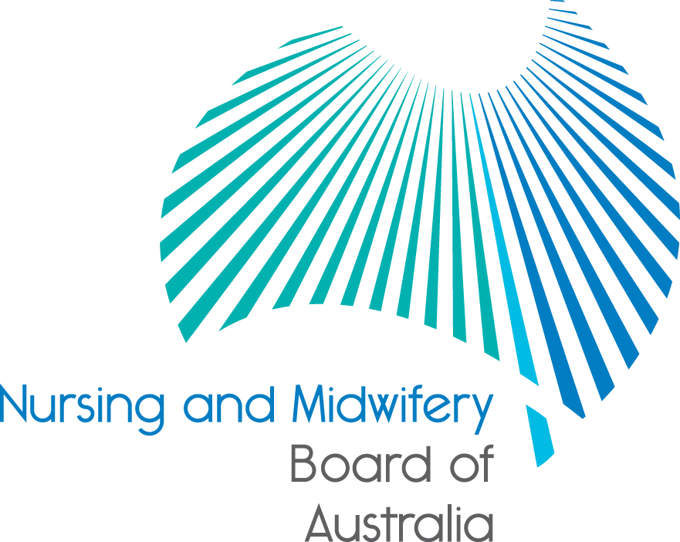

Registration standard: English language skills
Effective date: 1 March 2019
The Nursing and Midwifery Board of Australia (Board) requires all applicants for initial registration to demonstrate English language skills to be suitable for registration.
This registration standard sets out how an applicant for registration can demonstrate to the Board that their competency in speaking and communicating in English is sufficient to practise nursing and/or midwifery.
Does this standard apply to me?
This standard applies to all applicants for initial registration.
It does not apply if you are applying for non-practising registration or if you are a student.
What must I do?
If you are applying for initial registration you must demonstrate your English language competency in one of the following ways:
1. English is your primary language and:
- you have attended and satisfactorily completed at least six years of primary and secondary education taught and assessed solely in English in a recognised country, including at least two years between years 7 and 12, and
- your tertiary qualification in the relevant professional discipline, which you are relying on to support your eligibility for registration under the National Law was taught and assessed solely in English in a recognised country and:
- in the case of a registered nurse and/ or midwife, you must provide evidence of having successfully completed at least a two (2) years full-time equivalent pre-registration program of study approved by the recognised nursing and/or midwifery regulatory body in a recognised country.
- in the case of an enrolled nurse, you must provide evidence of having successfully completed at least a one year full-time equivalent pre-registration program of study approved by the recognised nursing and/or midwifery regulatory body in a recognised country.
OR
2. Registered nurses and midwives

If you are applying for registration as a registered nurse and/or midwife, you must provide evidence that you have successfully completed at least five (5) years (full-time equivalent) continuous education taught and assessed solely in English, in a recognised country, which includes tertiary qualifications in the relevant professional discipline which you are relying on to support your eligibility for registration under the National Law
The Board will only accept the successful completion of five (5) years (full-time equivalent) continuous education that is a combination of:
- tertiary and secondary education taught and assessed in English; or
- tertiary and vocational education taught and assessed in English; or
- combined tertiary, secondary and vocational education taught and assessed in English; or
- tertiary education taught and assessed in English
The last period of education must have been completed no more than five years prior to applying for registration.
OR
3. Enrolled nurses
If you are applying for registration as an enrolled nurse, you must provide evidence that you have successfully completed at least five (5) years (full-time equivalent) continuous education taught and assessed solely in English, in a recognised country, which includes vocational qualifications in the relevant professional discipline which you are relying on to support your eligibility for registration under the National Law.
The Board will only accept the successful completion of five (5) years (full-time equivalent) continuous education that is a combination of:
- vocational and secondary education taught and assessed in English; or
- tertiary and vocational education taught and assessed in English; or
- combined tertiary, secondary and vocational education taught and assessed in English; or
- tertiary education taught and assessed in English
The last period of education must have been completed no more than five years prior to applying for registration.
OR
4. You achieve the required minimum scores in one of the following English language tests and meet the requirements for test results specified in this standard:
- the IELTS (academic module) with a minimum overall score of 7 and a minimum score of 7 in each of the four components (listening, reading, writing and speaking).
NOTE:
We will only accept test results:
- from one test sitting, or
- a maximum of two test sittings in a six month period only if:
- you achieve a minimum overall score of 7 in each sitting, and
- you achieve a minimum score of 7 in each component across the two sittings, and
- no score in any component of the test is below 6.5
- the OET with a minimum score of B in each of the four components (listening, reading, writing and speaking).
NOTE:
We will only accept test results:
- from one test sitting, or
- maximum of two test sittings in a six month period only if:
- you are tested in all four components in each sitting, and
- you achieve a minimum score of B in each component across the two sittings, and
- no score in any component of the test is below C.
- the PTE Academic with a minimum overall score of 65 and a minimum score of 65 in each of the four communicative skills (listening, reading, writing and speaking).
NOTE:
We will only accept test results:
  - from one test sitting, or
  - a maximum of two test sittings in a six month period only if:
- a minimum overall score of 65 is achieved in each sitting, and
- you achieve a minimum score of 65 in each of the communicative skills across the two sittings, and
- no score in any of the communicative skills is below 58
- the TOEFL iBT with a minimum total score of 94 and the following minimum score in each section of the test:
- 24 for listening,
- 24 for reading,
- 27 for writing, and
- 23 for speaking.
NOTE:
We will only accept test results:
- from one test sitting, or
- a maximum of two test sittings in a six month period only if:
- a minimum total score of 94 is achieved in each sitting, and you achieve a minimum score of 24 for listening, 24 for reading, 27 for writing and 23 for speaking across the two sittings, and
- no score in any of the sections is below:
- 20 for listening
- 19 for reading
- 24 for writing, and
- 20 for speaking
- other English language tests approved by the Board from time to time and published on the Board’s website with the required minimum scores.
5. In other defined circumstances/cases where there is compelling evidence demonstrating English language proficiency at least equivalent to the other pathways in this standard set out in a policy published by the Board.
Test results
The following requirements apply to the English language test results:
- Test results will be accepted if they were obtained:
1.1 within the two years before the date you lodge your application for registration
OR
1.2 more than two years before the date you lodge your application for registration if, in the period since the test results were obtained, you:
- have been in continuous employment as a registered health practitioner in the nursing and/or midwifery profession (which commenced within 12 months of the date of the test) in one of the recognised countries where English was the primary language of practice, and
- lodge your application for registration within 12 months of finishing your last period of employment
OR
1.3 more than two years before the date you lodge your application for registration if, in the period since the test result was obtained, you:
- have been continuously enrolled in a Board approved program of study, which commenced within 12 months of the date of the test result and undertook subjects in each semester, with no break from study apart from the education provider’s scheduled holidays, and
- lodge your application for registration within 12 months of completing the Board approved program of study.
- For the purposes of calculating time, if an applicant relies on test results from two sittings, time begins to run from the date of the earlier sitting.
Exemptions
- The Board may grant an exemption to this standard when you apply for limited registration in the following circumstances:
- to perform a demonstration in clinical techniques
- to undertake research that involves limited or no patient contact, or
- to undertake a period of postgraduate study or supervised training while working in an appropriately supported environment that will ensure patient safety is not compromised.
- Conditions will generally apply to these exemptions, which will require supervision by a registered health practitioner and may also require the use of an interpreter.
- The Board reserves the right at any time to revoke an exemption and/or require an applicant to undertake a specified English language test.
More information
Practitioners who meet this standard on the basis of results from an English language test will be asked to declare that they have continued to use English as their primary language when they apply to move from non-practising to practising registration.
Further information regarding the evidence that applicants must provide to the Board to prove that they meet this standard is set out in the relevant application form.
Your test results will be verified independently with the test provider.
You are responsible for the cost of English language tests.
Authority
This registration standard was approved by the Ministerial Council on 22 August 2018.
Registration standards are developed under section 38 of the National Law and are subject to wide ranging consultation.
Definitions
Board approved program of study means an accredited program of study approved by the Nursing and Midwifery Board of Australia under section 49(1) of the National Law and published in the Board’s list of approved programs of study on the Board’s website
Continuous employment means working the equivalent of at least 26 weeks per year.

Five years (full-time equivalent) continuous education means education over a period of five consecutive calendar years without a break from study apart from the education institution (e.g. school, university or vocation education provider) scheduled holidays
IELTS means the International English Language Testing System
Initial registration means:
- a practitioner applying for registration in Australia in nursing and/or midwifery for the first time; or
- a practitioner applying for registration (including moving from non-practising to another registration type) who has not used English as their primary language for a period of greater than five years; or
- a practitioner who currently holds limited registration on the basis that they were granted an exemption from this standard in the limited circumstances described under Exemptions and who is applying for another type of registration.
Initial registration otherwise does not include a practitioner who has had continual registration in nursing and/or midwifery and is applying for a different category or division of registration in that profession, for example, a practitioner who holds provisional registration and is applying for general registration; or a practitioner who holds general registration and is applying for specialist registration.
National Law means the Health Practitioner Regulation National Law Act (as in force in each state and territory).
OET means Occupational English Test
Practising registration means provisional, general, specialist or limited registration
Primary language means the language primarily used for reading, writing, listening, and speaking and the language known best and most comfortable with.
PTE Academic means the Pearson Test of English Academic
Recognised country means one of the following countries:
- Australia
- Canada
- New Zealand
- Republic of Ireland
- South Africa
- United Kingdom
- United States of America.
Secondary education means Australian school years 7 through to 12, even where year 7 is classified as part of primary school in a particular state or territory.
Six years primary and secondary education means six years of Australian school years 1 through to 12 or the equivalent in a recognised country with two of the years being between 7 and 12.
Student means a student currently registered under the National Law
Test results means the official results provided by the English language test provider. If you are providing test results from two test sittings as defined, the results from both sittings must meet the requirements of this standard.
TOEFL iBT means the Test of English as a Foreign Language internet-based test
Two test sittings in a six month period means that the dates of the sittings must not be more than six months apart. For example, if your first test sitting was on 1 March, the second sitting must be no later than 30 August. If you are providing test results from two sittings, you may provide results of any two tests taken within a six month period as defined.
Vocational education for the purpose of this standard is education that is taught and assessed solely in English in a recognised country where:
- The level of vocational education was at the Australian Qualifications Framework Level 3 or Certificate III or higher, and
- The vocational education was delivered primarily face to face and required students to use English speaking, writing, reading and listening skills.
Review
This standard will be reviewed at least every three years.
Last reviewed: October 2018

Bolded terms are defined in the Definitions section of this registration standard

