Health Profession Agreement

Nursing and Midwifery Board of Australia

and

The Australian Health Practitioner Regulation Agency

2016-20

Health Profession Agreement
Preamble
The purpose of the Health Practitioner Regulation National Law (the National Law), as in force in each state and territory, is to establish the National Registration and Accreditation Scheme (the National Scheme). The National Scheme has six key objectives set out in s.3(2) of the National Law. In summary, the objectives are to:
- protect public safety,
- facilitate workforce mobility for health practitioners,
- facilitate high-quality education and training of health practitioners,
- facilitate assessment of overseas-trained health practitioners,
- facilitate access to health services, and
- development of a flexible, responsive and sustainable health workforce.
Fifteen National Boards and the Australian Health Practitioner Regulation Agency (AHPRA) work in partnership to achieve these objectives, with different and complementary functions.
The HPA is a statutory instrument. The National Board and AHPRA are required to negotiate in good faith and attempt to come to an agreement on the terms of the HPA. Although the National Board does not have the power to enter into contracts generally (as provided for in s.32(2)(a)), the National Law clearly intends that the National Board can agree and enter into an HPA with AHPRA. Furthermore, the National Board and AHPRA are each a separate body corporate, capable of reaching agreements between themselves.
The following schedules to this HPA record AHPRA and the National Board’s agreement on these matters: fees (Schedule 3); the National Board’s annual budget (Schedule 4); and the services AHPRA is to provide (Schedule 1).
The National Law also requires each National Board to publish on its website the fees agreed to in this HPA.
Accountabilities
Ministerial Council
Ultimate accountability to the public for the performance of the National Scheme rests with the parliaments of participating jurisdictions, through the Australian Health Workforce Ministerial Council (the Ministerial Council). The Ministerial Council appoints AHPRA’s Agency Management Committee and National Boards, and formally holds these bodies to account.
National Boards
A National Board is a body corporate with perpetual succession, has a common seal, and may sue and be sued in its corporate name. A National Board does not have power to enter into contracts, or employ staff, or acquire, hold, dispose of, and deal with, real property.
The principal regulatory decision-makers in the National Scheme are the National Boards and their committees, including, where relevant, State and Territory or Regional Boards. AHPRA undertakes delegated functions on behalf of the National Boards and provides services to the National Boards. National Boards are accountable to the community through the mechanism of the Ministerial Council and parliamentary reporting for the quality of their regulatory decisions, and through the court system and relevant administrative review bodies for the legality of their regulatory decisions. While National Boards can propose regulatory procedures, they do not establish or administer them. National Boards have specific ‘oversight’ roles in relation to the assessment of overseas qualifications, monitoring of practitioners and the receipt, assessment and investigation of notifications. Without the power to employ staff or enter into contracts, National Boards must rely on the services provided, or contracted, by AHPRA. The mechanism for National Boards to hold AHPRA to account is through this Health Profession Agreement. The Health Profession Agreement includes performance indicators to support the performance of National Boards’ oversight functions.
AHPRA
AHPRA is a body corporate with perpetual succession, has a common seal, and may sue and be sued in its corporate name. AHPRA has all the powers of an individual and in particular, may enter into contracts, or employ staff, or acquire, hold, dispose of, and deal with, real and personal property, and do anything necessary or convenient to be done in the exercise of its functions.
AHPRA’s Agency Management Committee directs and controls the affairs of AHPRA, and sets its policy directions. The Agency Management Committee is accountable for the performance of AHPRA’s functions, which include the establishment of regulatory procedures, financial management and administration of the Scheme. AHPRA is solely responsible for administering the Agency Fund, which has an account for each National Board. Payments out of a National Board’s account may be made only if the payment is in accordance with the National Board’s budget, as agreed as part of this Health Profession Agreement, or otherwise approved by the National Board. To enable it to perform the executive functions within the Scheme, AHPRA has powers to employ staff and enter into contracts. AHPRA provides administrative assistance and support to National Boards and their committees to exercise their functions.
AHPRA and the National Board can be described as governance partners in the Scheme. This is largely because AHPRA relies on National Boards to perform their functions consistent with the National Law objectives and in line with procedures established by AHPRA for ensuring effective and efficient operation of National Boards and to comply with procedures for development of professional standards that are in accordance with good regulatory practice.
The Agency Management Committee is accountable for ensuring that the corporate functions that are essential to any contemporary regulatory organisation are in place. This means that corporate services, including human resources, business planning, financial management and facilities management, are generally not specified in the services AHPRA is to provide (Schedule 1) except where the service deliverable is provided directly to the National Boards.
Purpose of this Agreement
The purpose of a Health Profession Agreement (HPA) is described in s.26(1) of the National Law, which provides that AHPRA must enter into a HPA with a National Board that makes provision for:
- fees payable by health practitioners and others in relation to the health profession for which the National Board is established,
- the National Board’s annual budget,
- the services to be provided to the National Board by AHPRA to enable the National Board to carry out its functions.
This HPA outlines agreement between the National Board and AHPRA on their general approach to performing their reciprocal obligations to ensure a common understanding and that the National Scheme operates with regard to its objectives and guiding principles.
Scope of this Agreement
This Agreement is for the period 1 July 2016 to 30 June 2020.
The National Board agrees to authorise the Chair of the Board (or his/her nominee) to act as liaison officer with respect to the Agreement. AHPRA agrees to authorise the Executive Director, Strategy and Policy to act as liaison officer with respect to the Agreement.

Partnership principles
To achieve the objectives of the National Law through different and complementary functions, the National Board and AHPRA understand that a sustainable partnership is essential.
This understanding is supported by a set of core partnership principles (the Partnership Principles). The National Board and AHPRA will ensure that these Partnership Principles underpin all our work. While differences in context may require different approaches, both parties will ensure that their respective activities respect these four Partnership Principles:
- Shared vision and values
- Integrity through interdependence
- Transparency and mutual accountability
- Commitment to joint learning
In particular, the National Board will do everything it can to make its requirements clear, and AHPRA will do everything it can to provide the services required by the National Board to perform its functions.
Each of the Partnership Principles is described in detail below.
- Shared vision and values
This partnership between the National Board and AHPRA is built on a shared vision for a competent and flexible health workforce that meets the needs of the Australian community.
While recognising and respecting the different and complementary functions of the National Board and AHPRA, there must be common ground in the approach the National Board and AHPRA take to implementing the National Scheme. The National Board and AHPRA share a commitment to the objectives and guiding principles of the National Scheme and the eight regulatory principles (Regulatory Principles) that will shape our thinking about regulatory decision-making.
In our shared principles, we balance all the objectives of the National Scheme, but our primary consideration is to protect the public in accordance with good regulatory practice.
The Regulatory Principles incorporate the concept of risk-based regulation. This means that in all areas of our work we:
- identify the risks that we are obliged to respond to,
- assess the likelihood and possible consequences of the risks, and
- respond in ways that are proportionate and manage risks so we can adequately protect the public.
In recognising our different and complementary functions, the National Board and AHPRA have agreed on an accountability framework for the National Scheme (the Accountability Framework).
The Accountability Framework recognises that all entities in the National Scheme are ultimately accountable to the Australian public through the Australian Health Workforce Ministerial Council (the Ministerial Council).
One of the recognised features of the National Scheme is that our structure provides for governance and accountability across the entities in the National Scheme for their performance. The effective delivery of professional regulation relies on strong partnerships between entities based on clear and agreed roles and functions. Our Accountability Framework is designed to articulate a shared understanding regarding who is accountable for what within the National Scheme and aims to provide clarity about the distinct and complementary roles of the different entities, and their respective duties and obligations.

- Integrity through interdependence
In exercising our different and complementary functions, the National Board and AHPRA will strive for mutual respect and to promote the integrity of the National Scheme. We are aware we have interdependent and complementary functions. The National Board and AHPRA will work to manage any tensions that arise through our consultation processes and the Accountability Framework.
We will each take responsibility for clearly communicating our positions to each other. We are each open to being challenged by the other, and we will each create opportunities for dialogue and debate around our respective approach, results and impact. While the National Board and AHPRA are each independent entities, we recognise that neither can meaningfully exist outside of the context of the relationship defined by the National Law. We agree to respect the other’s functions as set out in the National Law.
For example, AHPRA acknowledges its obligation to consult the National Board when developing procedures for the operation of the National Board, and will endeavour to incorporate the National Board’s feedback into those procedures. The National Board respects that AHPRA must endeavour to establish common procedures that apply to all National Boards and undertakes to comply with those procedures once finalised.
The National Board and AHPRA also have complementary duties in relation to financial management. AHPRA is accountable for the management of the Agency Fund and for ensuring that all expenditure from the National Board’s account is consistent with the National Law, in accordance with the Board’s annual budget (or with the approval of the National Board if a change to the agreed budget), and as far as possible represents reasonable value for money. Accountability for expenditure rests with the AHPRA financial delegate who approves that expenditure, including payments to enable the National Board to exercise its functions. The National Board respects this role and undertakes to support AHPRA in fulfilling this role and its obligations under the National Law generally.
- Transparency and mutual accountability
The Health Profession Agreement is the formal mechanism by which we hold each other to account, in accordance with the National Law and the Accountability Framework. It incorporates a transparent reporting framework to ensure that reciprocal obligations can be monitored.
The Agency Management Committee is formally accountable for AHPRA’s performance of its functions. The National Board relies on AHPRA to deliver services to it in order for it to carry out its functions. In turn AHPRA relies on National Boards to perform their functions consistent with the National Law objectives and in line with procedures established by AHPRA for ensuring effective and efficient operation of National Boards and procedures for development of professional standards that are in accordance with good regulatory practice.
Schedule 1 to this HPA outlines the services to be provided to the National Board by AHPRA to enable the National Board to carry out its functions. It also includes information about AHPRA’s performance of its own statutory functions. Schedule 1 also includes profession-specific services and any discretionary services the National Board may request of AHPRA.
In addition, the Agreement supports the National Board to fulfil its specific oversight functions in respect of:
- the assessment of overseas trained registration applicants who do not hold approved qualifications
- the assessment and investigation of matters about persons who—
- are or were registered health practitioners, or
- are students in the health profession,
- the management of registered health practitioners and students in the health profession, including monitoring conditions, undertaking and suspensions imposed on the registration of the practitioners or students.
In order to exercise these functions, the National Board must be given the opportunity to review timely information regarding relevant activities undertaken by AHPRA and the National Boards’ delegates, to raise questions and concerns and to suggest actions to remediate problems. AHPRA undertakes to ensure that performance reports will be provided to the National Board to fulfil these oversight functions; in particular these reports will include details of the timeliness, cost and quality of regulatory procedures and services AHPRA provides to the National Board. The performance reports AHPRA will provide, and the performance indicators underpinning them, are set out in Schedule 5 to this HPA.
- Commitment to joint learning
The National Board and AHPRA agree to promote continuous and systematic learning regarding the National Scheme. We will evaluate the outcomes of business and regulatory processes and use data generated by the National Scheme to better understand the risks we manage and the effectiveness of our actions.
Our learning agenda will explore both partnership processes and outcomes. We will take an evaluative approach to regulation that uses data to identify risks and measure our effectiveness in managing them. The National Board and AHPRA both have an interest in understanding the factors, including ways of working, which are the hallmarks of successful partnerships. We will work together to ensure that joint learning is used regularly to adjust our future strategy and plans as we strive for increased efficiency and effectiveness of the National Scheme.
The National Board and AHPRA are committed to the efficient management and continuous improvement of their respective functions.
Dispute resolution
The National Law provides that any failure to reach agreement between National Boards and AHPRA on matters relating the HPA is to be referred to the Ministerial Council for resolution.
The National Board and AHPRA have a commitment to resolve problems or disputes promptly. However, if a dispute arises regarding this HPA, as partners we will use our best endeavours to resolve the dispute fairly and promptly.
If the dispute cannot be resolved, the matter will be referred to the AHPRA Chief Executive Officer and the Chair of the National Board. If the dispute still cannot be resolved, it will be referred to the Chair of AHPRA’s Agency Management Committee and the Chair of the National Board.
Either the Chair of AHPRA’s Agency Management Committee or the Chair of the National Board may request the appointment of an independent, accredited mediator at any stage in the process.
If we are still unable to agree on the matter, we will seek direction from the Ministerial Council about how the dispute to be resolved.
Review
The National Board and AHPRA agree to review this HPA on an annual basis.

Schedules
Schedule 1: | Summary of Services to be provided to the National Board by AHPRA to enable the National Board to carry out its functions
Schedule 2: | Summary of National Scheme Strategy, implementation map, and National Board’s regulatory plan
Schedule 3: | Fees payable by health practitioners
Schedule 4: | Summary of National Board’s annual budget
Schedule 5:  Schedule 6: | Performance management framework  Principles of equity

This Agreement is made between
Nursing and Midwifery Board of Australia
and
The Australian Health Practitioner Regulation Agency (AHPRA)
Signed for and on behalf of AHPRA by:  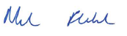 | Signed for and on behalf of the Nursing and Midwifery Board of Australia by:  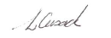
Signature of Chief Executive Officer | Signature of the Board Chair
Mr Martin Fletcher | Dr Lynette Cusack RN
Date  | Date 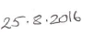

Schedule 1: Summary of services to be provided to the National Board by AHPRA to enable the National Board to carry out its functions
- Regulatory services, procedures and processes
1.1 Registrations
Core | Profession specific
1.1.1 Develop, implement and regularly review nationally consistent procedures for the registration of health practitioners | Profession-specific services, as listed in the National Board’s regulatory plan and annual budget.
1.1.2 Manage practitioner registration, renewal and audit
1.1.3 Maintain a public register of health practitioners
1.1.4 Maintain a register of health practitioner students
1.1.5 Promote online registration services to health practitioners
1.1.6 Operation of examinations (if required) is agreed between AHPRA and the National Board

1.2 Notifications
Core | Profession specific
1.2.1 Develop, implement and regularly review nationally consistent procedures to receive and deal with notifications against persons who are or were registered health practitioners and students | Profession-specific services, as listed in the National Board’s regulatory plan and annual budget.
1.2.2 Manage the end to end notification process
1.2.3 Establish and maintain relationships with co-regulatory authorities.

1.3 Compliance
Core | Profession specific
1.3.1 Develop compliance policy, process and systems | Profession-specific services, as listed in the National Board’s regulatory plan and annual budget.
1.3.2 Manage practitioners with registration restrictions, suspension or cancellation
1.3.3 Oversee the ongoing development and reporting of performance measures for monitoring of practitioners compliance

1.4 Legal services
Core | Profession specific
1.4.1 Provide legal advice to support effective and lawful registration and notifications procedures, and hearing panels processes | Profession-specific services, as listed in the National Board’s regulatory plan and annual budget.
1.4.2 Provide oversight for all Tribunal matters involving AHPRA and the National Boards
- Governance and secretariat
2.1 Governance
Core | Profession specific
2.1.1 Develop and administer procedures to support effective and efficient National Board and committee operations | Profession-specific services, as listed in the National Board’s regulatory plan and annual budget.
2.1.2 Provide National Board member orientation, induction and professional development
2.1.3 Support working relationships with relevant committees

2.2 Secretariat
Core | Profession specific
2.2.1 Provide secretariat and administrative support for National Board Meetings | Profession-specific services, as listed in the National Board’s regulatory plan and annual budget.
2.2.2 Provide secretariat and administrative support for National Board committee meetings
2.2.3 Provide panel hearing secretariat support
2.2.4 Secretariat and policy support for governance forums, including the Forum of Chairs and its sub-committees

- Communication and engagement
3.1 Communication
Core | Profession specific
3.1.1 Develop, implement and review communication strategies, tools and guidelines | Profession-specific services, as listed in the National Board’s regulatory plan and annual budget.
3.1.2 Develop and release National Board communiqués
3.1.3 Review and release National Board media releases
3.1.4 Develop and maintain National Board website and resources
3.1.5 Coordinate and manage the production of the AHPRA annual report and other publications
3.1.6 Provide communications support for crisis and issue management
3.1.7 Develop and produce National Board newsletters and news updates
3.1.8 Develop Branding for National Board and AHPRA Communication
3.1.9 Report on relevant media coverage
3.1.10 Manage social media

3.2 Engagement
Core | Profession specific
3.2.1 Engage with external stakeholders | Profession-specific services, as listed in the National Board’s regulatory plan and annual budget.
3.2.2 Manage intergovernmental relations
3.2.3 Undertake consultation to support cross-profession strategies and guidelines
3.2.4 Engage with external advisory groups
3.2.5 Monitor stakeholder engagement activities

- Planning and reporting
4.1 Planning
Core | Profession specific
4.1.1 Inform and support the NRAS Strategy | Profession-specific services, as listed in the National Board’s regulatory plan and annual budget.
4.1.2 Develop and implement AHPRA business plan
4.1.3 Develop and implement National Board regulatory plan
4.1.4 HPA engagement and development

4.2 Reporting
Core | Profession specific
4.2.1 Develop and report on outcomes related to National Boards’ regulatory functions and AHPRA’s administrative assistance and support to National Boards and the Boards’ committees, in exercising their functions. | Profession-specific services, as listed in the National Board’s regulatory plan and annual budget.
4.2.2 Establish corporate audit and compliance monitoring and reporting
4.2.3 Fulfil annual reporting requirements

- Policy and accreditation
5.1 Policy
Core | Profession specific
5.1.1 Maintain procedures for the development of registration standards, codes and guidelines | Profession-specific services, as listed in the National Board’s regulatory plan and annual budget.
5.1.2 Develop, review and implement cross-profession standards, codes and guidelines
5.1.3 Assist National Boards to develop, review and implement cross- profession regulatory policy
5.1.4 Provides tools to support regulatory policy development, review and evaluation

5.2 Accreditation
Core | Profession specific
5.2.1 Support National Boards to oversight effective delivery of accreditation functions | Profession-specific services, as listed in the National Board’s regulatory plan and annual budget.
5.2.2 Supporting accreditation committees to deliver the accreditation functions, where applicable
5.2.3 Maintain procedures for the development of accreditation standards

- Data, research and analysis
6.1 Evidence acquisition
Core | Profession specific
6.1.1 Assist National Boards to define and articulate regulatory evidence requirements | Profession-specific services, as listed in the National Board’s regulatory plan and annual budget.
6.1.2 Provide advice to National Boards about proposed research and analytical projects
6.1.3 Provide descriptive statistics for all professions
6.1.4 Undertake cross-profession regulatory risk analyses
6.1.5 Monitor and research cross-profession regulatory policy and trends
6.1.6 Develop and implement robust regulatory evaluation methodologies
6.1.7 Liaise with external stakeholders regarding the annual Health Workforce Survey questionnaires
6.1.8 Broker and maintain formal strategic data and research partnerships with external organisations

6.2 Data governance and organisational capacity
Core | Profession specific
6.2.1 Develop, implement and manage governance process and procedures for data access, release and exchange | Profession-specific services, as listed in the National Board’s regulatory plan and annual budget.
6.2.2 Develop and maintain core statistical infrastructure to support internal and external research and analyses
6.2.3 Provide tools and training to support evidence informed regulatory policy development
6.2.4 Develop organisational infrastructure for delivering regulatory research

Schedule 2: Summary of National Scheme Strategy, implementation map, and National Board’s regulatory plan
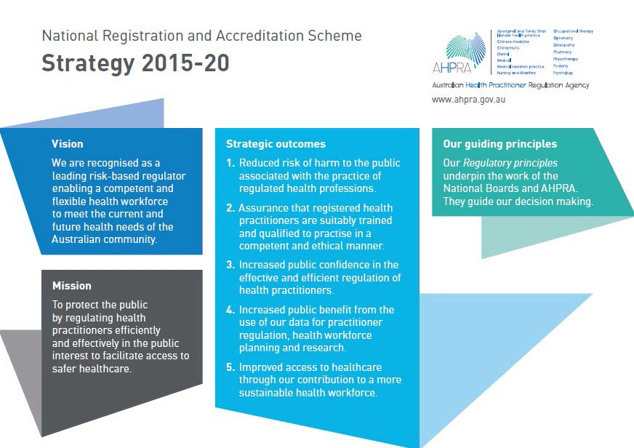
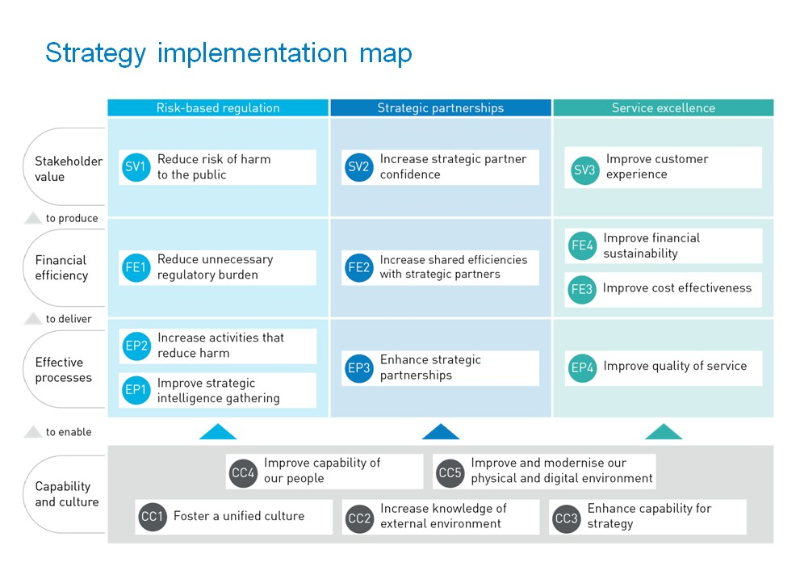

NMBA Regulatory Plan 2017-20 – progress against regulatory plan 2018/2019

Strategic goals outcomes | Strategic initiatives | Related NRAS strategic outcomes and objectives | Related NMBA initiatives
- Engage and educate nurses and midwives regarding regulatory responsibilities | - Establish baseline regarding students understanding of regulatory responsibility  - Based on 1.1 determine applicable strategies  Develop and disseminate suite of materials to engage nurses and midwives | Strategic outcomes 1 and 2  Strategic objectives EP1, EP2 and SV1 | - Conduct qualitative research/assessment of students’ understanding of their future professional responsibilities, and identify strong areas of communication between the National Scheme and students as well as areas for improvement.  2017: Conduct qualitative research and assessment  - Develop an NMBA campaign targeted at students and new graduates with the purpose of further engaging them with their professional obligations within the National Scheme and preparing them for a career-long relationship with their regulator.  2018: Develop student campaign strategy and materials  2019 - 2020: Launch student campaign  - Develop a brand campaign from the NMBA brand identity strategy, to engage nurses and midwives with their regulator and professional obligations, to further public safety and to strengthen consistency in our engagement with stakeholders. Brand campaign to include a refresh of current NMBA communications with registrants and stakeholders; and development and distribution of new engagement strategies and materials with particular focus on digital.  2017: Undertake benchmarking to determine impacts of recent engagement strategies. Develop brand campaign strategy; launch brand campaign with refresh of current communications.  2018: Develop new communications and engagement strategies and materials in-line with brand campaign strategy  2019 - 2020: Continue brand campaign with full suite of materials, evaluate strategy.
- Demonstrate improved regulatory performance | Develop and implement five year financial plan  Reduce variation in S&T decisions  Work with AHPRA to improve responsiveness (timeliness and effectiveness) to notifications  OBA for IQNMs  Regulatory documents are relevant and contemporary  Contribute to and lead international regulatory performance | Strategic outcomes 1, 2, 3 and 4  Strategic objectives EP1, SV1, SV2, SV3 and FE3 | Develop and implement five year financial plan  - 2017: Work with AHPRA Finance to agree on an equity model and level that provides a foundation for a five (5) year financial plan  Reduce variation in S&T decisions related to notifications  - Audit of S&T decisions  - 2017 - 2018: Develop a framework for the audit, inclusive of mechanisms, benchmarking and standards  - Undertake audit and report  - 2019-2020: Implement recommendations from audit report.  - Orientation of state and territory board members  - Review of NRAS committees  - 2017-2018: Await outcomes of the review, consider and implement agreed outcomes – link to cycle of board appointments as possible  - Undertake audit and report  - 2019-2020: Implement recommendations from audit report.  - Implementation of NMBA registration and notification policy  - 2017 - 2018: Review and undertake a gap analysis of structure and process of implementing NMBA policy – both through AHPRA and the State and Territory boards and develop strategy’s for improvement  - 2019-2020: Implement recommendations from review.  Work with AHPRA to improve responsiveness (timeliness and effectiveness) to notifications  - Notifications Liaison Officer  - 2017 - 2018 establish evaluation KPIs to demonstrate value of position  - 2019 - 2020: evaluation of value of position/unintended consequences  - Performance assessment processes for nurses and midwives  - 2017: Review the current performance assessment processes and develop a national model of performance assessment for nurses and midwives  - 2018: National implementation of the performance assessment model  - 2019 - 2020: Evaluate model  OBA for IQNMs  - Implementation of the OBA for IQNM  - 2017: Finalise and implement Business Case  - 2018 - 2020: Deliver new OBA model  - 2022: Evaluate model  Regulatory documents are relevant and contemporary  - Strategic and responsive approach to review of regulatory documents (refer planning schedule)  - Approach informed by Risk Based Regulation Unit and utilisation of data to inform decision-making  Contribute to and lead international regulatory performance  - Further develop strategic partnerships with international regulators and work on strategies to improve international regulatory performance  - 2017 - 2018: International Nurse Regulator Collaborative, support work on harmonisation. New Zealand Nursing Council and New Zealand Midwifery Council – collaborative work on outcomes based assessment processes for internationally qualified nurses and midwives.  - 2019 - 2020:
- Shape a stakeholder focussed and multi professional approach to NRAS | Strengthen NMBA standing and influence with all stakeholders  Targeted collaboration with other Boards for integrated/multi disciplinary regulatory response | Strategic outcomes 3 and 5  Strategic objectives SV2, FE1, FE2 and FE3 | Strengthen NMBA standing and influence with all stakeholders  - 2017 - 2018: Continue collaboration with key stakeholders, specific focus Agency Management Committee  - 2019 - 2020:  Targeted collaboration with other Boards for integrated/multi disciplinary regulatory response  - 2017-2018:  - Involvement in the review of generic National Board Codes of Conduct and the development of the NRAS reconciliation plan.  - Explore and support further opportunities through the NRAS Chairs forum.  - 2019-2020:
- Position the NMBA as a risk based, adaptive regulator | Better use of data and analytical tools to underpin decision making and determine both the regulatory risks 2017 - 2018 and risks in future workforce for nursing and midwifery | Strategic outcomes 1 and 4  Strategic objectives SV1, EP1 and EP2 | Better use of data and analytical tools to underpin decision making and determine both the regulatory risks 2017 - 2018 and risks in future workforce for nursing and midwifery  - Work with Strategy and Policy – Risked-based Regulation Unit and STB to develop a strategic research plan or approach to analyse data to determine regulatory performance and risk indicators including ageing, gender, isolated practice, impairment and technology - consider opportunistic specific data analysis  - Link with other national boards to identify emerging technologies  - AHPRA performance reporting  - 2019: Review and benchmark international and other relevant strategies relating to revalidation/continuing competence  - 2019-2020:

NRAS strategic outcomes and objectives (for information)
Strategic outcomes | Relevant strategic objectives  (Please refer to narratives for details on each objective)
- Reduce risk of harm to the public associated with the practice of regulated health professions | SV1: Reduce risk of harm to the public  EP2 Increase activities that reduce harm  EP1: Improve strategic intelligence gathering  EP5: Refine our operating model
- Assurance that registered health practitioners are suitably trained and qualified to practise in a competent and ethical manner | SV1: Reduce risk of harm to the public  EP2 Increase activities that reduce harm  EP1: Improve strategic intelligence gathering  EP4: Improve quality of service  EP5: Refine our operating model  CC5 Improve and modernise our physical and digital environment
- Increased public confidence in the effective and efficient regulation of health practitioners | SV2: Increase strategic partner confidence  SV3: Improve customer experience  FE1: Reduce unnecessary regulatory burden  FE3: Improve financial sustainability  FE3: Improve cost effectiveness  EP4: Improve quality of service
- Increased public benefit from the use of our data for practitioner regulation, health workforce planning and research | FE2 Increase shared efficiencies with our strategic partners  EP1: Improve strategic intelligence gathering  EP3: Enhance strategic partnerships  CC2: Increase knowledge of the external environment  CC3: Enhance capacity for strategy  CC5 Improve and modernise our physical and digital environment
- Improved access to healthcare through our contribution to a more sustainable health workforce | SV3: Improve customer experience  FE1: Reduce unnecessary regulatory burden  EP3: Enhance strategic partnerships  FE2: Increase shared efficiencies with our strategic partners  CC2: Increase knowledge of the external environment

Schedule 3: Fees payable by health practitioners
Nursing and Midwifery Board of Australia
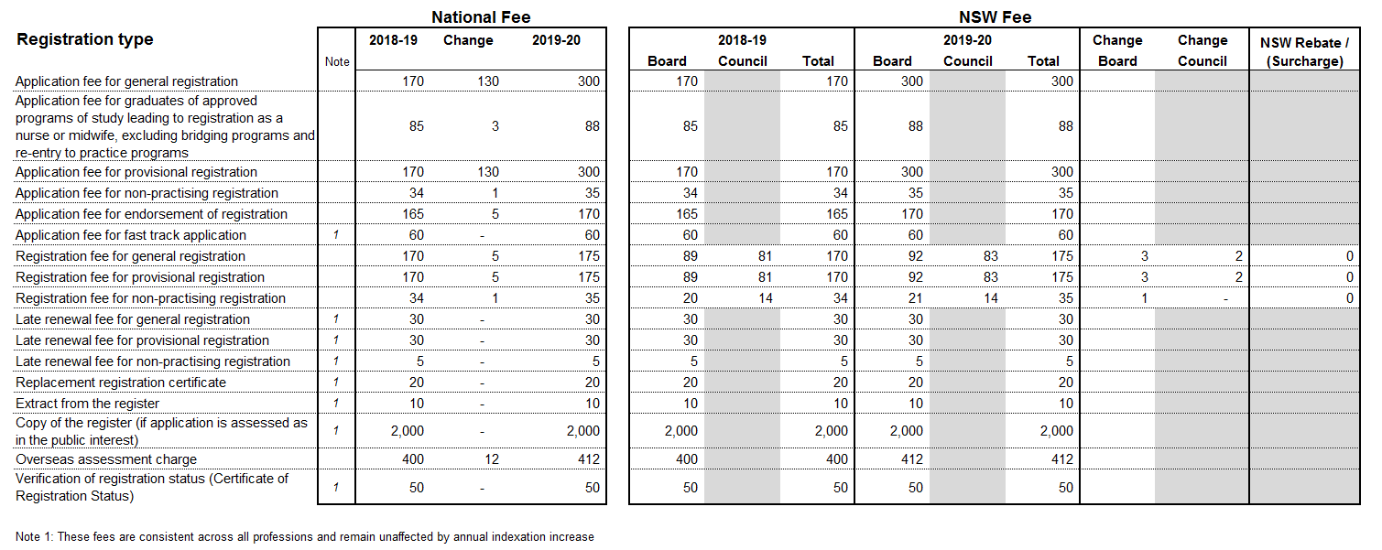

Schedule 4: Summary of National Board’s annual budget
Nursing and Midwifery Board of Australia
Income and expenditure budget and notes, equity statement
Summary budget 2019/20
Item | $
Income
Registration (see note 1) | 61,088,300
Application | 6,623,360
Interest | 1,141,000
Late fees and fast track fees | 347,900
Other | 232,250
Total income | 69,432,810
Expenses
Board and committee (see note 2) | 2,148,140
Legal, tribunal costs and expert advice (see note 3) | 3,018,780
Accreditation (see note 4) | 2,900,427
Office of the Health Ombudsman (Queensland) | 2,066,740
Other direct expenditure (see note 5) | 4,430,090
Indirect expenditure (see note 6) | 54,535,600
Total expenses | 69,099,777
Net result | 333,033

Budget notes
- Registrant numbers | The budget for registration income is based on the following:  - Number of registrants invited to renew at 31 May 2019 renewal period: 411,595  - Lapse rate of renewals: ...............................................................3.58%
- Board and committee expenses | This covers the meeting costs of the National Board and its committees which have the delegated authority to make decisions about individual registered health practitioners.  Costs include sitting fees, travel and accommodation while attending meetings for the Board
- Legal, tribunal costs, and expert advice | These costs are incurred in the management of complaints against practitioners (notifications). The costs do not include the significant Board and committee costs, including sitting fees, related to notifications. These are included in ‘2’ above.  Also not included are the material staff costs in each state and territory office relating directly to notifications. These are included in “indirect expenditure” below.
- Accreditation | Accreditation expenses include the costs of funding provided to the Australian Nursing and Midwifery Accreditation Council (ANMAC) for accreditation functions. It also includes the costs of the Accreditation Committee which is overseeing the assessment of overseas qualified nurses and midwives.
- Other direct expenditure | Costs associated with the Board’s work on registration standards, policies and guidelines. See work plan 2016/17.  This includes the following activities:  - costs involved in consultation with the community and the profession  - engagement of consultants necessary to support the Board’s work  - publication of material to guide the profession, such as the Board’s newsletter  - Board member professional development  - policy development and projects, and  - funding of external nurses’ and midwives’ health program.
- Indirect expenditure | The proportion of AHPRA’s business as usual costs allocated to the Board as indirect costs is 35.335%. The percentage allocation for the Board in 2018/19 was 35.591%.  In addition, indirect costs include a one-off cost of implementing a major information systems replacement program. The project is ongoing and should be completed in FY 2019-20.  Indirect costs are shared by the National Boards based on an agreed formula. The percentage is based on an analysis of historical and financial data to estimate the proportion of costs required to regulate the profession. Costs include salaries, systems and communication, property and administration costs.  AHPRA supports the work of the National Boards and committees by employing all staff and providing systems and infrastructure to manage core regulatory (registration, notifications, compliance, accreditation and professional standards) and support services in eight state and territory offices.  The 2019/20 AHPRA business plan sets out AHPRA’s objectives for 2019/20 and how they will be achieved.

Schedule 5: Performance management framework
Volume and trend data reports
National Boards will receive quarterly AHPRA performance report and volume and trend reports in accordance with the Performance Reporting Framework. The Performance Reporting Framework will be reviewed in 2019/20.

Schedule 6: Principles of equity
AHPRA and the National Boards have been working in close partnership to improve the management of equity on behalf of the NRAS in the interests of greater cost effectiveness and efficiency with a view to ensuring the long-term financial sustainability of the Scheme.
Equity has accumulated from baseline contributions made by National Boards upon inception of the NRAS, and through subsequent operating surpluses.
Equity serves several important purposes including:

- Mitigating against unexpected loss not covered by the National Scheme’s comprehensive insurance
- Funding capital and strategic projects that support the effective and efficient operation of Boards and the Scheme
- Management of financial volatility by smoothing out timing differences between income and expenditure
To set a strong foundation of financial discipline, AHPRA and the National Boards have agreed on a number of key principles to guide equity management and decision making. The key principles are:

- Joint accountability for the financial resilience and sustainability of the NRAS and National Boards, whilst ensuring that no stakeholder is no worse off under the proposed new equity approach
- Appropriate and efficient use of resources
- Using evidence to support funding based on a robust risk assessment
- Transparency of process
- Appreciation of the different profession profiles and equity positions, and
- Recognition that the fee strategies for each Board are integral to meeting the equity needs of each National Board.
The new equity model establishes two discrete equity pools. The first pool is for each National Board to cover board strategic projects, primary risk provision, large case costs and movements in Business As Usual (‘BAU’) costs. The second pool is a centralised NRAS pool that covers scheme-wide strategic projects and a secondary risk provision.
By improving our approach to the management of equity, it is anticipated that the following outcomes will be achieved:
- Improved clarity of purpose
- Greater visibility and line of sight of accountability and responsibility
- Improved collaboration, communication and coordination
- Increased effectiveness and efficiency
- Enhanced trust and confidence in process, oversight and sustainability

