Nurse and Midwife registrant data: December 2014
Published March 2015

Introduction
This report contains registration information about nurses and midwives registered with the Nursing and Midwifery Board of Australia (National Board or NMBA).
The functions of the NMBA are defined under the National Law, and include:
- Registering nurses, midwives and students of nursing and midwifery
- Determining national registration requirements
- Developing professional codes, standards, guidelines and position statements to guide the practice of nurses and midwives
- Managing notifications, investigations and panel hearings
- Overseeing the assessment of internationally qualified nurses and midwives who wish to register in Australia
- Approving national accreditation standards and accredited programs of study leading to registration and endorsement
- Delegating to state and territory boards and committees of the NMBA, and AHPRA staff, the power to determine individual applications for registration and notification of a nurse’s or midwife’s health, performance and/or conduct, and a student’s health or criminal history
*In New South Wales (NSW) and Queensland (QLD), where co-regulatory models apply, notifications are managed separately by the Nursing and Midwifery Council in NSW and Office of Health Ombudsman (OHO) in QLD and the NSW Board and the QLD Board of the NMBA are only responsible for the registration of nurses, midwives and students.
The NMBA’s functions are supported by the Australian Health Practitioner Regulation Agency (AHPRA). For information about legislation governing the NMBA and AHPRA, see AHPRA's Legislation & Publications at www.ahpra.gov.au/Legislation-and-Publications.aspx
AHPRA has analysed the NMBA’s registration data and produced a number of statistical tables about registrants to share with the professions and community. The NMBA will update this statistical report regularly.
For more information on nursing and midwifery registration, please see the NMBA’s website:www.nursingmidwiferyboard.gov.au/Registration-and-Endorsement.aspx
Contents
Nurse and midwife – registration type by state or territory 3
Totals for practitioners with general registration as Nurse and/or Midwife 4
Totals for practitioners with non-practising registration as Nurse and/or Midwife 4
Registered Nurse and Midwife – endorsements by type 6
Registered Nurse Notation by Principal Place of Practice 6
Nurse and Midwife – general registration by age group 8
Nurse and Midwife – general registration by age group 8
Nurse and Midwife – non-practising registration by age group 9
Nurse and Midwife – non-practising registration by age group 9
Nurse and Midwife – general registration by gender 10
Nurse and Midwife – total general registration by gender 11
Nurse and Midwife – general registration by gender percentages 11
Nurse and Midwife – non-practising registration by gender 12
Nurse and Midwife – total non-practising totals by gender 13
Nurse and Midwife – non-practising registration by gender percentages 13
Nurse and midwife – registration type by state or territory
The NMBA recognises four nursing and midwifery registration types: general registration, non-practising registration and student registration. A nurse may be either a Registered Nurse or an Enrolled Nurse, or both.
 |  |  | Principal Place of practice
Profession | Registration Type | Divisions | ACT | NSW | NT | QLD | SA | TAS | VIC | WA | No PPP | Total
Nurse | General | Enrolled Nurse (EN) | 678 | 13,179 | 395 | 11,588 | 7,695 | 1,422 | 19,766 | 5,169 | 62 | 59,954
Nurse | General | Registered Nurse (RN) | 4,255 | 74,245 | 3,178 | 49,519 | 21,644 | 6,325 | 64,562 | 27,746 | 8,020 | 259,494
Nurse | General | Enrolled Nurse & Registered Nurse | 46 | 895 | 43 | 902 | 563 | 40 | 1,782 | 437 | 16 | 4,724
Nurse | Total General Nurse |  | 4,979 | 88,319 | 3,616 | 62,009 | 29,902 | 7,787 | 86,110 | 33,352 | 8,098 | 324,172
Nurse | Non-practising | Enrolled Nurse (EN) | 13 | 298 | 8 | 123 | 85 | 15 | 197 | 54 | 8 | 801
Nurse | Non-practising | Registered Nurse (RN) | 57 | 1,339 | 25 | 429 | 226 | 74 | 541 | 233 | 218 | 3,142
Nurse | Non-practising | Enrolled Nurse & Registered Nurse | 1 | 2 |  | 1 | 1 |  | 1 |  |  | 6
Nurse | Total Non-practising Nurse |  | 71 | 1,639 | 33 | 553 | 312 | 89 | 739 | 287 | 226 | 3,949
Total Nurse |  |  | 5,050 | 89,958 | 3,649 | 62,562 | 30,214 | 7,876 | 86,849 | 33,639 | 8,324 | 328,121
Nurse & Midwife | General | Enrolled Nurse (EN) & Midwife | 4 | 5 |  | 9 | 4 |  | 32 |  |  | 54
Nurse & Midwife | General | Registered Nurse (RN) & Midwife | 561 | 8,785 | 516 | 6,001 | 2,162 | 635 | 7,686 | 2,949 | 225 | 29,520
Nurse & Midwife | General | Enrolled Nurse & Registered Nurse & Midwife | 1 | 6 |  | 1 | 1 |  | 29 | 8 |  | 46
Nurse & Midwife | Total General Nurse & Midwife |  | 566 | 8,796 | 516 | 6,011 | 2,167 | 635 | 7,747 | 2,957 | 225 | 29,620
Nurse & Midwife | Non-practising | Enrolled Nurse (EN) & Midwife |  |  |  |  |  |  | 1 |  |  | 1
Nurse & Midwife | Non-practising | Registered Nurse (RN) & Midwife | 11 | 321 | 4 | 72 | 22 | 8 | 77 | 40 | 23 | 578
Nurse & Midwife | Non-practising | Enrolled Nurse & Registered Nurse and Midwife
Nurse & Midwife | Total Non-practising Nurse & Midwife |  | 11 | 321 | 4 | 72 | 22 | 8 | 78 | 40 | 23 | 579
Total Nurse & Midwife |  |  | 577 | 9,117 | 520 | 6,083 | 2,189 | 643 | 7,825 | 2,997 | 248 | 30,199
Midwife | General |  | 91 | 739 | 56 | 584 | 456 | 15 | 985 | 325 | 85 | 3,336
Midwife | Non-practising |  |  | 17 |  | 6 | 8 | 1 | 15 | 3 | 5 | 55
Midwife Total |  |  | 91 | 756 | 56 | 590 | 464 | 16 | 1,000 | 328 | 90 | 3,391
Grand Total |  |  | 5,718 | 99,831 | 4,225 | 69,235 | 32,867 | 8,535 | 95,674 | 36,964 | 8,662 | 361,711

Totals for practitioners with general registration as Nurse and/or Midwife
The following table and charts show totals for General Registration
 | Principal place of practice
 | ACT | NSW | NT | QLD | SA | TAS | VIC | WA | No PPP | Total
Enrolled Nurse (EN) | 678 | 13,179 | 395 | 11,588 | 7,695 | 1,422 | 19,766 | 5,169 | 62 | 59,954
Registered Nurse (RN) | 4,255 | 74,245 | 3,178 | 49,519 | 21,644 | 6,325 | 64,562 | 27,746 | 8,020 | 259,494
Enrolled Nurse & Registered Nurse | 46 | 895 | 43 | 902 | 563 | 40 | 1,782 | 437 | 16 | 4,724
Nurse (EN & RN) and Midwife | 566 | 8,796 | 516 | 6,011 | 2,167 | 635 | 7,747 | 2,957 | 225 | 29,620
Midwife | 91 | 739 | 56 | 584 | 456 | 15 | 985 | 325 | 85 | 3,336

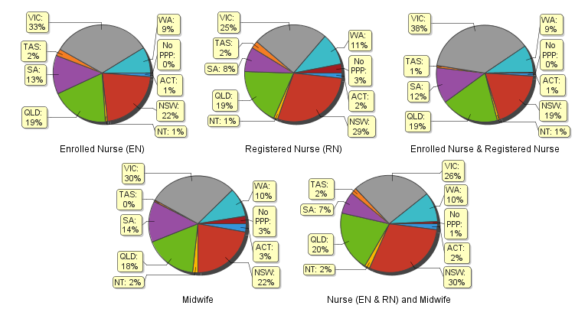
Totals for practitioners with non-practising registration as Nurse and/or Midwife
The following table and charts show totals for Non-Practising Registration
 | Principal place of practice
 | ACT | NSW | NT | QLD | SA | TAS | VIC | WA | No PPP | Total
Enrolled Nurse (EN) | 13 | 298 | 8 | 123 | 85 | 15 | 197 | 54 | 8 | 801
Registered Nurse (RN) | 57 | 1,339 | 25 | 429 | 226 | 74 | 541 | 233 | 218 | 3,142
Enrolled Nurse & Registered Nurse | 1 | 2 |  | 1 | 1 |  | 1 |  |  | 6
Nurse (EN & RN) and Midwife | 11 | 321 | 4 | 72 | 22 | 8 | 78 | 40 | 23 | 579
Midwife |  | 17 |  | 6 | 8 | 1 | 15 | 3 | 5 | 55
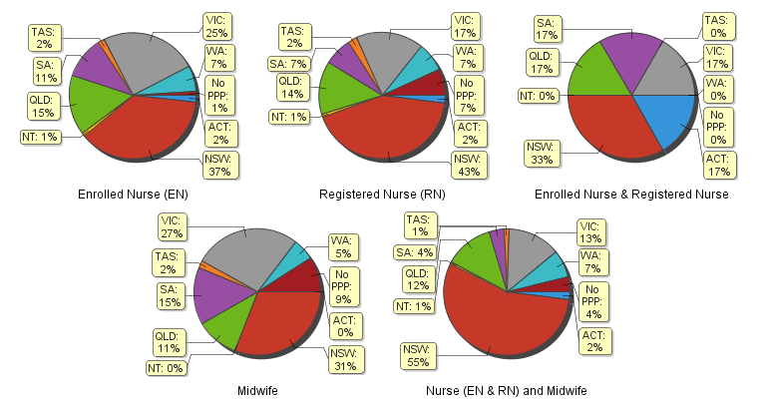
Registered Nurse and Midwife – endorsements by type
The endorsement of registration identifies registered nurses and midwives with additional qualifications and specific expertise. The NMBA endorsements for registered nurses are:
- Nurse Practitioner – includes prescribing scheduled medicines
- Registered Nurse - supply scheduled medicines (rural and isolated practice)
Note: No principal place of practice (PPP) will include nurses and midwives with an overseas address.
The NMBA endorsements for midwives are:
- Eligible Midwife – prescribe scheduled medicines
- Midwife Practitioner – refer Position-Statement Midwife Practitioners (7 April 2011)

 |  | Principal place of practice
Profession | Endorsement type | ACT | NSW | NT | QLD |  | SA |  | TAS |  | VIC |  | WA |  | No PPP |  | Total
Nurse | Nurse Practitioner | 37 | 265 | 18 | 306 |  | 106 |  | 25 |  | 208 |  | 193 |  | 7 |  | 1,165
Nurse | Scheduled Medicines - Rural and isolated practice | 3 | 34 | 10 | 757 |  | 6 |  | 5 |  | 96 |  | 13 |  | 4 |  | 928
Midwife | Scheduled Medicines- Eligible Midwife | 2 | 31 | 1 | 52 |  | 13 |  | 3 |  | 26 |  | 29 |  |  |  | 157
 | Midwife Practitioner |  | 1 |  |  |  |  |  |  |  |  |  |  |  |  |  | 1

Registered Nurse Notation by Principal Place of Practice
Registered Nurses with a sole qualification in mental health nursing or paediatric nursing or disability nursing.
To ensure national consistency, registered nurses with a sole qualification in mental health nursing or paediatric nursing or disability nursing - rather than a qualification in general nursing - are identified on the national register with a notation, which states: Solely qualified in the area of Disability Nursing / Mental Health Nursing / Paediatric Nursing.
Registered Nurse |  | Principal place of practice
Notation | ACT |  | NSW | NT | QLD | SA | TAS | VIC | WA | No PPP | Total
Disability Nursing | 1 |  | 21 | 3 | 9 | 3 | 0 | 11 | 18 | 7 | 73
Mental Health nursing | 5 |  | 214 | 25 | 57 | 53 | 5 | 166 | 1,166 | 74 | 1,765
Paediatric Nursing | 2 |  | 105 | 4 | 30 | 8 | 0 | 46 | 142 | 29 | 366
Total | 8 |  | 340 | 32 | 96 | 64 | 5 | 223 | 1,326 | 110 | 2,204

The NMBA also recognises those midwives that meet the requirements of the Eligible Midwife registration standard with a notation on their registration.
The notation states:
Eligible midwife competent to provide pregnancy, labour, birth and post natal care and qualified to provide the associated services and order diagnostic investigations required for midwifery practice, in accordance with relevant State and Territory legislation.
An Eligible midwife, is not qualified to obtain endorsement under section 94 to prescribe Schedule 2, 3, 4 & 8 medicines required for midwifery practice in accordance with state and territory legislation.
Eligible midwives will be endorsed to prescribe scheduled medicines when they successfully complete a NMBA-approved program of study for prescribing midwifery medicines.
Midwife | Principal place of practice
Notation | ACT | NSW | NT | QLD | SA | TAS | VIC | WA | Total
Eligible midwife | 2 | 52 | 3 | 110 | 19 | 7 | 51 | 38 | 282

Nurse and Midwife – general registration by age group
Nurse and Midwife | Nurse |  |  | Nurse & Midwife |  |  | Midwife
Age group | Enrolled Nurse (EN) | Registered Nurse (RN) | Enrolled Nurse & Registered Nurse | Enrolled Nurse (EN) | Registered Nurse (RN) | Enrolled Nurse & Registered Nurse | Midwife | Total |  | % by Age Group
U - 25 | 4,149 | 12,772 | 418 | 3 | 419 | 9 | 311 | 18,081 |  | 5.06%
25 - 29 | 4,976 | 31,690 | 1,163 | 17 | 1,454 | 7 | 601 | 39,908 |  | 11.17%
30 - 34 | 4,599 | 31,506 | 693 | 6 | 1,770 | 8 | 490 | 39,072 |  | 10.94%
35 - 39 | 4,394 | 29,202 | 546 | 8 | 1,781 | 6 | 450 | 36,387 |  | 10.19%
40 - 44 | 5,902 | 33,680 | 508 | 10 | 2,605 | 4 | 485 | 43,194 |  | 12.09%
45 - 49 | 7,975 | 30,260 | 553 | 3 | 3,611 | 5 | 406 | 42,813 |  | 11.99%
50 - 54 | 10,035 | 31,185 | 476 | 3 | 5,799 | 5 | 240 | 47,743 |  | 13.37%
55 - 59 | 9,888 | 30,052 | 260 | 3 | 6,263 | 1 | 182 | 46,649 |  | 13.06%
60 - 64 | 5,890 | 19,178 | 86 | 1 | 3,991 | 1 | 104 | 29,251 |  | 8.19%
65 - 69 | 1,822 | 7,886 | 18 |  | 1,448 |  | 51 | 11,225 |  | 3.14%
70 - 74 | 283 | 1,700 | 3 |  | 317 |  | 15 | 2,318 |  | 0.65%
75 - 79 | 37 | 333 |  |  | 54 |  | 1 | 425 |  | 0.12%
80+ | 4 | 50 |  |  | 8 |  |  | 62 |  | 0.02%
Total | 59,954 | 259,494 | 4,724 | 54 | 29,520 | 46 | 3,336 | 357,128 |  | 100.00%
Nurse and Midwife – general registration by age group
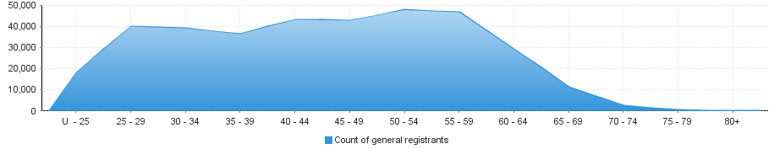
Nurse and Midwife – non-practising registration by age group
Nurse and Midwife | Nurse |  |  | Nurse & Midwife |  |  | Midwife
Age group | Enrolled Nurse (EN) | Registered Nurse (RN) | Enrolled Nurse & Registered Nurse | Enrolled Nurse (EN) | Registered Nurse (RN) | Enrolled Nurse & Registered Nurse | Midwife | Total |  | % by Age Group
U - 25 | 26 | 33 |  |  |  |  |  | 59 |  | 1.29%
25 - 29 | 54 | 197 |  |  | 7 |  | 12 | 270 |  | 5.89%
30 - 34 | 56 | 310 |  | 1 | 20 |  | 8 | 395 |  | 8.62%
35 - 39 | 55 | 306 |  |  | 23 |  | 7 | 391 |  | 8.53%
40 - 44 | 80 | 364 |  |  | 38 |  | 6 | 488 |  | 10.65%
45 - 49 | 98 | 332 | 1 |  | 40 |  | 6 | 477 |  | 10.41%
50 - 54 | 140 | 350 | 3 |  | 75 |  | 4 | 572 |  | 12.48%
55 - 59 | 168 | 461 |  |  | 111 |  | 9 | 749 |  | 16.34%
60 - 64 | 92 | 409 |  |  | 123 |  | 1 | 625 |  | 13.64%
65 - 69 | 26 | 256 | 1 |  | 91 |  | 1 | 375 |  | 8.18%
70 - 74 | 6 | 83 |  |  | 33 |  | 1 | 123 |  | 2.68%
75 - 79 |  | 33 | 1 |  | 12 |  |  | 46 |  | 1.00%
80+ |  | 8 |  |  | 5 |  |  | 13 |  | 0.28%
Total | 801 | 3,142 | 6 | 1 | 578 |  | 55 | 4,583 |  | 100.00%
Nurse and Midwife – non-practising registration by age group
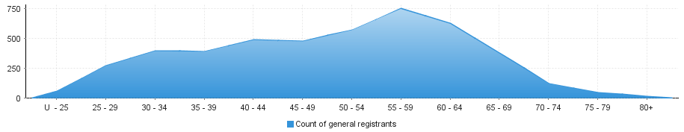
Nurse and Midwife – general registration by gender
Nurse and Midwife |  |  | Principal place of practice
Profession | Gender | Divisions | ACT | NSW | NT | QLD | SA | TAS | VIC | WA | No PPP | Total
Nurse | Female | Enrolled Nurse (EN) | 616 | 11,683 | 329 | 10,480 | 7,018 | 1,297 | 17,973 | 4,826 | 57 | 54,279
Nurse | Female | Registered Nurse (RN) | 3,742 | 64,554 | 2,686 | 43,954 | 19,052 | 5,546 | 57,491 | 25,029 | 6,884 | 228,938
Nurse | Female | Enrolled Nurse & Registered Nurse | 38 | 749 | 38 | 785 | 476 | 39 | 1,510 | 394 | 15 | 4,044
Nurse | Female Nurse Total |  | 4,396 | 76,986 | 3,053 | 55,219 | 26,546 | 6,882 | 76,974 | 30,249 | 6,956 | 287,261
Nurse | Male | Enrolled Nurse (EN) | 62 | 1,496 | 66 | 1,108 | 677 | 125 | 1,793 | 343 | 5 | 5,675
Nurse | Male | Registered Nurse (RN) | 513 | 9,691 | 492 | 5,565 | 2,592 | 779 | 7,071 | 2,717 | 1,136 | 30,556
Nurse | Male | Enrolled Nurse & Registered Nurse | 8 | 146 | 5 | 117 | 87 | 1 | 272 | 43 | 1 | 680
Nurse | Male Nurse Total |  | 583 | 11,333 | 563 | 6,790 | 3,356 | 905 | 9,136 | 3,103 | 1,142 | 36,911
Nurse Total |  |  | 4,979 | 88,319 | 3,616 | 62,009 | 29,902 | 7,787 | 86,110 | 33,352 | 8,098 | 324,172
Nurse & Midwife | Female | Enrolled Nurse (EN) & Midwife | 4 | 5 |  | 8 | 4 |  | 32 |  |  | 53
Nurse & Midwife | Female | Registered Nurse (RN) & Midwife | 548 | 8,601 | 490 | 5,888 | 2,111 | 619 | 7,610 | 2,899 | 220 | 28,986
Nurse & Midwife |  | Enrolled Nurse & Registered Nurse & Midwife | 1 | 6 |  | 1 | 1 |  | 29 | 8 |  | 46
Nurse & Midwife | Female Nurse & Midwife Total |  | 553 | 8,612 | 490 | 5,897 | 2,116 | 619 | 7,671 | 2,907 | 220 | 29,085
Nurse & Midwife |  | Enrolled Nurse (EN) & Midwife |  |  |  | 1 |  |  |  |  |  | 1
Nurse & Midwife | Male | Registered Nurse (RN) & Midwife | 13 | 184 | 26 | 113 | 51 | 16 | 76 | 50 | 5 | 534
Nurse & Midwife |  | Enrolled Nurse & Registered Nurse & Midwife
Nurse & Midwife | Male Nurse & Midwife Total |  | 13 | 184 | 26 | 114 | 51 | 16 | 76 | 50 | 5 | 535
Nurse & Midwife Total |  |  | 566 | 8,796 | 516 | 6,011 | 2,167 | 635 | 7,747 | 2,957 | 225 | 29,620
Midwife | Female |  | 91 | 736 | 55 | 581 | 455 | 14 | 983 | 325 | 84 | 3,324
 | Male |  |  | 3 | 1 | 3 | 1 | 1 | 2 |  | 1 | 12
Midwife Total |  |  | 91 | 739 | 56 | 584 | 456 | 15 | 985 | 325 | 85 | 3,336
Grand Total |  |  | 5,636 | 97,854 | 4,188 | 68,604 | 32,525 | 8,437 | 94,842 | 36,634 | 8,408 | 357,128

Nurse and Midwife – total general registration by gender
 | Principal place of practice
General | ACT | NSW | NT | QLD | SA | TAS | VIC | WA | No PPP | Total
Female | 5,040 | 86,334 | 3,598 | 61,697 | 29,117 | 7,515 | 85,628 | 33,481 | 7,260 | 319,670
Male | 596 | 11,520 | 590 | 6,907 | 3,408 | 922 | 9,214 | 3,153 | 1,148 | 37,458

Nurse and Midwife – general registration by gender percentages
 | Principal place of practice
General | ACT | NSW | NT | QLD | SA | TAS | VIC | WA | No PPP | Total
Female | 89.43% | 88.23% | 85.91% | 89.93% | 89.52% | 89.07% | 90.28% | 91.39% | 86.35% | 89.55%
Male | 10.57% | 11.77% | 14.09% | 10.07% | 10.48% | 10.93% | 9.72% | 8.61% | 13.65% | 10.45%

Nurse and Midwife – non-practising registration by gender
Nurse and Midwife |  |  | Principal place of practice
Profession | Gender | Divisions | ACT | NSW | NT | QLD | SA | TAS | VIC | WA | No PPP | Total
Nurse | Female | Enrolled Nurse (EN) | 12 | 273 | 8 | 119 | 80 | 14 | 186 | 53 | 6 | 751
Nurse | Female | Registered Nurse (RN) | 48 | 1,213 | 23 | 395 | 194 | 70 | 493 | 218 | 198 | 2,852
Nurse | Female | Enrolled Nurse & Registered Nurse |  | 2 |  | 1 |  |  | 1 |  |  | 4
Nurse | Female Nurse Total |  | 60 | 1,488 | 31 | 515 | 274 | 84 | 680 | 271 | 204 | 3,607
Nurse | Male | Enrolled Nurse (EN) | 1 | 25 |  | 4 | 5 | 1 | 11 | 1 | 2 | 50
Nurse | Male | Registered Nurse (RN) | 9 | 126 | 2 | 34 | 32 | 4 | 48 | 15 | 20 | 290
Nurse | Male | Enrolled Nurse & Registered Nurse | 1 |  |  |  | 1 |  |  |  |  | 2
Nurse | Male Nurse Total |  | 11 | 151 | 2 | 38 | 38 | 5 | 59 | 16 | 22 | 342
Nurse Total |  |  | 71 | 1,639 | 33 | 553 | 312 | 89 | 739 | 287 | 226 | 3,949
Nurse & Midwife | Female | Enrolled Nurse (EN) & Midwife |  |  |  |  |  |  | 1 |  |  | 1
Nurse & Midwife | Female | Registered Nurse (RN) & Midwife | 11 | 315 | 4 | 71 | 22 | 7 | 77 | 40 | 22 | 569
Nurse & Midwife |  | Enrolled Nurse & Registered Nurse & Midwife
Nurse & Midwife | Female Nurse & Midwife Total |  | 11 | 315 | 4 | 71 | 22 | 7 | 78 | 40 | 22 | 570
Nurse & Midwife |  | Enrolled Nurse (EN) & Midwife
Nurse & Midwife | Male | Registered Nurse (RN) & Midwife |  | 6 |  | 1 |  | 1 |  |  | 1 | 9
Nurse & Midwife |  | Enrolled Nurse & Registered Nurse & Midwife
Nurse & Midwife | Male Nurse & Midwife Total |  |  | 6 |  | 1 |  | 1 |  |  | 1 | 9
Nurse & Midwife Total |  |  | 11 | 321 | 4 | 72 | 22 | 8 | 78 | 40 | 23 | 579
Midwife | Female |  |  | 17 |  | 6 | 8 | 1 | 15 | 3 | 5 | 55
 | Male
Midwife Total |  |  |  | 17 |  | 6 | 8 | 1 | 15 | 3 | 5 | 55
Grand Total |  |  | 82 | 1,977 | 37 | 631 | 342 | 98 | 832 | 330 | 254 | 4,583

Nurse and Midwife – total non-practising totals by gender
 | Principal place of practice
General | ACT | NSW | NT | QLD | SA | TAS | VIC | WA | No PPP | Total
Female | 71 | 1,820 | 35 | 592 | 304 | 92 | 773 | 314 | 231 | 4,232
Male | 11 | 157 | 2 | 39 | 38 | 6 | 59 | 16 | 23 | 351

Nurse and Midwife – non-practising registration by gender percentages
 | Principal place of practice
General | ACT | NSW | NT | QLD | SA | TAS | VIC | WA | No PPP | Total
Female | 86.59% | 92.06% | 94.59% | 93.82% | 88.89% | 93.88% | 92.91% | 95.15% | 90.94% | 89.55%
Male | 13.41% | 7.94% | 5.41% | 6.18% | 11.11% | 6.12% | 7.09% | 4.85% | 9.06% | 10.45%

Note that the data for dual registration in the tables and diagrams includes where a nurse or a midwife may be non-practising in one category, for example enrolled nurse (non-practising) & registered nurse (practising) or nurse (non-practising) & midwife (practising).

