Nurse and Midwife Registrant Data: October 2013

Published December 2013

Introduction
This report contains registration information about nurses and midwives registered with the Nursing and Midwifery Board of Australia (National Board).
The functions of the National Board are defined under the National Law, and include:
- Registering nurses, midwives and students of nursing and midwifery
- Determining national registration requirements
- Developing registration standards and professional codes and guidelines to guide nurses and midwives
- Managing notifications, investigations and panel hearings
- Assessing internationally qualified nurses and midwives who wish to practice in Australia
- Approving national accreditation standards and accredited programs of study leading to registration and endorsement
Delegating to state and territory boards and committees*, and AHPRA staff, the power to determine individual applications for registration and notifications of a nurse’s or midwife’s health, performance and/or conduct, and a student’s health or criminal history
*In New South Wales (NSW), where a co-regulatory model applies and notifications are managed separately by the Nursing and Midwifery Council NSW, the NSW Board of the National Board is only responsible for the registration of nurses, midwives and students.
The National Board’s functions are supported by the Australian Health Practitioner Regulation Agency (AHPRA). For information about legislation governing the National Board and AHPRA, see AHPRA's Legislation & Publications at www.ahpra.gov.au/Legislation-and-Publications.aspx
AHPRA has analysed the National Board’s registration data and produced a number of statistical tables about registrants to share with the professions and community. The National Board will update this statistical report regularly.
For more information on nursing and midwifery registration, please see the National Board’s website: www.nursingmidwiferyboard.gov.au/Registration-and-Endorsement.aspx

Index of tables

Nurse and Midwife – Registration by Type 2

Registered Nurse and Midwife – Endorsements by Type 4

Registered Nurse and Midwife – Notations 4

Nurse and Midwife – Registration by Age 5

Nurse and Midwife – Non-Practising by Age 6

Nurse and Midwife – Registration by Gender 6

Nurse and Midwife – Percent by Gender 7

Nurse and Midwife – Non-Practising by Gender 8

Nurse and Midwife – Non-Practising Percent by Gender 8

Nurse & Midwife by Registration Type
The National Board recognises four nursing and midwifery registration types: general registration, limited registration, non-practising registration and student registration.
The nurse may be either a Registered Nurse or an Enrolled Nurse, or both. Refer the National Board Position Statement: Position statement on concurrent registration as an Enrolled Nurse and Registered Nurse.
Nurse | ACT | NSW | NT | QLD | SA | TAS | VIC | WA | No PPP | Total
General
Enrolled Nurse (EN) | 702 | 13,140 | 420 | 11,162 | 7,760 | 1,354 | 19,666 | 5,046 | 46 | 59,296
Registered Nurse (RN) | 4,168 | 70,986 | 3,050 | 47,631 | 20,819 | 6,179 | 62,360 | 27,009 | 6,376 | 248,578
Enrolled Nurse & Registered Nurse | 32 | 722 | 33 | 693 | 348 | 25 | 1,284 | 283 | 6 | 3,426
Total General Nurse | 4,902 | 84,848 | 3,503 | 59,486 | 28,927 | 7,558 | 83,310 | 32,338 | 6,428 | 311,300
Non-practising
Enrolled Nurse (EN) | 13 | 294 | 4 | 107 | 60 | 16 | 168 | 49 | 3 | 714
Registered Nurse (RN) | 50 | 1,307 | 19 | 363 | 178 | 73 | 508 | 231 | 84 | 2,813
Enrolled Nurse & Registered Nurse | 1 | 1 |  | 3 |  |  | 2 |  |  | 7
Total Non-practising Nurse | 64 | 1,602 | 23 | 473 | 238 | 89 | 678 | 280 | 87 | 3,534
Total Nurse | 4,966 | 86,450 | 3,526 | 59,959 | 29,165 | 7,647 | 83,988 | 32,618 | 6,515 | 314,834
Nurse & Midwife | ACT | NSW | NT | QLD | SA | TAS | VIC | WA | No PPP | Total
General
Enrolled Nurse (EN) | 2 | 6 |  | 3 | 4 |  | 23 |  |  | 38
Registered Nurse (RN) | 571 | 8,750 | 529 | 6,143 | 2,228 | 626 | 7,736 | 2,986 | 201 | 29,770
Enrolled Nurse & Registered Nurse | 1 | 3 |  | 1 |  |  | 18 | 5 |  | 28
Total General Nurse & Midwife | 574 | 8,759 | 529 | 6,147 | 2,232 | 626 | 7,777 | 2,991 | 201 | 29,836
Non-practising
Enrolled Nurse (EN) |  |  |  |  |  |  | 3 |  |  | 3
Registered Nurse (RN) | 24 | 949 | 9 | 148 | 50 | 24 | 206 | 85 | 18 | 1,513
Enrolled Nurse & Registered Nurse |  | 1 |  |  |  |  |  |  |  | 1
Total Non-practising Nurse & Midwife | 24 | 950 | 9 | 148 | 50 | 24 | 209 | 85 | 18 | 1,517
Total Nurse & Midwife | 598 | 9,709 | 538 | 6,295 | 2,282 | 650 | 7,986 | 3,076 | 219 | 31,353
Midwife | ACT | NSW | NT | QLD | SA | TAS | VIC | WA | No PPP | Total
General | 73 | 565 | 51 | 438 | 394 | 13 | 851 | 290 | 62 | 2,737
Non-practising |  | 14 |  | 3 | 5 |  | 18 | 5 | 2 | 47
Total Midwife | 73 | 579 | 51 | 441 | 399 | 13 | 869 | 295 | 64 | 2,784
Grand Total | 5,637 | 96,738 | 4,115 | 66,695 | 31,846 | 8,310 | 92,843 | 35,989 | 6,798 | 348,971
The following table and charts show totals for General Registration

Totals for General Nurse & Midwife
 | ACT | NSW | NT | QLD | SA | TAS | VIC | WA | No PPP | Total
Enrolled Nurse (EN) | 702 | 13140 | 420 | 11,162 | 7,760 | 1,354 | 19,666 | 5,046 | 46 | 59,296
Registered Nurse (RN) | 4,168 | 70,986 | 3,050 | 47,631 | 20,819 | 6,179 | 62,360 | 27,009 | 6,376 | 248,578
EN & ER | 32 | 722 | 33 | 693 | 348 | 25 | 1,284 | 283 | 6 | 3,426
Midwife | 73 | 565 | 51 | 438 | 394 | 13 | 851 | 290 | 62 | 2,737
Nurse (EN & RN) & Midwife | 574 | 8,759 | 529 | 6,147 | 2,232 | 626 | 7,777 | 2,991 | 201 | 29,836

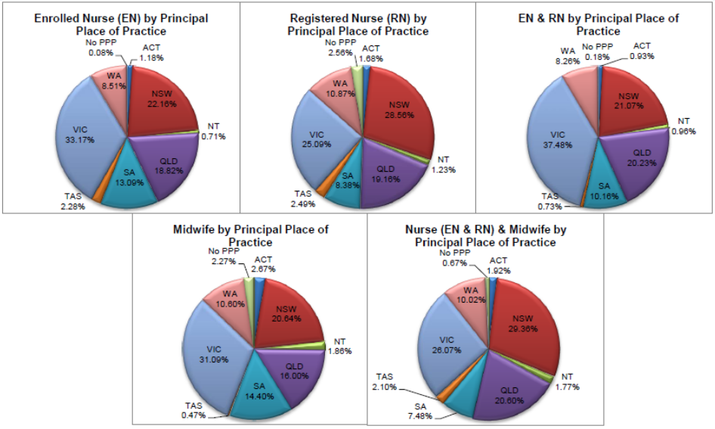

Totals for Non-Practising Nurse & Midwife
 | ACT | NSW | NT | QLD | SA | TAS | VIC | WA | No PPP | Total
Enrolled Nurse (EN) | 13 | 294 | 4 | 107 | 60 | 16 | 168 | 49 | 3 | 714
Registered Nurse (RN) | 50 | 1,307 | 19 | 363 | 178 | 73 | 508 | 231 | 84 | 2,813
EN & ER | 1 | 1 |  | 3 |  |  | 2 |  |  | 7
Midwife |  | 14 |  | 3 | 5 |  | 16 | 5 | 2 | 47
Nurse (EN & RN) & Midwife | 24 | 950 | 9 | 148 | 50 | 24 | 209 | 85 | 18 | 1,517

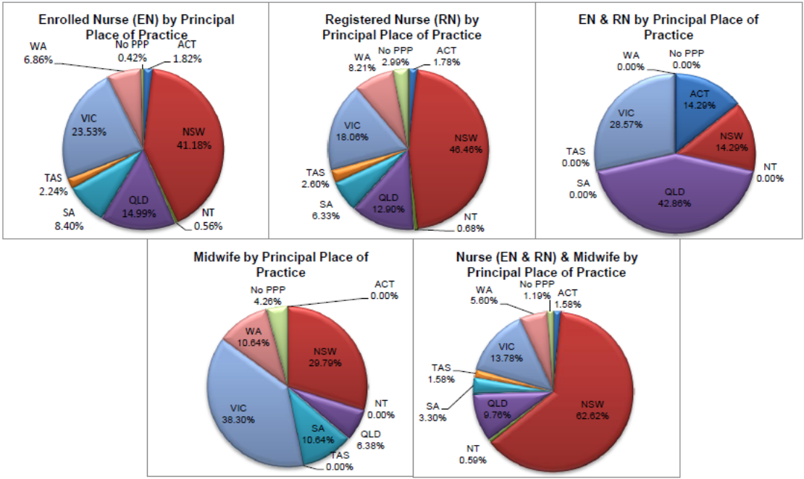

Registered Nurse & Midwife by Endorsement
The endorsement of registration identifies registered nurses and midwives with additional qualifications and specific expertise.
The National Board endorsements for registered nurses are:
- Nurse Practitioner – includes prescribing scheduled medicines
- Midwife Practitioner – refer Position-Statement Midwife Practitioners (7 April 2011)
Registered Nurse - supply scheduled medicines (rural and isolated practice)
Note: No principal place of practice (PPP) will include nurses and midwives with an overseas address.
The National Board endorsement for midwives is:
Eligible Midwife – prescribe scheduled medicines
Registered Nurse | ACT | NSW | NT | QLD | SA | TAS | VIC | WA | No PPP | Total
Nurse practitioner | 36 | 240 | 15 | 259 | 79 | 22 | 153 | 158 | 4 | 966
Schedule Medicines – Rural & Isolated Practice | 3 | 30 | 9 | 710 | 7 | 3 | 59 | 13 | 3 | 837
Midwife | ACT | NSW | NT | QLD | SA | TAS | VIC | WA | No PPP | Total
Schedule Medicines – Eligible Midwife |  | 5 |  | 12 | 3 | 2 | 12 | 7 |  | 41

Registered Nurse & Midwife by Notation
Registered Nurses with a sole qualification in mental health nursing or paediatric nursing or disability nursing.
To ensure national consistency, registered nurses with a sole qualification in mental health nursing or paediatric nursing or disability nursing - rather than a qualification in general nursing - are identified on the national register with a notation, which states: Solely qualified in the area of Disability Nursing / Mental Health Nursing / Paediatric Nursing .

Registered Nurse Notation by State and Territory
Registered Nurse | ACT | NSW | NT | QLD | SA | TAS | VIC | WA | No PPP | Total
Disability Nursing |  | 19 | 3 | 5 | 4 | 1 | 10 | 18 | 2 | 62
Mental Health Nursing | 5 | 181 | 19 | 40 | 46 | 3 | 131 | 1,174 | 42 | 1,641
Paediatric Nursing | 1 | 99 | 2 | 21 | 10 | 1 | 35 | 134 | 10 | 313
Total | 6 | 299 | 24 | 66 | 60 | 5 | 176 | 1,326 | 54 | 2,016
The National Board also recognises those midwives that meet the requirements of the Eligible Midwife registration standard with a notation on their registration.
The notation states:
Eligible midwife competent to provide pregnancy, labour, birth and post natal care and qualified to provide the associated services and order diagnostic investigations required for midwifery practice, in accordance with relevant State and Territory legislation.
Eligible midwife, but NOT qualified to obtain endorsement under section 94 to prescribe Schedule 2, 3, 4 & 8 medicines required for midwifery practice in accordance with state and territory legislation.
These eligible midwives will be endorsed to prescribe scheduled medicines when they successfully complete a Board-approved program of study for prescribing midwifery medicines.

Midwife Notation by State and Territory
Midwife | ACT |  | NSW | NT | QLD | SA | TAS | VIC | WA | No PPP | Total
Eligible Midwife |  |  | 36 |  | 85 | 13 | 4 | 41 | 21 |  | 200

General Registration by Age
 | Nurse |  |  | Nurse and Midwife |  |  | Midwife | Total | % by Age Group
Age Group | Enrolled Nurse (EN) | Registered Nurse (RN) | Enrolled Nurse & Registered Nurse | Enrolled Nurse (EN) | Registered Nurse (RN) | Enrolled Nurse & Registered Nurse
U-25 | 3,867 | 10,498 | 309 | 3 | 326 | 3 | 243 | 15,249 | 4.42%
25-29 | 4,835 | 30,244 | 842 | 14 | 1,350 | 5 | 477 | 37,767 | 10.95%
30-34 | 4,244 | 29,130 | 464 | 5 | 1,685 | 4 | 383 | 35,915 | 10.41%
35-39 | 4,441 | 29,162 | 386 | 5 | 1,904 | 6 | 373 | 36,277 | 10.52%
40-44 | 6,209 | 33,187 | 396 | 5 | 2,846 | 3 | 399 | 43,045 | 12.48%
45-49 | 8,216 | 29,371 | 414 | 2 | 4,020 | 2 | 351 | 42,376 | 12.29%
50-54 | 10,615 | 31,771 | 351 | 3 | 6,395 | 3 | 226 | 49,364 | 14.31%
55-59 | 9,528 | 28,356 | 191 | 1 | 6,466 | 2 | 153 | 44,697 | 12.96%
60-64 | 5,437 | 17,876 | 58 | 2 | 3,987 | 1 | 76 | 27,437 | 7.96%
65-69 | 1,605 | 7,092 | 13 | 0 | 1,412 | 0 | 39 | 10,161 | 2.95%
70-74 | 238 | 1,519 | 2 | 0 | 318 | 0 | 16 | 2,093 | 0.61%
75-79 | 33 | 303 | 0 | 0 | 49 | 0 | 1 | 386 | 0.11%
80+ | 28 | 69 | 0 | 0 | 13 | 0 | 0 | 110 | 0.03%
Total | 59,296 | 248,578 | 3,426 | 40 | 30,771 | 29 | 2737 | 344,877 | 100.00%

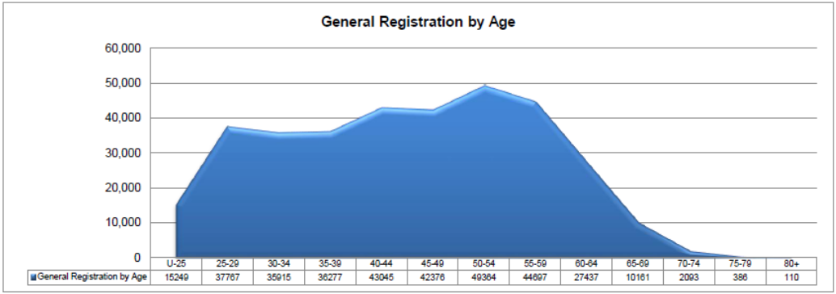

Non-practising Registration by Age
 | Nurse |  |  | Nurse and Midwife |  |  | Midwife | Total | % by Age Group
Age Group | Enrolled Nurse (EN) | Registered Nurse (RN) | Enrolled Nurse & Registered Nurse | Enrolled Nurse (EN) | Registered Nurse (RN) | Age Group | Enrolled Nurse (EN) | Registered Nurse (RN) | Enrolled Nurse & Registered Nurse
U-25 | 29 | 34 | 0 | 0 | 1 | 0 | 3 | 67 | 0.02%
25-29 | 45 | 215 | 0 | 2 | 8 | 0 | 7 | 277 | 0.08%
30-34 | 52 | 245 | 1 | 0 | 26 | 0 | 6 | 330 | 0.10%
35-39 | 51 | 306 | 0 | 0 | 50 | 0 | 6 | 413 | 0.12%
40-44 | 79 | 349 | 2 | 0 | 85 | 0 | 7 | 522 | 0.15%
45-49 | 96 | 299 | 1 | 0 | 158 | 0 | 4 | 558 | 0.16%
50-54 | 132 | 337 | 1 | 0 | 339 | 0 | 7 | 816 | 0.24%
55-59 | 124 | 400 | 0 | 1 | 418 | 1 | 5 | 949 | 0.28%
60-64 | 84 | 327 | 0 | 0 | 279 | 0 | 0 | 690 | 0.20%
65-69 | 18 | 194 | 1 | 0 | 100 | 0 | 2 | 315 | 0.09%
70-74 | 4 | 76 | 1 | 0 | 33 | 0 | 0 | 114 | 0.03%
75-79 | 0 | 24 | 0 | 0 | 11 | 0 | 0 | 35 | 0.01%
80+ | 0 | 7 | 0 | 0 | 5 | 0 | 0 | 12 | 0.00%
Total | 714 | 2,813 | 7 | 3 | 1,513 | 1 | 47 | 5,098 | 1.48%

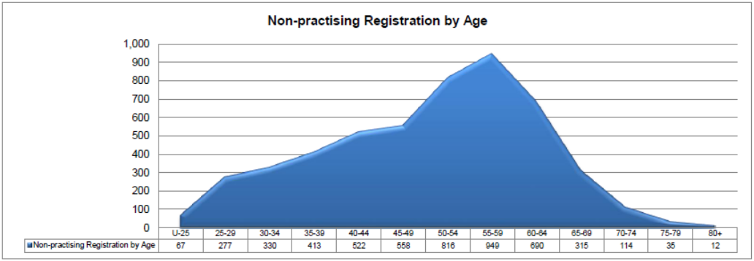

General Registration by Gender
General | ACT | NSW | NT | QLD | SA | TAS | VIC | WA | No PPP | Total
Female | 4,348 | 74,057 | 2,932 | 52,961 | 25,712 | 6,674 | 74,493 | 29,232 | 5,551 | 275,960
Enrolled Nurse (EN) | 644 | 11,644 | 338 | 10,107 | 7,084 | 1,243 | 17,915 | 4,716 | 43 | 53,734
Registered Nurse (RN) | 3,678 | 61,810 | 2,564 | 42,254 | 18,340 | 5,406 | 55,504 | 24,252 | 5,502 | 219,310
Enrolled Nurse & Registered Nurse | 26 | 603 | 30 | 600 | 288 | 25 | 1,074 | 264 | 6 | 2,916
Male | 554 | 10,791 | 571 | 6,525 | 3,215 | 884 | 8,817 | 3,106 | 877 | 35,340
Enrolled Nurse (EN) | 58 | 1,496 | 82 | 1,055 | 676 | 111 | 1,751 | 330 | 3 | 5,562
Registered Nurse (RN) | 490 | 9,176 | 486 | 5,377 | 2,479 | 773 | 6,856 | 2,757 | 874 | 29,268
Enrolled Nurse & Registered Nurse | 6 | 119 | 3 | 93 | 60 |  | 210 | 19 |  | 510
Total | 4,902 | 84,848 | 3,503 | 59,486 | 28,927 | 7,558 | 83,310 | 32,338 | 6,428 | 311,300
Nurse and Midwife | ACT | NSW | NT | QLD | SA | TAS | VIC | WA | No PPP | Total
Female | 574 | 920 | 511 | 6,117 | 2,207 | 628 | 7,830 | 2,989 | 198 | 30,262
Enrolled Nurse (EN) | 2 | 6 |  | 3 | 3 |  | 25 |  |  | 39
Registered Nurse (RN) | 571 | 9,198 | 511 | 6,113 | 2,204 | 628 | 7,787 | 2,984 | 198 | 30,194
Enrolled Nurse & Registered Nurse | 1 | 4 |  | 1 |  |  | 18 | 5 |  | 29
Male | 16 | 195 | 24 | 129 | 57 | 17 | 89 | 47 | 4 | 578
Enrolled Nurse (EN) |  |  |  |  | 1 |  |  |  |  | 1
Registered Nurse (RN) | 16 | 195 | 24 | 129 | 56 | 17 | 89 | 47 | 4 | 577
Enrolled Nurse & Registered Nurse |  |  |  |  |  |  |  |  |  | 0
Total | 590 | 9,403 | 535 | 6,246 | 2,264 | 645 | 7,919 | 3,036 | 202 | 30,840
Midwife | ACT | NSW | NT | QLD | SA | TAS | VIC | WA | No PPP | Total
Female | 73 | 561 | 50 | 437 | 394 | 12 | 848 | 290 | 61 | 2,726
Male |  | 4 | 1 | 1 |  | 1 | 3 |  | 1 | 11
Total | 73 | 565 | 51 | 438 | 394 | 13 | 851 | 290 | 62 | 2,737
Grand Total | 5,565 | 94,816 | 4,089 | 66,170 | 31,585 | 8,216 | 92,080 | 35,664 | 6,692 | 344,877

Total General Registration by Gender
General | ACT | NSW | NT | QLD | SA | TAS | VIC | WA | No PPP | Total
Female | 4,995 | 83,826 | 3,493 | 59,515 | 28,313 | 7,314 | 83,171 | 32,511 | 5,810 | 308,948
Male | 570 | 10,990 | 596 | 6,655 | 3,272 | 902 | 8,909 | 3,153 | 882 | 35,929

General Registration by Gender - Percentages
General | ACT | NSW | NT | QLD | SA | TAS | VIC | WA | No PPP | Total
Female | 89.76% | 88.41% | 85.42% | 89.94% | 89.64% | 89.02% | 90.32% | 91.16% | 86.82% | 89.58%
Male | 10.24% | 11.59% | 14.58% | 10.06% | 10.36% | 10.98% | 9.66% | 8.84% | 13.16% | 10.42%

Non-practising Registration by Gender
General | ACT | NSW | NT | QLD | SA | TAS | VIC | WA | No PPP | Total
Female | 54 | 1474 | 22 | 444 | 216 | 86 | 624 | 262 | 79 | 3261
Enrolled Nurse (EN) | 12 | 275 | 4 | 101 | 57 | 15 | 160 | 47 | 1 | 672
Registered Nurse (RN) | 42 | 1,198 | 18 | 340 | 159 | 71 | 462 | 215 | 78 | 2,583
Enrolled Nurse & Registered Nurse |  | 1 |  | 3 |  |  | 2 |  |  | 6
Male | 10 | 128 | 1 | 29 | 22 | 3 | 54 | 18 | 8 | 273
Enrolled Nurse (EN) | 1 | 19 |  | 6 | 3 | 1 | 8 | 2 | 2 | 42
Registered Nurse (RN) | 8 | 109 | 1 | 23 | 19 | 2 | 46 | 16 | 6 | 230
Enrolled Nurse & Registered Nurse | 1 |  |  |  |  |  |  |  |  | 1
Total | 64 | 1602 | 23 | 473 | 238 | 89 | 678 | 280 | 87 | 3534
Female | 22 | 932 | 8 | 144 | 49 | 22 | 206 | 84 | 18 | 1,485
Enrolled Nurse (EN) |  |  |  |  |  |  | 3 |  |  | 3
Registered Nurse (RN) | 22 | 931 | 8 | 144 | 49 | 22 | 203 | 84 | 18 | 1,481
Enrolled Nurse & Registered Nurse |  | 1 |  |  |  |  |  |  |  | 1
Male | 2 | 18 | 1 | 4 | 1 | 2 | 3 | 1 |  | 32
Enrolled Nurse (EN) |  |  |  |  |  |  |  |  |  | 0
Registered Nurse (RN) | 2 | 18 | 1 | 4 | 1 | 2 | 3 | 1 |  | 32
Enrolled Nurse & Registered Nurse |  |  |  |  |  |  |  |  |  | 0
Total | 24 | 950 | 9 | 148 | 50 | 24 | 209 | 85 | 18 | 1,517
Female | 0 | 14 | 0 | 3 | 5 | 0 | 18 | 5 | 2 | 47
Male |  |  |  |  |  |  |  |  |  | 0
Total | 0 | 14 | 0 | 3 | 5 | 0 | 18 | 5 | 2 | 47
Grand Total | 88 | 2,566 | 32 | 624 | 293 | 113 | 905 | 370 | 107 | 5,098

Total Non-practising Registration by Gender
 | Non-practicing | ACT | NSW | NT | QLD | SA | TAS | VIC | WA | No PPP | Total
Female |  | 76 | 2,420 | 30 | 591 | 270 | 108 | 848 | 351 | 99 | 4,793
Male |  | 12 | 146 | 2 | 33 | 23 | 5 | 57 | 19 | 8 | 305

Non-practising Registration by Gender - Percentages
 | Non-practicing | ACT | NSW | NT | QLD | SA | TAS | VIC | WA | No PPP | Total
Female |  | 86.36% | 94.31% | 93.75% | 94.71% | 92.15% | 95.58% | 93.70% | 94.86% | 92.52% | 94.02%
Male |  | 13.64% | 5.69% | 6.25% | 5.29% | 7.85% | 4.42% | 6.30% | 5.14% | 7.48% | 5.98%

