Fact Sheet
May 2016

Re-entry to practice
Introduction
The Nursing and Midwifery Board of Australia (NMBA) has developed a Recency of practice registration standard (the Standard) to document its requirements in relation to the nature, extent, period, and recency of any previous practice.
In accordance with the Health Practitioner Regulation National Law as in force in each state and territory (the National Law), all applicants for registration and renewal of registration in Australia must meet the recency of practice requirements set out in the Standard.
In order to meet the Standard:
- applicants who hold general or non-practising registration, but have not practiced for more than five years: must satisfactorily complete a period of supervised practice or a re-entry program that is approved by the NMBA
- applicants who are no longer registered and wish to return to practice: must apply for provisional registration before engaging in any form of practice, supervised or otherwise.
Who does this apply to?
This fact sheet is relevant to those who:
- have had a lapse in practice of five years or more
- have held non-practising registration for five or more years, or
- are no longer on the register.

The process outlined in this document applies specifically to nurses and midwives (whether they are registered or not) who have not practiced in the last five years or longer.

This document must be read in conjunction with the Recency of practice registration standard and the Re-entry to practice policy.
Background
The NMBA undertakes functions as set out by the National Law and regulates the practice of nursing and midwifery in Australia. One of its key roles is to protect the public by ensuring that only nurses and midwives who are suitably qualified to practice in a competent and ethical manner are registered.

When do I need to consider my recency of practice?
When applying for registration or at renewal of registration you are required to make a declaration about your practice in the last five years. It is important to evaluate your knowledge and skills to make sure that you have the appropriate education, training, experience, and competence to undertake nursing and/or midwifery practice.
The only exception is for recent graduates who are applying for registration for the first time and whose qualification for registration was awarded not more than two years before the date of their application.
What needs to be done?
If you have been out of practice for five years or more, you need to give the relevant state or territory board or registration committee of the NMBA sufficient information to review your specific requirements for re-entry into practice.
The documentation and application forms collect information about your qualifications, work and registration history, continuing professional development activities, plans for future professional practice, and length of time away from practising in the profession/s. The information collected is used to determine whether you require any additional training, periods of supervision, programs, or other requirements to meet eligibility for general registration.
All applications are assessed on a case by case basis and the relevant state or territory board or registration committee of the NMBA must be satisfied that you are safe and competent to practice the profession in Australia.
If you currently hold general registration and have not practiced for five years or more
You will need to declare at registration renewal that you do not meet recency of practice. Your renewal will go into assessment and you may be requested to provide further information.
Optional: you may wish to complete and submit a re-entry to practice self-assessment questionnaire (see below).
If you currently hold non-practising registration and wish to return to practice
You will need to change to a registration type that permits practice by completing the Application for general registration as an enrolled nurse, registered nurse or midwife (for current non-practising registrants - AGNP-40.
If you are no longer registered
You will need to apply for provisional registration by completing the Application for provisional registration for re-entry to practice - APRO-40.
What is provisional registration?
Provisional registration is a registration type that enables a nurse and/or midwife to complete a period of supervised practice or a NMBA-approved re-entry to practice program to be eligible for general registration.
Re-entry to practice self-assessment questionnaire
The NMBA has range of tools and resources to help you if you are considering returning to practice.
The re-entry to practice self-assessment questionnaires help nurses and/or midwives assess their readiness for re-entry into practice. They provide an easily structured format for you to evaluate your skills, knowledge, and competence, and identify any gaps. The attributes and competencies described in the questionnaires are those expected of a new graduate from an NMBA-approved program of study.
The questionnaires are individually tailored for enrolled nurses, registered nurses, and midwives, based on the NMBA’s competency standards/standards for practice for that profession. Completion of the questionnaire is optional and you may wish to include it with your application.
If you plan to return to practice in a limited scope of practice, this needs to be communicated to the NMBA as part of the re-entry to practice application.
Additional tools and resources are also available in the Professional Codes & Guidelines section on the NMBA website.
Additional documentation at the time of application
If you have secured a supervised practice position, it is recommended that you submit evidence of this offer and a copy of the position description, in addition to a completed copy of the supervised practice agreement along with your application.
To access application forms go to registration and endorsement forms on the NMBA website.
How will my application be processed?
A range of factors are considered when assessing what is needed for your re-entry to practice, including qualifications, work and registration history, continuing professional development activities, plans for future professional practice, and length of time away from practising in the profession/s. The relevant state or territory board or registration committee of the NMBA may require that you:
- submit additional information or documentation, and/or
- attend in person before the relevant state or territory board or registration committee of the NMBA.
What is the likely outcome of my application?
After the documentation is considered, the relevant state or territory board or registration committee of the NMBA may decide to approve your application subject to conditions, or grant provisional registration for applicants not on the register. You may be required to complete any one of the following:
- A NMBA-approved period of supervised practice (Pathway 1)
- A NMBA-approved re-entry to practice program (Pathway 2)
Overview of the process

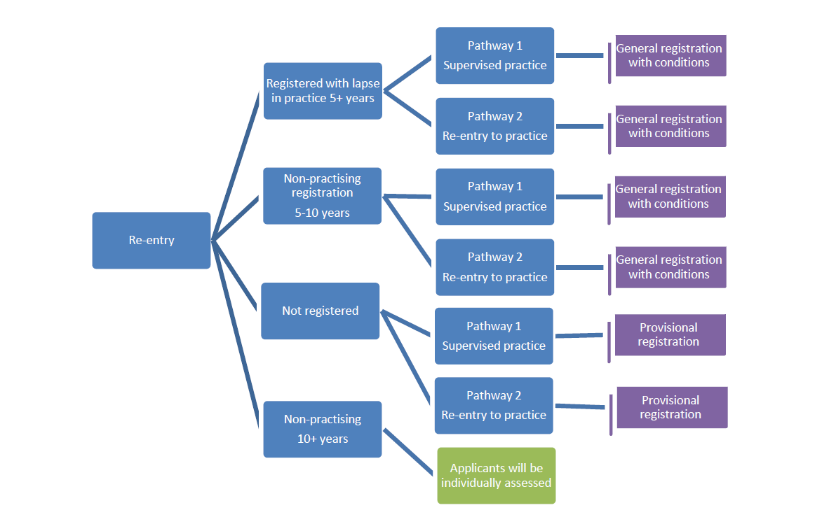

Further information regarding the assessment of applications is available in the Framework for assessing nursing and midwifery applicants for re-entry to practice on the NMBA’s website.
What are my practice requirements when registered?
You must hold general or provisional registration before, and for the duration of, your re-entry program or supervised practice placement. The relevant state or territory board or registration committee of the NMBA will also stipulate the level of supervision within which you will practise.
You are also required to review the Supervision guidelines for nursing and midwifery. Within the guidelines, you will be directed to submit the following to the relevant state or territory board or registration committee of the NMBA:
- Letter of offer for a supervised practice position or acceptance letter of an approved re-entry program: before commencing practice
- Supervised practice agreement: before commencing practice
- Supervised practice plan: within 14 days of commencing practice
- Formative reports as listed in the supervision guidelines
- Summative report as listed in the supervision guidelines.

What is the likely outcome if I have not practiced for 10 years or more?
If you have not practised for ten years or more you will not be eligible for Pathway 1 & 2. Based upon your individual assessment by the relevant state or territory board or registration committee of the NMBA, you may need to complete requisite studies within an NMBA-approved program of study leading to initial registration, as identified by an NMBA-approved education provider (following recognition of prior learning).
Where to submit your application
Send all documentation to the AHPRA office in your capital city as listed in the contact us section of the AHPRA website (www.ahpra.gov.au)
AHPRA  Nursing & Midwifery Registrations  GPO Box 9958  In your capital city (refer below) |  | You may contact the Australian Health Practitioner Regulation Agency on 1300 419 495 or you can lodge a web enquiry at www.ahpra.gov.au
Sydney NSW 2001  Adelaide SA 5001 | Canberra ACT 2601  Perth WA 6001 | Melbourne VIC 3001  Hobart TAS 7001 | Brisbane QLD 4001  Darwin NT 0801

For information on the Nursing and Midwifery Board of Australia refer to the website: www.nursingmidwiferyboard.gov.au

Registration standards, codes, and guidelines are located at www.nursingmidwiferyboard.gov.au
Competency standards/standards for practice are located under Codes and guidelines on the NMBA website.
Evidence of employment and completed supervision agreements are not required for application assessment to occur and have no bearing on the relevant state or territory Board or registration committee of the NMBA’s decision making
Registrants completing an NMBA-approved re-entry to practice program (Pathway 2), listed as an approved program of study are not required to complete a formative report unless specifically requested to do so by the NMBA or other entity, including the education provider.

