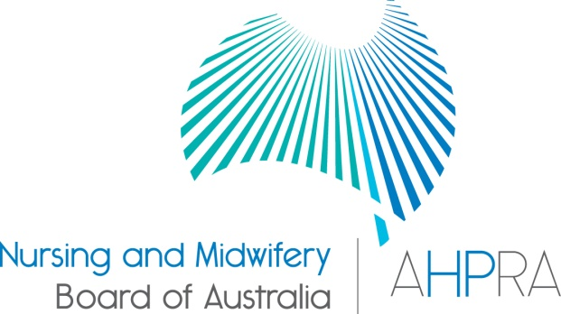

Nurse and Midwife Registrant Data: September 2014

Published December 2014

Introduction

This report contains registration information about nurses and midwives registered with the Nursing and Midwifery Board of Australia (National Board or NMBA).

The functions of the National Board are defined under the National Law, and include:
- Registering nurses, midwives and students of nursing and midwifery
- Determining national registration requirements
- Developing professional codes, standards, guidelines and position statements to guide the practice of nurses and midwives
- Managing notifications, investigations and panel hearings
- Overseeing the assessment of internationally qualified nurses and midwives who wish to register in Australia
- Approving national accreditation standards and accredited programs of study leading to registration and endorsement
- Delegating to state and territory boards and committees of the NMBA, and AHPRA staff, the power to determine individual applications for registration and notification of a nurse’s or midwife’s health, performance and/or conduct, and a student’s health or criminal history
*In New South Wales (NSW), where a co-regulatory model applies and notifications are managed separately by the Nursing and Midwifery Council NSW, the NSW Board of the NMBA is only responsible for the registration of nurses, midwives and students.

The National Board’s functions are supported by the Australian Health Practitioner Regulation Agency (AHPRA). For information about legislation governing the National Board and AHPRA, see AHPRA's Legislation & Publications at www.ahpra.gov.au/Legislation-and-Publications.aspx
AHPRA has analysed the National Board’s registration data and produced a number of statistical tables about registrants to share with the professions and community. The National Board will update this statistical report regularly.

For more information on nursing and midwifery registration, please see the National Board’s website:
www.nursingmidwiferyboard.gov.au/Registration-and-Endorsement.aspx

Table of contents

Nurse and Midwife – Registration type 3
Totals for General Nurse & Midwife 4
Totals for Non-Practising Nurse & Midwife 5
Registered Nurse and Midwife – Endorsement by Type 6
Registered Nurse Notation by Principal Place of Practice 6
Midwife Notation by Principal Place of Practice 7
Nurse and Midwife – general registration by age group 8
Nurse and Midwife – non-practising registration by age group 9
Nurse and Midwife – general registration by gender 10
Nurse and Midwife – total general registration by gender 11
Nurse and Midwife – general registration by gender percentages 11
Nurse and Midwife – non-practising registration by gender 12
Nurse and Midwife – total non-practising totals by gender 13
Nurse and Midwife – non-practising registration by gender percentages 13

Nurse and Midwife – Registration type

The National Board recognises four nursing and midwifery registration types: general registration, limited registration, non-practising registration and student registration.
The nurse may be either a Registered Nurse or an Enrolled Nurse, or both.
 |  |  | Principal Place of practice
Profession | Registration Type | Divisions | ACT | NSW | NT | QLD | SA | TAS | VIC | WA | No PPP | Total
Nurse | General | Enrolled Nurse (EN) | 675 | 13,144 | 393 | 11,452 | 7,683 | 1,408 | 19,689 | 5,112 | 60 | 59,616
Nurse | General | Registered Nurse (RN) | 4,212 | 73,372 | 3,145 | 48,643 | 21,039 | 6,244 | 63,509 | 27,262 | 7,842 | 255,268
Nurse | General | Enrolled Nurse & Registered Nurse | 40 | 792 | 34 | 799 | 417 | 31 | 1,486 | 368 | 15 | 3,982
Nurse | Total General Nurse |  | 4,927 | 87,308 | 3,572 | 60,894 | 29,139 | 7,683 | 84,684 | 32,742 | 7,917 | 318,866
Nurse | Non-practising | Enrolled Nurse (EN) | 13 | 297 | 6 | 125 | 85 | 15 | 197 | 54 | 8 | 800
Nurse | Non-practising | Registered Nurse (RN) | 55 | 1,331 | 23 | 427 | 227 | 73 | 540 | 232 | 216 | 3,124
Nurse | Non-practising | Enrolled Nurse & Registered Nurse | 1 | 2 |  | 1 | 1 |  | 1 |  |  | 6
Nurse | Total Non-practising Nurse |  | 69 | 1,630 | 29 | 553 | 313 | 88 | 738 | 286 | 224 | 3,930
Total Nurse |  |  | 4,996 | 88,938 | 3,601 | 61,447 | 29,452 | 7,771 | 85,422 | 33,028 | 8,141 | 322,796
Nurse & Midwife | General | Enrolled Nurse (EN) and Midwife | 4 | 4 |  | 8 | 4 |  | 27 |  |  | 47
Nurse & Midwife | General | Registered Nurse (RN) and Midwife | 557 | 8,785 | 512 | 5,950 | 2,154 | 629 | 7,622 | 2,941 | 223 | 29,373
Nurse & Midwife | General | Enrolled Nurse & Registered Nurse and Midwife | 1 | 6 |  | 1 | 1 |  | 28 | 8 |  | 45
Nurse & Midwife | Total General Nurse & Midwife |  | 562 | 8,795 | 512 | 5,959 | 2,159 | 629 | 7,677 | 2,949 | 223 | 29,465
Nurse & Midwife | Non-practising | Enrolled Nurse (EN) |  |  |  |  |  |  | 1 |  |  | 1
Nurse & Midwife | Non-practising | Registered Nurse (RN) | 11 | 320 | 4 | 72 | 22 | 8 | 78 | 41 | 23 | 579
Nurse & Midwife | Non-practising | Enrolled Nurse & Registered Nurse and Midwife
Nurse & Midwife | Total Non-practising Nurse & Midwife |  | 11 | 320 | 4 | 72 | 22 | 8 | 79 | 41 | 23 | 580
Total Nurse & Midwife |  |  | 573 | 9,115 | 516 | 6,031 | 2,181 | 637 | 7,756 | 2,990 | 246 | 30,045
Midwife | General |  | 91 | 686 | 54 | 537 | 445 | 14 | 952 | 317 | 80 | 3,176
Midwife | Non-practising |  |  | 15 |  | 6 | 8 | 1 | 16 | 3 | 5 | 54
Midwife Total |  |  | 91 | 701 | 54 | 543 | 453 | 15 | 968 | 320 | 85 | 3,230
Grand Total |  |  | 5,660 | 98,754 | 4,171 | 68,021 | 32,086 | 8,423 | 94,146 | 36,338 | 8,472 | 356,071

Totals for General Nurse & Midwife
The following table and charts show totals for General Registration
 | Principal place of practice
 | ACT | NSW | NT | QLD | SA | TAS | VIC | WA | No PPP | Total
Enrolled Nurse (EN) | 675 | 13,144 | 393 | 11,452 | 7,683 | 1,408 | 19,689 | 5,112 | 60 | 59,616
Registered Nurse (RN) | 4,212 | 73,372 | 3,145 | 48,643 | 21,039 | 6,244 | 63,509 | 27,262 | 7,842 | 255,268
Enrolled Nurse (EN) & Registered Nurse(RN) | 40 | 792 | 34 | 799 | 417 | 31 | 1,486 | 368 | 15 | 3,982
Nurse (EN & RN) and Midwife | 562 | 8,795 | 512 | 5,959 | 2,159 | 629 | 7,677 | 2,949 | 223 | 29,465
Midwife | 91 | 686 | 54 | 537 | 445 | 14 | 952 | 317 | 80 | 3,176

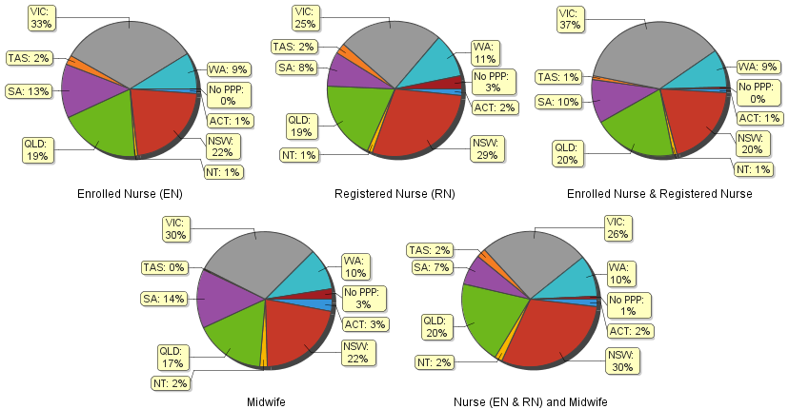

Totals for Non-Practising Nurse & Midwife
The following table and charts show totals for Non-Practising Registration

 | Principal place of practice
 | ACT |  | NSW | NT | QLD | SA | TAS | VIC | WA | No PPP | Total
Enrolled Nurse (EN) | 13 |  | 297 | 6 | 125 | 85 | 15 | 197 | 54 | 8 | 800
Registered Nurse (RN) | 55 |  | 1,331 | 23 | 427 | 227 | 73 | 540 | 232 | 216 | 3,124
Enrolled Nurse (EN) & Registered Nurse(RN) | 1 |  | 2 |  | 1 | 1 |  | 1 |  |  | 6
Nurse (EN & RN) and Midwife | 11 |  | 320 | 4 | 72 | 22 | 8 | 79 | 41 | 23 | 580
Midwife |  |  | 15 |  | 6 | 8 | 1 | 16 | 3 | 5 | 54
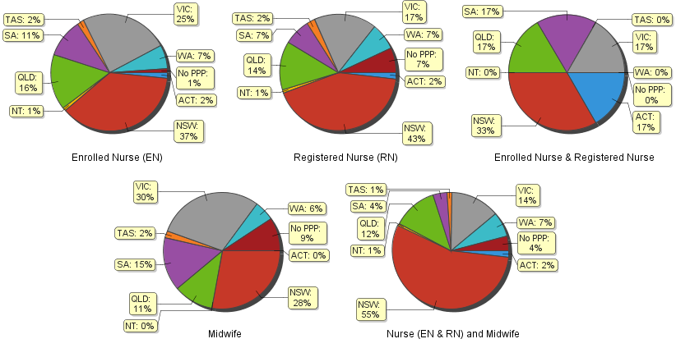

Registered Nurse and Midwife – Endorsement by Type
The endorsement of registration identifies registered nurses and midwives with additional qualifications and specific expertise.

The National Board endorsements for registered nurses are:
- Nurse Practitioner – includes prescribing scheduled medicines
- Midwife Practitioner – refer Position-Statement Midwife Practitioners (7 April 2011)
- Registered Nurse - supply scheduled medicines (rural and isolated practice)

Note: No principal place of practice (PPP) will include nurses and midwives with an overseas address.

The National Board endorsement for midwives is:
- Eligible Midwife – prescribe scheduled medicines
 |  | Principal state of practice
Profession | Endorsement type | ACT | NSW | NT | QLD |  | SA |  |  | TAS |  | VIC |  | WA |  | No PPP |  | Total
Nurse | Nurse Practitioner | 37 | 261 | 16 | 301 |  | 100 |  |  | 25 |  | 197 |  | 185 |  | 6 |  | 1,128
Nurse | Scheduled Medicines - Rural and isolated practice | 3 | 33 | 10 | 744 |  | 6 |  |  | 5 |  | 82 |  | 13 |  | 4 |  | 900
Midwife | Scheduled Medicines- Eligible Midwife | 2 | 28 | 0 | 42 |  | 11 |  |  | 2 |  | 22 |  | 21 |  | 0 |  | 128

Registered Nurse Notation by Principal Place of Practice
Registered Nurses with a sole qualification in mental health nursing or paediatric nursing or disability nursing.

To ensure national consistency, registered nurses with a sole qualification in mental health nursing or paediatric nursing or disability nursing - rather than a qualification in general nursing - are identified on the national register with a notation, which states: Solely qualified in the area of Disability Nursing / Mental Health Nursing / Paediatric Nursing.

Registered Nurse | Principal place of practice
Notation | ACT | NSW | NT | QLD | SA | TAS | VIC | WA | No PPP | Total
Disability Nursing | 1 | 20 | 3 | 7 | 3 | 0 | 10 | 17 | 6 | 67
Mental Health nursing | 5 | 203 | 23 | 54 | 51 | 5 | 163 | 1,156 | 62 | 1,722
Paediatric Nursing | 2 | 100 | 3 | 29 | 8 | 0 | 43 | 136 | 21 | 342
Total | 8 | 323 | 29 | 90 | 62 | 5 | 216 | 1,309 | 89 | 2,131

Midwife Notation by Principal Place of Practice

The National Board also recognises those midwives that meet the requirements of the Eligible Midwife registration standard with a notation on their registration.

The notation states:
Eligible midwife competent to provide pregnancy, labour, birth and post natal care and qualified to provide the associated services and order diagnostic investigations required for midwifery practice, in accordance with relevant State and Territory legislation.

Eligible midwife, but NOT qualified to obtain endorsement under section 94 to prescribe Schedule 2, 3, 4 & 8 medicines required for midwifery practice in accordance with state and territory legislation.

These eligible midwives will be endorsed to prescribe scheduled medicines when they successfully complete a Board-approved program of study for prescribing midwifery medicines.

Midwife | Principal place of practice
Notation | ACT | NSW | NT | QLD | SA | TAS | VIC | WA | Total
Eligible midwife | 2 | 47 | 2 | 100 | 17 | 7 | 48 | 32 | 255

Nurse and Midwife – general registration by age group

Nurse and Midwife | Nurse |  |  | Nurse & Midwife |  |  | Midwife
Age group | Enrolled Nurse (EN) | Registered Nurse (RN) | Enrolled Nurse & Registered Nurse | Enrolled Nurse (EN) | Registered Nurse (RN) | Enrolled Nurse & Registered Nurse | Midwife | Total |  | % by Age Group
U - 25 | 3,931 | 10,667 | 253 | 1 | 338 | 8 | 274 | 15,472 |  | 4.40%
25 - 29 | 4,934 | 30,817 | 1,000 | 16 | 1,414 | 7 | 569 | 38,757 |  | 11.03%
30 - 34 | 4,545 | 31,046 | 599 | 4 | 1,748 | 8 | 458 | 38,408 |  | 10.93%
35 - 39 | 4,369 | 28,902 | 467 | 7 | 1,771 | 6 | 424 | 35,946 |  | 10.23%
40 - 44 | 5,895 | 33,448 | 429 | 9 | 2,601 | 4 | 461 | 42,847 |  | 12.19%
45 - 49 | 7,984 | 30,110 | 464 | 3 | 3,602 | 5 | 406 | 42,574 |  | 12.11%
50 - 54 | 10,029 | 31,097 | 423 | 3 | 5,794 | 5 | 234 | 47,585 |  | 13.54%
55 - 59 | 9,873 | 30,021 | 249 | 3 | 6,268 | 1 | 181 | 46,596 |  | 13.26%
60 - 64 | 5,898 | 19,185 | 80 | 1 | 4,002 | 1 | 101 | 29,268 |  | 8.33%
65 - 69 | 1,828 | 7,886 | 16 |  | 1,456 |  | 52 | 11,238 |  | 3.20%
70 - 74 | 288 | 1,706 | 2 |  | 317 |  | 15 | 2,328 |  | 0.66%
75 - 79 | 38 | 333 |  |  | 54 |  | 1 | 426 |  | 0.12%
80+ | 4 | 50 |  |  | 8 |  |  | 62 |  | 0.02%
Total | 59,616 | 255,268 | 3,982 | 47 | 29,373 | 45 | 3,176 | 351,507 |  | 100.00%

Nurse and Midwife – general registration by age group
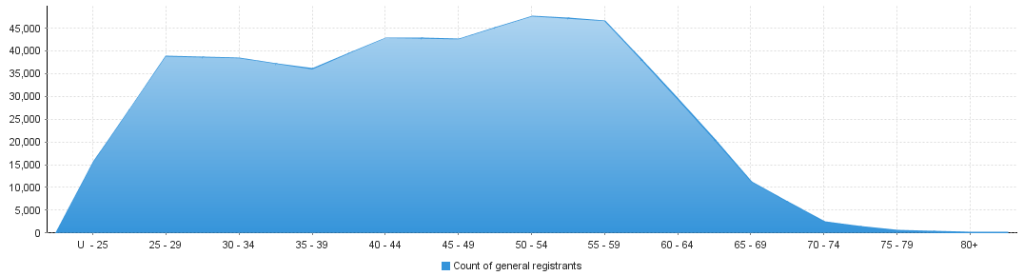

Nurse and Midwife – non-practising registration by age group
Nurse and Midwife | Nurse |  |  | Nurse & Midwife |  |  |  | Midwife
Age group | Enrolled Nurse (EN) | Registered Nurse (RN) | Enrolled Nurse & Registered Nurse | Enrolled Nurse (EN) |  | Registered Nurse (RN) | Enrolled Nurse & Registered Nurse | Midwife | Total |  | % by Age Group
U - 25 | 28 | 34 |  |  |  |  |  |  | 62 |  | 1.36%
25 - 29 | 53 | 202 |  |  |  | 7 |  | 13 | 275 |  | 6.03%
30 - 34 | 59 | 303 |  | 1 |  | 22 |  | 7 | 392 |  | 8.59%
35 - 39 | 55 | 308 |  |  |  | 23 |  | 7 | 393 |  | 8.61%
40 - 44 | 80 | 366 |  |  |  | 38 |  | 6 | 490 |  | 10.74%
45 - 49 | 98 | 326 | 1 |  |  | 39 |  | 7 | 471 |  | 10.32%
50 - 54 | 138 | 350 | 3 |  |  | 74 |  | 4 | 569 |  | 12.47%
55 - 59 | 166 | 454 |  |  |  | 112 |  | 8 | 740 |  | 16.21%
60 - 64 | 91 | 401 |  |  |  | 125 |  | 1 | 618 |  | 13.54%
65 - 69 | 26 | 257 | 1 |  |  | 89 |  |  | 373 |  | 8.17%
70 - 74 | 6 | 82 |  |  |  | 33 |  | 1 | 122 |  | 2.67%
75 - 79 |  | 33 | 1 |  |  | 12 |  |  | 46 |  | 1.01%
80+ |  | 8 |  |  |  | 5 |  |  | 13 |  | 0.28%
Total | 800 | 3,124 | 6 |  |  | 579 |  | 54 | 4,564 |  | 100.00%

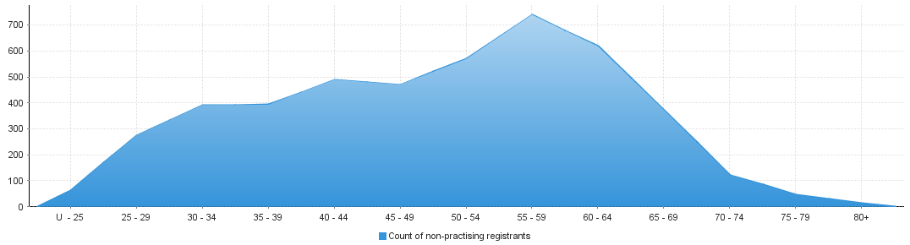
Nurse and Midwife – non-practising registration by age group

Nurse and Midwife – general registration by gender
Nurse and Midwife |  |  |  | Principal place of practice
Profession | Gender | Divisions |  | ACT | NSW | NT | QLD | SA | TAS | VIC | WA | No PPP | Total
Nurse | Female | Enrolled Nurse (EN) |  | 613 | 11,657 | 328 | 10,364 | 7,002 | 1,281 | 17,918 | 4,767 | 55 | 53,985
Nurse | Female | Registered Nurse (RN) |  | 3,701 | 63,798 | 2,659 | 43,158 | 18,539 | 5,468 | 56,520 | 24,583 | 6,737 | 225,163
Nurse | Female | Enrolled Nurse & Registered Nurse |  | 34 | 654 | 30 | 692 | 347 | 31 | 1,246 | 334 | 14 | 3,382
Nurse | Female Nurse Total |  |  | 4,348 | 76,109 | 3,017 | 54,214 | 25,888 | 6,780 | 75,684 | 29,684 | 6,806 | 282,530
Nurse | Male | Enrolled Nurse (EN) |  | 62 | 1,487 | 65 | 1,088 | 681 | 127 | 1,771 | 345 | 5 | 5,631
Nurse | Male | Registered Nurse (RN) |  | 511 | 9,574 | 486 | 5,485 | 2,500 | 776 | 6,989 | 2,679 | 1,105 | 30,105
Nurse | Male | Enrolled Nurse & Registered Nurse |  | 6 | 138 | 4 | 107 | 70 |  | 240 | 34 | 1 | 600
Nurse | Male Nurse Total |  |  | 579 | 11,199 | 555 | 6,680 | 3,251 | 903 | 9,000 | 3,058 | 1,111 | 36,336
Nurse Total |  |  |  | 4,927 | 87,308 | 3,572 | 60,894 | 29,139 | 7,683 | 84,684 | 32,742 | 7,917 | 318,866
Nurse & Midwife | Female | Enrolled Nurse (EN) |  | 4 | 4 |  | 7 | 4 |  | 27 |  |  | 46
Nurse & Midwife | Female | Registered Nurse (RN) |  | 544 | 8,601 | 487 | 5,837 | 2,103 | 613 | 7,547 | 2,891 | 217 | 28,840
Nurse & Midwife | Female | Enrolled Nurse & Registered Nurse |  | 1 | 6 |  | 1 | 1 |  | 28 | 8 |  | 45
Nurse & Midwife | Female Nurse & Midwife Total |  |  | 549 | 8,611 | 487 | 5,845 | 2,108 | 613 | 7,602 | 2,899 | 217 | 28,931
Nurse & Midwife | Male | Enrolled Nurse (EN) |  |  |  |  | 1 |  |  |  |  |  | 1
Nurse & Midwife | Male | Registered Nurse (RN) |  | 13 | 184 | 25 | 113 | 51 | 16 | 75 | 50 | 6 | 533
Nurse & Midwife | Male | Enrolled Nurse & Registered Nurse
Nurse & Midwife | Male Nurse & Midwife Total |  |  | 13 | 184 | 25 | 114 | 51 | 16 | 75 | 50 | 6 | 534
Nurse & Midwife Total |  |  |  | 549 | 8,611 | 487 | 5,845 | 2,108 | 613 | 7,602 | 2,899 | 217 | 28,931
Midwife | Female |  |  | 91 | 683 | 53 | 535 | 444 | 13 | 950 | 317 | 79 | 3,165
Midwife | Male |  |  |  | 3 | 1 | 2 | 1 | 1 | 2 |  | 1 | 11
Midwife Total |  |  |  | 91 | 686 | 54 | 537 | 445 | 14 | 952 | 317 | 80 | 3,176
Grand Total |  |  |  | 5,580 | 96,789 | 4,138 | 67,390 | 31,743 | 8,326 | 93,313 | 36,008 | 8,220 | 351,507

Nurse and Midwife – total general registration by gender

 | Principal place of practice
General | ACT |  | NSW |  | NT |  | QLD |  | SA |  | TAS |  | VIC |  | WA |  | No PPP | Total
Female | 4,988 |  | 85,403 |  | 3,557 |  | 60,594 |  | 28,440 |  | 7,406 |  | 84,236 |  | 32,900 |  | 7,102 | 314,626
Male | 592 |  | 11,386 |  | 581 |  | 6,796 |  | 3,303 |  | 920 |  | 9,077 |  | 3,108 |  | 1,118 | 36,881

Nurse and Midwife – general registration by gender percentages

 | Principal place of practice
General |  |  | ACT |  | NSW | NT |  | QLD |  | SA |  | TAS |  | VIC |  | WA |  | No PPP | Total
Female |  |  | 89.39% |  | 88.24% | 85.96% |  | 89.92% |  | 89.59% |  | 88.95% |  | 90.27% |  | 91.37% |  | 86.40% | 89.51%
Male |  |  | 10.61% |  | 11.76% | 14.04% |  | 10.08% |  | 10.41% |  | 11.05% |  | 9.73% |  | 8.63% |  | 13.60% | 10.49%

Nurse and Midwife – non-practising registration by gender

Nurse and Midwife |  |  | Principal place of practice
Profession | Gender | Divisions | ACT | NSW |  | NT |  | QLD |  |  | SA |  | TAS |  | VIC |  |  | WA |  | No PPP | Total
Nurse | Female | Enrolled Nurse (EN) | 12 | 272 |  | 6 |  | 121 |  |  | 80 |  | 14 |  | 186 |  |  | 53 |  | 6 | 750
Nurse | Female | Registered Nurse (RN) | 46 | 1,206 |  | 21 |  | 396 |  |  | 195 |  | 69 |  | 492 |  |  | 217 |  | 197 | 2,839
Nurse | Female | Enrolled Nurse & Registered Nurse |  | 2 |  |  |  | 1 |  |  |  |  |  |  | 1 |  |  |  |  |  | 4
Nurse | Female Nurse Total |  | 58 | 1,480 |  | 27 |  | 518 |  |  | 275 |  | 83 |  | 679 |  |  | 270 |  | 203 | 3,593
Nurse | Male | Enrolled Nurse (EN) | 1 | 25 |  |  |  | 4 |  |  | 5 |  | 1 |  | 11 |  |  | 1 |  | 2 | 50
Nurse | Male | Registered Nurse (RN) | 9 | 125 |  | 2 |  | 31 |  |  | 32 |  | 4 |  | 48 |  |  | 15 |  | 19 | 285
Nurse | Male | Enrolled Nurse & Registered Nurse | 1 |  |  |  |  |  |  |  | 1 |  |  |  |  |  |  |  |  |  | 2
Nurse | Male Nurse Total |  | 11 | 150 |  | 2 |  | 35 |  |  | 38 |  | 5 |  | 59 |  |  | 16 |  | 21 | 337
Nurse Total |  |  | 69 | 1630 |  | 29 |  | 553 |  |  | 313 |  | 88 |  | 738 |  |  | 286 |  | 224 | 3930
Nurse & Midwife | Female | Enrolled Nurse (EN) |  |  |  |  |  |  |  |  |  |  |  |  | 1 |  |  |  |  |  | 1
Nurse & Midwife | Female | Registered Nurse (RN) | 11 | 314 |  | 4 |  | 71 |  |  | 22 |  | 7 |  | 78 |  |  | 41 |  | 22 | 570
Nurse & Midwife |  | Enrolled Nurse & Registered Nurse
Nurse & Midwife | Female Nurse & Midwife Total |  | 11 | 314 |  | 4 |  | 71 |  |  | 22 |  | 7 |  | 79 |  |  | 41 |  | 22 | 571
Nurse & Midwife |  | Enrolled Nurse (EN)
Nurse & Midwife | Male | Registered Nurse (RN) |  | 6 |  |  |  | 1 |  |  |  |  | 1 |  |  |  |  |  |  | 1 | 9
Nurse & Midwife |  | Enrolled Nurse & Registered Nurse
Nurse & Midwife | Male Nurse & Midwife Total |  |  | 6 |  |  |  | 1 |  |  |  |  | 1 |  |  |  |  |  |  | 1 | 9
Nurse & Midwife Total |  |  | 11 | 320 |  | 4 |  | 72 |  |  | 22 |  | 8 |  | 79 |  |  | 41 |  | 23 | 580
Midwife | Female |  |  | 15 |  |  |  | 6 |  |  | 8 |  | 1 |  | 16 |  |  | 3 |  | 5 | 54
 | Male
Midwife Total |  |  |  | 15 |  |  |  | 6 |  |  | 8 |  | 1 |  | 16 |  |  | 3 |  | 5 | 54
Grand Total |  |  | 80 | 1,965 |  | 33 |  | 631 |  |  | 343 |  | 97 |  | 833 |  |  | 330 |  | 252 | 4,564

Nurse and Midwife – total non-practising totals by gender
 | Principal place of practice
Non-practising | ACT |  | NSW |  | NT |  |  | QLD |  | SA |  | TAS |  | VIC |  | WA |  | No PPP | Total
Female | 69 |  | 1,809 |  | 31 |  |  | 595 |  | 305 |  | 91 |  | 774 |  | 314 |  | 230 | 4,218
Male | 11 |  | 156 |  | 2 |  |  | 36 |  | 38 |  | 6 |  | 59 |  | 16 |  | 22 | 346

Nurse and Midwife – non-practising registration by gender percentages

Practitioners | Principal place of practice
Gender |  |  | ACT |  | NSW |  | NT |  | QLD |  | SA | TAS |  | VIC |  | WA |  | No PPP |  | Total
Female |  |  | 86.25% |  | 92.06% |  | 93.94% |  | 94.29% |  | 88.92% | 93.81% |  | 92.92% |  | 95.15% |  | 91.27% |  | 92.42%
Male |  |  | 13.75% |  | 7.94% |  | 6.06% |  | 5.71% |  | 11.08% | 6.19% |  | 7.08% |  | 4.85% |  | 8.73% |  | 7.58%

Note that the data for dual registration in the tables and diagrams includes where a nurse or a midwife may be non-practising in one category, for example enrolled nurse (non-practising) & registered nurse (practising) or nurse (non-practising) & midwife (practising).

