

Nursing and Midwifery Board of Australia

Registrant data

Reporting period: 1 October 2018 – 31 December 2018

Table of contents
Introduction 3
Principal place of practice 4
1. Registration type 4
2. General Registration 6
3. Non-practising Registration 7
4. Provisional Registration 8
5. Notations 10
Age group 11
6. General registration 11
7. Non-practising registration 12
8. Provisional registration 13
Gender 14
9. General Registration 14
10. Non-practising Registration 16
11. Provisional Registration 18

Introduction
This report contains registration information about nurses and midwives registered with the Nursing and Midwifery Board of Australia (NMBA).
The functions of the NMBA are defined under the National Law, and include:
- Registering nurses, midwives and students of nursing and midwifery
- Determining national registration requirements
- Developing professional codes, standards, guidelines and position statements to guide the practice of nurses and midwives
- Managing notifications, investigations and panel hearings
- Overseeing the assessment of internationally qualified nurses and midwives who wish to register in Australia
- Approving national accreditation standards and accredited programs of study leading to registration and endorsement
- Delegating to state and territory boards and committees of the NMBA, and AHPRA staff, the power to determine individual applications for registration and notification of a nurse’s or midwife’s health, performance and/or conduct, and a student’s health or criminal history

*Co-regulatory models apply in New South Wales (NSW) and Queensland (QLD). In NSW, notifications are managed separately by the Nursing and Midwifery Council of NSW; the NSW Board of the NMBA only manages registration matters. In QLD, notifications are received by the Office of the Health Ombudsman (OHO), who determines which notifications should be managed by the NMBA.
The NMBA’s functions are supported by the Australian Health Practitioner Regulation Agency (AHPRA). For information about legislation governing the NMBA and AHPRA, see AHPRA's Legislation & Publications at www.ahpra.gov.au/Legislation-and-Publications.aspx
AHPRA has analysed the NMBA’s registration data and produced a number of statistical tables about registrants to share with the professions and community. This report is updated on a quarterly basis.
For more information on nursing and midwifery registration, please see the NMBA’s website: www.nursingmidwiferyboard.gov.au/Registration-and-Endorsement.aspx
Principal place of practice
- Registration type
Registration type by principal place of practice*
Profession | Registration type | Divisions | ACT | NSW | NT | QLD | SA | TAS | VIC | WA | No PPP | Total
Nurse | General | Enrolled Nurse (EN) | 679 | 13,573 | 416 | 13,141 | 7,768 | 1,580 | 20,343 | 5,457 | 124 | 63,081
Nurse | General | Registered Nurse (RN) | 5,028 | 83,694 | 3,539 | 59,156 | 22,366 | 7,048 | 73,770 | 29,741 | 10,048 | 294,390
Nurse | General | EN & RN | 84 | 1,399 | 57 | 1,680 | 806 | 79 | 2,901 | 719 | 26 | 7,751
Nurse | Total General Nurse |  | 5,791 | 98,666 | 4,012 | 73,977 | 30,940 | 8,707 | 97,014 | 35,917 | 10,198 | 365,222
Nurse | Non-practising | Enrolled Nurse (EN) | 17 | 321 | 5 | 180 | 127 | 23 | 253 | 86 | 15 | 1,027
Nurse | Non-practising | Registered Nurse (RN) | 76 | 1,472 | 21 | 638 | 289 | 103 | 715 | 309 | 460 | 4,083
Nurse | Non-practising | EN & RN |  | 5 |  | 6 | 3 | 1 | 7 | 1 | 5 | 28
Nurse | Total Non-practising Nurse |  | 93 | 1,798 | 26 | 824 | 419 | 127 | 975 | 396 | 480 | 5,138
Nurse | Provisional | Enrolled Nurse (EN) | 2 | 6 | 1 | 11 | 3 | 1 | 18 | 4 |  | 46
Nurse | Provisional | Registered Nurse (RN) | 3 | 45 |  | 36 | 21 | 4 | 40 | 27 | 4 | 180
Nurse | Provisional | EN & RN |  |  |  |  |  |  | 1 |  |  | 1
Nurse | Total Provisional Nurse |  | 5 | 51 | 1 | 47 | 24 | 5 | 59 | 31 | 4 | 227
Total Nurse |  |  | 5,889 | 100,515 | 4,039 | 74,848 | 31,383 | 8,839 | 98,048 | 36,344 | 10,682 | 370,587
Table 1.1 (continued from page 4)
Profession | Registration type | Divisions |  | ACT | NSW | NT | QLD | SA | TAS | VIC | WA | No PPP | Total
Nurse & Midwife | General | EN & Midwife |  | 1 | 10 | 3 | 27 | 10 |  | 31 | 2 |  | 84
Nurse & Midwife | General | RN & Midwife |  | 489 | 7,343 | 478 | 5,515 | 1,774 | 604 | 7,212 | 2,750 | 273 | 26,438
Nurse & Midwife | General | EN & RN & Midwife |  |  | 18 | 2 | 4 | 2 | 2 | 27 | 12 |  | 67
Nurse & Midwife | Total General NMW |  |  | 490 | 7,371 | 483 | 5,546 | 1,786 | 606 | 7,270 | 2,764 | 273 | 26,589
Nurse & Midwife | Non-practising | EN & Midwife |  |  |  |  |  |  |  | 1 |  |  | 1
Nurse & Midwife | Non-practising | RN & Midwife |  | 16 | 264 |  | 83 | 40 | 8 | 111 | 39 | 26 | 587
Nurse & Midwife | Total Non-practising NMW |  |  | 16 | 264 |  | 83 | 40 | 8 | 112 | 39 | 26 | 588
Nurse & Midwife | Provisional |  | Registered Nurse (RN) |  | 2 |  | 1 | 1 |  | 1 | 1 |  | 6
Nurse & Midwife | Total Provisional NMW |  |  |  | 2 |  | 1 | 1 |  | 1 | 1 |  | 6
Total NMW |  |  |  | 506 | 7,637 | 483 | 5,630 | 1,827 | 614 | 7,383 | 2,804 | 299 | 27,183
Midwife | General |  |  | 170 | 1,209 | 84 | 1,125 | 640 | 31 | 1,358 | 436 | 190 | 5,243
Midwife | Non-practising |  |  |  | 16 | 1 | 7 | 5 |  | 23 | 8 | 7 | 67
Midwife | Provisional |  |  |  | 1 |  | 2 | 1 |  |  |  |  | 4
Total Midwife |  |  |  | 170 | 1,226 | 85 | 1,134 | 646 | 31 | 1,381 | 444 | 197 | 5,314
Total |  |  |  | 6,565 | 109,378 | 4,607 | 81,612 | 33,856 | 9,484 | 106,812 | 39,592 | 11,178 | 403,084
* The Nursing and Midwifery Board introduced Provisional Registration for Nurses and Midwives in September 2015.

- General Registration
Table 2.1 Totals for practitioners with general registration as Nurse and/or Midwife
 | ACT | NSW | NT | QLD | SA | TAS | VIC | WA | No PPP | Total
Enrolled Nurse (EN) | 679 | 13,573 | 416 | 13,141 | 7,768 | 1,580 | 20,343 | 5,457 | 124 | 63,081
Registered Nurse (RN) | 5,028 | 83,694 | 3,539 | 59,156 | 22,366 | 7,048 | 73,770 | 29,741 | 10,048 | 294,390
EN & RN | 84 | 1,399 | 57 | 1,680 | 806 | 79 | 2,901 | 719 | 26 | 7,751
Midwife | 170 | 1,209 | 84 | 1,125 | 640 | 31 | 1,358 | 436 | 190 | 5,243
Nurse (EN & RN) and Midwife* | 490 | 7,371 | 483 | 5,546 | 1,786 | 606 | 7,270 | 2,764 | 273 | 26,589
* Practitioners with a Nurse and Midwife registration may hold registration as an EN and Midwife, RN and Midwife, or EN and RN and Midwife.

Percentage of general registration by principal place of practice

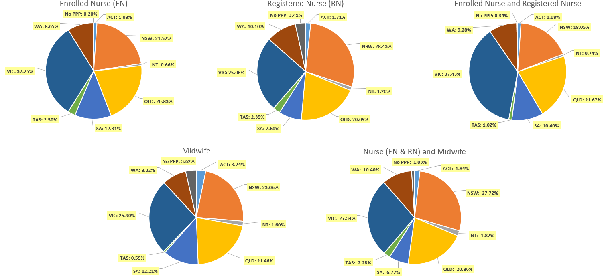

- Non-practising Registration
Totals for practitioners with non-practising registration as Nurse and/or Midwife
Division | ACT | NSW | NT | QLD | SA | TAS | VIC | WA | No PPP | Total
Enrolled Nurse (EN) | 17 | 321 | 5 | 180 | 127 | 23 | 253 | 86 | 15 | 1,027
Registered Nurse (RN) | 76 | 1,472 | 21 | 638 | 289 | 103 | 715 | 309 | 460 | 4,083
EN & RN |  | 5 |  | 6 | 3 | 1 | 7 | 1 | 5 | 28
Midwife |  | 16 | 1 | 7 | 5 |  | 23 | 8 | 7 | 67
Nurse (EN & RN) and Midwife* | 16 | 264 |  | 83 | 40 | 8 | 112 | 39 | 26 | 588
* Practitioners with a Nurse and Midwife registration may hold registration as an EN and Midwife, RN and Midwife, or EN and RN and Midwife.
Percentage of non-practising registration by principal place of practice

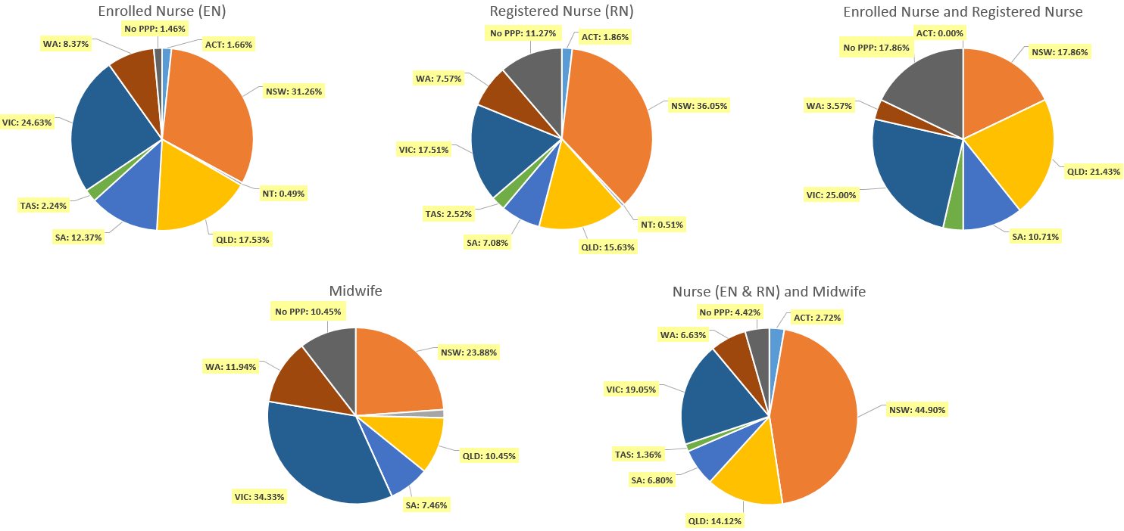

- Provisional Registration
Provisional registration is a registration type used by the NMBA for registered nurses, enrolled nurses and/or midwives who want to return to the register after an absence from practice. Provisional registration enables a registered nurse, enrolled nurse and/or midwife to complete a period of supervised practice or a NMBA-approved re-entry to practice program to be eligible for general registration.

Table 4.1 Totals for practitioners with provisional registration as Nurse and/or Midwife
Division | ACT | NSW | NT | QLD | SA | TAS | VIC | WA | No PPP | Total
Enrolled Nurse (EN) | 2 | 6 | 1 | 11 | 3 | 1 | 18 | 4 |  | 46
Registered Nurse (RN) | 3 | 45 |  | 36 | 21 | 4 | 40 | 27 | 4 | 180
EN & RN |  |  |  |  |  |  | 1 |  |  | 1
Midwife |  | 1 |  | 2 | 1 |  |  |  |  | 4
Nurse (EN & RN) and Midwife* |  | 2 |  | 1 | 1 |  | 1 | 1 |  | 6
* Practitioners with a Nurse and Midwife registration may hold registration as an EN and Midwife, RN and Midwife, or EN and RN and Midwife.
Table 4.2 Percentage of provisional by principal place of practice

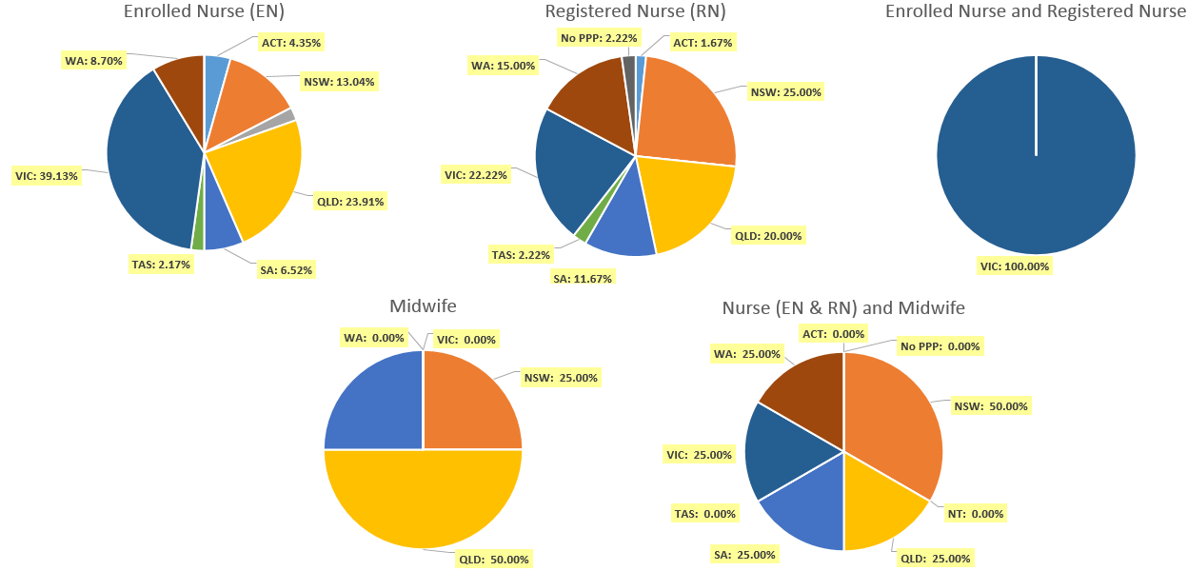

Endorsements by Type
The NMBA endorsements for registered nurses are:
- Nurse Practitioner
- Registered Nurse - scheduled medicines (rural and isolated practice)
The NMBA endorsements for midwives are:
- Midwife – scheduled medicines
- Midwife Practitioner – refer Position-Statement Midwife Practitioners (7 April 2011)

Table 5.1 Registered Nurse and Midwife – Endorsements by principal place of practice
Profession | Endorsement | ACT | NSW | NT | QLD | SA | TAS | VIC | WA | No PPP | Total
Nurse | Nurse Practitioner | 45 | 410 | 28 | 461 | 143 | 42 | 379 | 248 | 28 | 1,784
Nurse | Scheduled Medicines - Rural and isolated practice | 7 | 42 | 26 | 818 | 11 | 8 | 181 | 25 | 10 | 1,128
Midwife | Midwife Practitioner |  | 1 |  |  |  |  |  |  |  | 1
Midwife | Scheduled Medicines* | 6 | 71 | 5 | 184 | 45 | 12 | 88 | 77 | 1 | 489
Total |  | 58 | 524 | 59 | 1,463 | 199 | 62 | 648 | 350 | 39 | 3,402
* The above numbers under ‘Midwife Scheduled Medicines’ reflect those midwives who have met the NMBA Registration standard for endorsement for scheduled medicines for midwives.

Notations
Registered nurses with a sole qualification in mental health nursing or paediatric nursing or disability nursing - rather than a qualification in general nursing - are identified on the national register with a notation, which states: Solely qualified in the area of Disability Nursing / Mental Health Nursing / Paediatric Nursing.
Table 6.1 Registered Nurse notations
Notation | ACT | NSW | NT | QLD | SA | TAS | VIC | WA | No PPP | Total
Disability Nursing |  | 38 | 2 | 10 | 4 |  | 13 | 21 | 13 | 101
Mental health nursing | 8 | 268 | 25 | 199 | 211 | 17 | 310 | 1,021 | 155 | 2,214
Paediatric Nursing | 3 | 131 | 2 | 115 | 16 | 2 | 86 | 158 | 66 | 579
Total | 11 | 437 | 29 | 324 | 231 | 19 | 409 | 1,200 | 234 | 2,894
Midwife notations
Note: All midwives who held the Eligible Midwife notation either now hold the Midwife Scheduled Medicines endorsement or have determined they no longer require the Eligible Midwife notation.
Age group
- General registration
Table 7.1 General registration by age group
 | Nurse |  |  | Nurse & Midwife |  |  | Midwife | Total
Age group | EN | RN | EN & RN | EN | RN | EN & RN | Midwife | Total | % age bracket
U - 25 | 5,441 | 14,990 | 474 | 2 | 529 |  | 450 | 21,886 | 5.5%
25 - 29 | 6,208 | 36,091 | 1,545 | 10 | 1,704 | 20 | 938 | 46,516 | 11.7%
30 - 34 | 6,051 | 44,585 | 1,583 | 20 | 1,987 | 10 | 887 | 55,123 | 13.9%
35 - 39 | 5,365 | 34,018 | 1,034 | 18 | 1,884 | 13 | 760 | 43,092 | 10.9%
40 - 44 | 5,155 | 32,014 | 834 | 11 | 1,992 | 6 | 648 | 40,660 | 10.2%
45 - 49 | 6,709 | 34,644 | 834 | 13 | 2,742 | 6 | 593 | 45,541 | 11.5%
50 - 54 | 8,117 | 29,867 | 669 | 5 | 3,627 | 6 | 415 | 42,706 | 10.8%
55 - 59 | 9,608 | 30,919 | 523 | 4 | 5,399 | 4 | 274 | 46,731 | 11.8%
60 - 64 | 7,317 | 24,023 | 195 | 1 | 4,368 | 2 | 185 | 36,091 | 9.1%
65 - 69 | 2,533 | 10,103 | 52 |  | 1,723 |  | 72 | 14,483 | 3.6%
70 - 74 | 506 | 2,616 | 7 |  | 394 |  | 18 | 3,541 | 0.9%
75 - 79 | 61 | 432 | 1 |  | 76 |  | 3 | 573 | 0.1%
80+ | 10 | 88 |  |  | 13 |  |  | 111 | < 0.1%
Total | 63,081 | 294,390 | 7,751 | 84 | 26,438 | 67 | 5,243 | 397,054 | 100.0%

Table 7.2 General registration by age group
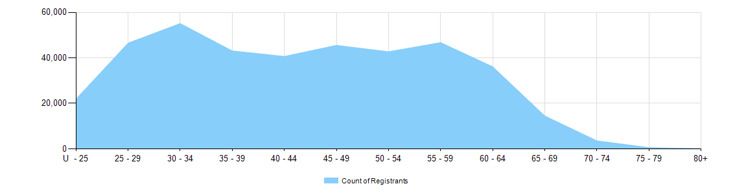

- Non-practising registration
Table 8.1 Non-practising registration by age group
Age group | Nurse |  |  | Nurse & Midwife
Age group | EN | RN | EN & RN | EN | RN | Midwife | Total | % age bracket
U - 25 | 32 | 39 |  |  |  | 2 | 73 | 1.3%
25 - 29 | 71 | 241 | 5 |  | 7 | 9 | 333 | 5.7%
30 - 34 | 67 | 340 | 7 | 1 | 13 | 7 | 435 | 7.5%
35 - 39 | 81 | 382 | 3 |  | 16 | 10 | 492 | 8.5%
40 - 44 | 64 | 374 | 3 |  | 20 | 8 | 469 | 8.1%
45 - 49 | 118 | 424 | 2 |  | 43 | 6 | 593 | 10.2%
50 - 54 | 146 | 391 | 3 |  | 32 | 8 | 580 | 10.0%
55 - 59 | 197 | 503 | 2 |  | 88 | 6 | 796 | 13.7%
60 - 64 | 157 | 656 | 2 |  | 148 | 7 | 970 | 16.7%
65 - 69 | 70 | 456 | 1 |  | 140 | 2 | 669 | 11.5%
70 - 74 | 19 | 194 |  |  | 56 | 2 | 271 | 4.7%
75 - 79 | 5 | 64 |  |  | 17 |  | 86 | 1.5%
80+ |  | 19 |  |  | 7 |  | 26 | 0.4%
Total | 1,027 | 4,083 | 28 | 1 | 587 | 67 | 5,793 | 100.0%

Table 8.2 Non-practising registration by age group

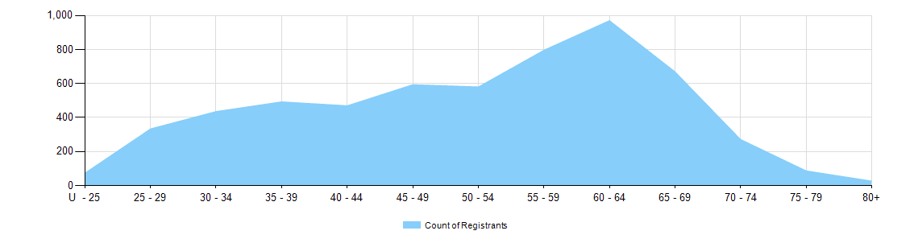
- Provisional registration
Provisional registration is a registration type used by the NMBA for registered nurses, enrolled nurses and/or midwives who want to return to the register after an absence from practice. Provisional registration enables a registered nurse, enrolled nurse and/or midwife to complete a period of supervised practice or a NMBA-approved re-entry to practice program to be eligible for general registration.
Table 9.1 Provisional registration by age group
Age group | Nurse |  |  | Nurse & Midwife
Age group | EN | RN | EN & RN | EN | RN | EN & RN | Midwife | Total | % age bracket
U - 25 |  |  |  |  |  |  |  |  | 0.0%
25 - 29 | 2 | 5 |  |  |  |  |  | 7 | 3.0%
30 - 34 | 9 | 27 |  |  |  |  |  | 36 | 15.2%
35 - 39 | 10 | 44 | 1 |  | 1 |  |  | 56 | 23.6%
40 - 44 | 7 | 35 |  |  | 1 |  | 1 | 44 | 18.6%
45 - 49 | 7 | 30 |  |  | 1 |  | 3 | 41 | 17.3%
50 - 54 | 5 | 20 |  |  | 1 |  |  | 26 | 11.0%
55 - 59 | 2 | 15 |  |  | 1 |  |  | 18 | 7.6%
60 - 64 | 3 | 2 |  |  | 1 |  |  | 6 | 2.5%
65 - 69 |  | 2 |  |  |  |  |  | 2 | 0.8%
70 - 74 | 1 |  |  |  |  |  |  | 1 | 0.4%
75 - 79 |  |  |  |  |  |  |  |  | 0.0%
80+ |  |  |  |  |  |  |  |  | 0.0%
Total | 46 | 180 | 1 | 0 | 6 | 0 | 4 | 237 | 100.0%

Tale 9.2 Provisional registration by age group

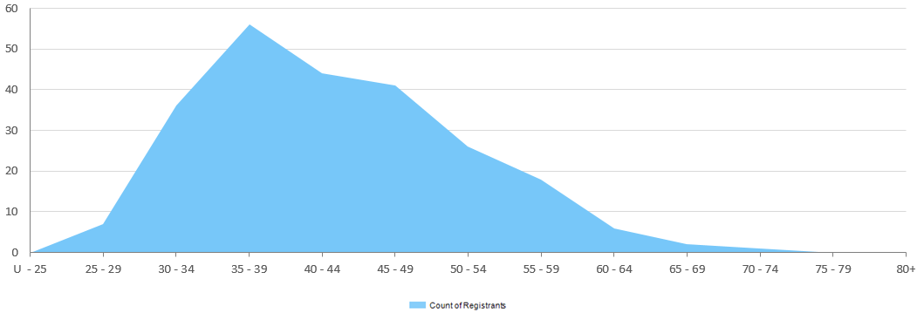
Gender
- General Registration
Table 10.1 General registration by gender
Profession | Gender | Divisions |  | ACT | NSW | NT | QLD | SA | TAS | VIC | WA | No PPP | Total
Nurse | Female | Enrolled Nurse (EN) |  | 604 | 11,993 | 343 | 11,806 | 7,022 | 1,432 | 18,385 | 5,023 | 109 | 56,717
Nurse | Female | Registered Nurse (RN) |  | 4,352 | 72,350 | 2,981 | 52,282 | 19,663 | 6,165 | 65,250 | 26,821 | 8,476 | 258,340
Nurse | Female | EN & RN |  | 68 | 1,192 | 47 | 1,464 | 655 | 73 | 2,488 | 654 | 25 | 6,666
Nurse | Total female General Nurse |  |  | 5,024 | 85,535 | 3,371 | 65,552 | 27,340 | 7,670 | 86,123 | 32,498 | 8,610 | 321,723
Nurse | Male | Enrolled Nurse (EN) |  | 75 | 1,580 | 73 | 1,335 | 746 | 148 | 1,958 | 433 | 15 | 6,363
Nurse | Male | Registered Nurse (RN) |  | 676 | 11,342 | 558 | 6,873 | 2,703 | 883 | 8,520 | 2,920 | 1,572 | 36,047
Nurse | Male | EN & RN |  | 16 | 207 | 10 | 216 | 151 | 6 | 413 | 65 | 1 | 1,085
Nurse | Total male General Nurse |  |  | 767 | 13,129 | 641 | 8,424 | 3,600 | 1,037 | 10,891 | 3,418 | 1,588 | 43,495
Nurse | Intersex or Indeterminate |  | Enrolled Nurse (EN) |  |  |  |  |  |  |  | 1 |  | 1
Nurse |  |  | Registered Nurse (RN) |  | 1 |  | 1 |  |  |  |  |  | 2
Nurse | Total Intersex or Indeterminate General Nurse |  |  | 0 | 1 | 0 | 1 | 0 | 0 | 0 | 1 | 0 | 3
Total General Nurse |  |  |  | 5,791 | 98,665 | 4,012 | 73,977 | 30,940 | 8,707 | 97,014 | 35,917 | 10,198 | 365,221
Nurse & Midwife* | Female | EN & Midwife |  | 1 | 10 | 2 | 26 | 10 |  | 31 | 2 |  | 82
Nurse & Midwife* | Female | RN & Midwife |  | 481 | 7,183 | 448 | 5,432 | 1,736 | 591 | 7,149 | 2,708 | 267 | 25,995
Nurse & Midwife* | Female | EN & RN & Midwife |  |  | 17 | 2 | 4 | 2 | 2 | 27 | 12 |  | 66
Nurse & Midwife* | Total female General NMW |  |  | 482 | 7,210 | 452 | 5,462 | 1,748 | 593 | 7,207 | 2,722 | 267 | 26,143
Nurse & Midwife* | Male | EN & Midwife |  |  |  | 1 | 1 |  |  |  |  |  | 2
Nurse & Midwife* | Male | RN & Midwife |  | 8 | 160 | 30 | 83 | 38 | 13 | 63 | 42 | 6 | 443
Nurse & Midwife* | Male | EN & RN & Midwife |  |  | 1 |  |  |  |  |  |  |  | 1
Nurse & Midwife* | Total male General NMW |  |  | 8 | 161 | 31 | 84 | 38 | 13 | 63 | 42 | 6 | 446
Total General NMW |  |  |  | 490 | 7,371 | 483 | 5,546 | 1,786 | 606 | 7,270 | 2,764 | 273 | 26,589
Table 10.1 (continued from page 14)
Profession | Gender | Divisions | ACT | NSW | NT | QLD | SA | TAS | VIC | WA | No PPP | Total
Midwife | Female |  | 169 | 1,203 | 83 | 1,124 | 639 | 30 | 1,353 | 435 | 190 | 5,226
Midwife | Male |  | 1 | 6 | 1 | 1 | 1 | 1 | 5 | 1 |  | 17
Total General Midwife |  |  | 170 | 1,209 | 84 | 1,125 | 640 | 31 | 1,358 | 436 | 190 | 5,243
Total |  |  | 6,451 | 107,245 | 4,579 | 80,648 | 33,366 | 9,344 | 105,642 | 39,117 | 10,661 | 397,053
* Practitioners with a Nurse and Midwife registration may hold registration as an EN and Midwife, RN and Midwife, or EN and RN and Midwife.

Table 10.2 Total general registration by gender
Gender | ACT | NSW | NT | QLD | SA | TAS | VIC | WA | No PPP | Total
Female | 5,675 | 93,948 | 3,906 | 72,138 | 29,727 | 8,293 | 94,683 | 35,655 | 9,067 | 353,092
Male | 776 | 13,296 | 673 | 8,509 | 3,639 | 1,051 | 10,959 | 3,461 | 1,594 | 43,958
Intersex or Indeterminate |  | 1 |  | 1 |  |  |  | 1 |  | 3

Table 10.3 Total general registration by gender percentages
Gender | ACT | NSW | NT | QLD | SA | TAS | VIC | WA | No PPP | Total
Female | 88.0% | 87.6% | 85.3% | 89.4% | 89.1% | 88.8% | 89.6% | 91.1% | 85.0% | 88.9%
Male | 12.0% | 12.4% | 14.7% | 10.6% | 10.9% | 11.2% | 10.4% | 8.8% | 15.0% | 11.1%
Intersex or Indeterminate |  | < 0.1% |  | < 0.1% |  |  |  | < 0.1% |  | < 0.1%

Non-practising Registration
Table 11.1 Non-practising registration by gender
Profession | Gender | Divisions |  | ACT | NSW | NT | QLD | SA | TAS | VIC | WA | No PPP | Total
Nurse | Female | Enrolled Nurse (EN) |  | 16 | 294 | 5 | 170 | 122 | 23 | 236 | 82 | 14 | 962
Nurse | Female | Registered Nurse (RN) |  | 66 | 1,329 | 18 | 574 | 254 | 95 | 647 | 292 | 413 | 3,688
Nurse | Female | EN & RN |  |  | 5 |  | 5 | 3 | 1 | 7 | 1 | 4 | 26
Nurse | Total Female  Non-practising Nurse |  |  | 82 | 1,628 | 23 | 749 | 379 | 119 | 890 | 375 | 431 | 4,676
Nurse | Male | Enrolled Nurse (EN) |  | 1 | 27 |  | 10 | 5 |  | 17 | 4 | 1 | 65
Nurse | Male | Registered Nurse (RN) |  | 10 | 143 | 3 | 64 | 35 | 8 | 68 | 17 | 47 | 395
Nurse | Male | EN & RN |  |  |  |  | 1 |  |  |  |  | 1 | 2
Nurse | Total Male  Non-practising Nurse |  |  | 11 | 170 | 3 | 75 | 40 | 8 | 85 | 21 | 49 | 462
Total Non-practising Nurse |  |  |  | 93 | 1,798 | 26 | 824 | 419 | 127 | 975 | 396 | 480 | 5,138
Nurse & Midwife | Female | EN & Midwife |  |  |  |  |  |  |  | 1 |  |  | 1
Nurse & Midwife | Female | RN & Midwife |  | 16 | 257 |  | 81 | 40 | 8 | 111 | 38 | 26 | 577
Nurse & Midwife | Total Female  Non-practising NMW |  |  | 16 | 257 | 0 | 81 | 40 | 8 | 112 | 38 | 26 | 578
Nurse & Midwife | Male |  | RN & Midwife |  | 7 |  | 2 |  |  |  | 1 |  | 10
Nurse & Midwife | Total Male  Non-practising NMW |  |  | 0 | 7 | 0 | 2 | 0 | 0 | 0 | 1 | 0 | 10
Total Non-practising NMW |  |  |  | 16 | 264 | 0 | 83 | 40 | 8 | 112 | 39 | 26 | 588
Midwife | Female |  |  |  | 16 | 1 | 7 | 5 |  | 23 | 8 | 7 | 67
Total Non-practising Midwife |  |  |  | 0 | 16 | 1 | 7 | 5 | 0 | 23 | 8 | 7 | 67
Total |  |  |  | 109 | 2,078 | 27 | 914 | 464 | 135 | 1,110 | 443 | 513 | 5,793

Table 11.2 Total non-practising registration by gender
Gender | ACT | NSW | NT | QLD | SA | TAS | VIC | WA | No PPP | Total
Female | 98 | 1,901 | 24 | 837 | 424 | 127 | 1,025 | 421 | 464 | 5,321
Male | 11 | 177 | 3 | 77 | 40 | 8 | 85 | 22 | 49 | 472

Table 11.3 Total non-practising registration by gender percentages
Gender | ACT | NSW | NT | QLD | SA | TAS | VIC | WA | No PPP | Total
Female | 89.9% | 91.5% | 88.9% | 91.6% | 91.4% | 94.1% | 92.3% | 95.0% | 90.4% | 91.9%
Male | 10.1% | 8.5% | 11.1% | 8.4% | 8.6% | 5.9% | 7.7% | 5.0% | 9.6% | 8.1%

- Provisional Registration
Provisional registration is a registration type used by the NMBA for registered nurses, enrolled nurses and/or midwives who want to return to the register after an absence from practice. Provisional registration enables a registered nurse, enrolled nurse and/or midwife to complete a period of supervised practice or a NMBA-approved re-entry to practice program to be eligible for general registration.

Table 12.1 Provisional registration by gender
Profession | Gender | Divisions | ACT | NSW | NT | QLD | SA | TAS | VIC | WA | No PPP | Total
Nurse | Female | Enrolled Nurse (EN) | 2 | 6 | 1 | 11 | 3 | 1 | 17 | 4 |  | 45
Nurse | Female | Registered Nurse (RN) | 3 | 38 |  | 33 | 21 | 3 | 36 | 21 | 3 | 158
Nurse | Female | EN & RN |  |  |  |  |  |  | 1 |  |  | 1
Nurse | Total Female  Provisional Nurse |  | 5 | 44 | 1 | 44 | 24 | 4 | 54 | 25 | 3 | 204
Nurse | Male | Enrolled Nurse (EN) |  |  |  |  |  |  | 1 |  |  | 1
Nurse | Male | Registered Nurse (RN) |  | 7 |  | 3 |  | 1 | 4 | 6 | 1 | 22
Nurse | Total Male  Provisional Nurse |  | 0 | 7 | 0 | 3 | 0 | 1 | 5 | 6 | 1 | 23
Total Provisional Nurse |  |  | 5 | 51 | 1 | 47 | 24 | 5 | 59 | 31 | 4 | 227
Nurse & Midwife | Female | RN & Midwife |  | 2 |  | 1 | 1 |  | 1 | 1 |  | 6
Nurse & Midwife | Total Female  Provisional NMW |  | 0 | 2 | 0 | 1 | 1 | 0 | 1 | 1 | 0 | 6
Total Provisional NMW |  |  | 0 | 2 | 0 | 1 | 1 | 0 | 1 | 1 | 0 | 6
Midwife | Female |  |  | 1 |  | 2 | 1 |  |  |  |  | 4
Total Provisional Midwife |  |  | 0 | 1 | 0 | 2 | 1 | 0 | 0 | 0 | 0 | 4
Total |  |  | 5 | 54 | 1 | 50 | 26 | 5 | 60 | 32 | 4 | 237

Table 12.2 Provisional registration by gender
Gender | ACT | NSW | NT | QLD | SA | TAS | VIC | WA | No PPP | Total
Female | 5 | 47 | 1 | 47 | 26 | 4 | 55 | 26 | 3 | 214
Male |  | 7 |  | 3 |  | 1 | 5 | 6 | 1 | 23

Table 12.3 Provisional registration by gender percentages
Gender | ACT | NSW | NT | QLD | SA | TAS | VIC | WA | No PPP | Total
Female | 100.0% | 87.0% | 100.0% | 94.0% | 100.0% | 80.0% | 91.7% | 81.3% | 75.0% | 90.3%
Male |  | 13.0% |  | 6.0% |  | 20.0% | 8.3% | 18.8% | 25.0% | 9.7%

Note that the data for dual registration in the tables and diagrams includes where a nurse or a midwife may be non-practising in one category, for example enrolled nurse (non-practising) & registered nurse (practising) or nurse (non-practising) & midwife (practising).

