Nurse and Midwife registrant data: March 2015
Published May 2015

Introduction
This report contains registration information about nurses and midwives registered with the Nursing and Midwifery Board of Australia (NMBA).
The functions of the NMBA are defined under the National Law, and include:
- Registering nurses, midwives and students of nursing and midwifery
- Determining national registration requirements
- Developing professional codes, standards, guidelines and position statements to guide the practice of nurses and midwives
- Managing notifications, investigations and panel hearings
- Overseeing the assessment of internationally qualified nurses and midwives who wish to register in Australia
- Approving national accreditation standards and accredited programs of study leading to registration and endorsement
- Delegating to state and territory boards and committees of the NMBA, and AHPRA staff, the power to determine individual applications for registration and notification of a nurse’s or midwife’s health, performance and/or conduct, and a student’s health or criminal history
*Co-regulatory models apply in In New South Wales (NSW) and Queensland (QLD). In NSW, notifications are managed separately by the Nursing and Midwifery Council of NSW; the NSW Board of the NMBA only manages registration matters. In QLD, notifications are received by the Office of the Health Ombudsman (OHO), who determines which complaints should be managed by the NMBA.
The NMBA’s functions are supported by the Australian Health Practitioner Regulation Agency (AHPRA). For information about legislation governing the NMBA and AHPRA, see AHPRA's Legislation & Publications at www.ahpra.gov.au/Legislation-and-Publications.aspx
AHPRA has analysed the NMBA’s registration data and produced a number of statistical tables about registrants to share with the professions and community. This report is updated on a quarterly basis.
For more information on nursing and midwifery registration, please see the NMBA’s website:www.nursingmidwiferyboard.gov.au/Registration-and-Endorsement.aspx

Contents
Nurse and midwife – registration type by state or territory 3
Totals for practitioners with general registration as Nurse and/or Midwife 4
Totals for practitioners with non-practising registration as Nurse and/or Midwife 4
Registered Nurse and Midwife – endorsements by type 6
Registered Nurse Notation 6
Nurse and Midwife – general registration by age group 8
Nurse and Midwife – general registration by age group 8
Nurse and Midwife – non-practising registration by age group 9
Nurse and Midwife – non-practising registration by age group 9
Nurse and Midwife – general registration by gender 10
Nurse and Midwife – total general registration by gender 11
Nurse and Midwife – general registration by gender percentages 11
Nurse and Midwife – non-practising registration by gender 12
Nurse and Midwife – total non-practising totals by gender 13
Nurse and Midwife – non-practising registration by gender percentages 13
Nurse and midwife – registration type by state or territory
The NMBA recognises three nursing and midwifery registration types: general registration, non-practising registration and student registration. A nurse may be either a Registered Nurse or an Enrolled Nurse, or both.
 |  |  | Principal Place of practice
Profession | Registration Type | Divisions | ACT | NSW | NT | QLD | SA | TAS | VIC | WA | No PPP | Total
Nurse | General | Enrolled Nurse (EN) | 678 | 13,188 | 406 | 11,696 | 7,735 | 1,426 | 19,834 | 5,277 | 66 | 60,306
Nurse | General | Registered Nurse (RN) | 4,334 | 76,120 | 3,207 | 50,556 | 21,854 | 6,429 | 65,496 | 28,044 | 8,198 | 264,238
Nurse | General | Enrolled Nurse & Registered Nurse | 54 | 1,076 | 54 | 1,096 | 615 | 47 | 2,038 | 469 | 18 | 5,467
Nurse | Total General Nurse |  | 5,066 | 90,384 | 3,667 | 63,348 | 30,204 | 7,902 | 87,368 | 33,790 | 8,282 | 330,011
Nurse | Non-practising | Enrolled Nurse (EN) | 13 | 301 | 8 | 123 | 86 | 15 | 193 | 52 | 9 | 800
Nurse | Non-practising | Registered Nurse (RN) | 57 | 1,345 | 27 | 429 | 227 | 72 | 529 | 236 | 223 | 3,145
Nurse | Non-practising | Enrolled Nurse & Registered Nurse | 1 | 3 |  | 1 | 1 |  | 1 |  | 1 | 8
Nurse | Total Non-practising Nurse |  | 71 | 1,649 | 35 | 553 | 314 | 87 | 723 | 288 | 233 | 3,953
Total Nurse |  |  | 5,137 | 92,033 | 3,702 | 63,901 | 30,518 | 7,989 | 88,091 | 34,078 | 8,515 | 333,964
Nurse & Midwife | General | Enrolled Nurse (EN) & Midwife | 4 | 5 |  | 12 | 3 |  | 37 |  |  | 61
Nurse & Midwife | General | Registered Nurse (RN) & Midwife | 564 | 8,822 | 518 | 6,041 | 2,171 | 639 | 7,804 | 3,000 | 227 | 29,786
Nurse & Midwife | General | Enrolled Nurse & Registered Nurse & Midwife | 1 | 8 |  | 1 | 3 |  | 35 | 8 |  | 56
Nurse & Midwife | Total General Nurse & Midwife |  | 569 | 8,835 | 518 | 6,054 | 2,177 | 639 | 7,876 | 3,008 | 227 | 29,903
Nurse & Midwife | Non-practising | Enrolled Nurse (EN) & Midwife |  |  |  |  |  |  | 1 |  |  | 1
Nurse & Midwife | Non-practising | Registered Nurse (RN) & Midwife | 11 | 323 | 3 | 73 | 22 | 8 | 75 | 41 | 22 | 578
Nurse & Midwife | Non-practising | Enrolled Nurse & Registered Nurse and Midwife
Nurse & Midwife | Total Non-practising Nurse & Midwife |  | 11 | 323 | 3 | 73 | 22 | 8 | 76 | 41 | 22 | 579
Total Nurse & Midwife |  |  | 580 | 9,158 | 521 | 6,127 | 2,199 | 647 | 7,952 | 3,049 | 249 | 30,482
Midwife | General |  | 100 | 802 | 59 | 628 | 495 | 16 | 1,052 | 342 | 93 | 3,587
Midwife | Non-practising |  |  | 17 |  | 6 | 7 | 1 | 15 | 3 | 5 | 54
Midwife Total |  |  | 100 | 819 | 59 | 634 | 502 | 17 | 1,067 | 345 | 98 | 3,641
Grand Total |  |  | 5,817 | 102,010 | 4,282 | 70,662 | 33,219 | 8,653 | 97,110 | 37,472 | 8,862 | 368,087
Totals for practitioners with general registration as Nurse and/or Midwife
The following table and charts show totals for General Registration
 | Principal place of practice
 | ACT | NSW | NT | QLD | SA | TAS | VIC | WA | No PPP | Total
Enrolled Nurse (EN) | 678 | 13,188 | 406 | 11,696 | 7,735 | 1,426 | 19,834 | 5,277 | 66 | 60,306
Registered Nurse (RN) | 4,334 | 76,120 | 3,207 | 50,556 | 21,854 | 6,429 | 65,496 | 28,044 | 8,198 | 264,238
Enrolled Nurse & Registered Nurse | 54 | 1,076 | 54 | 1,096 | 615 | 47 | 2,038 | 469 | 18 | 5,467
Nurse (EN & RN) and Midwife | 569 | 8,835 | 518 | 6,054 | 2,177 | 639 | 7,876 | 3,008 | 227 | 29,903
Midwife | 100 | 802 | 59 | 628 | 495 | 16 | 1,052 | 342 | 93 | 3,587

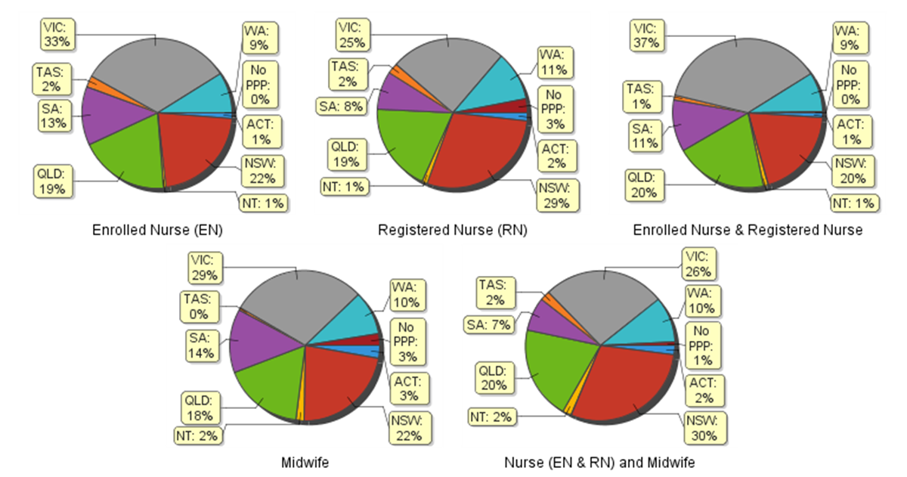
Totals for practitioners with non-practising registration as Nurse and/or Midwife
The following table and charts show totals for Non-Practising Registration
 | Principal place of practice
 | ACT | NSW | NT | QLD | SA | TAS | VIC | WA | No PPP | Total
Enrolled Nurse (EN) | 13 | 301 | 8 | 123 | 86 | 15 | 193 | 52 | 9 | 800
Registered Nurse (RN) | 57 | 1,345 | 27 | 429 | 227 | 72 | 529 | 236 | 223 | 3,145
Enrolled Nurse & Registered Nurse | 1 | 3 |  | 1 | 1 |  | 1 |  | 1 | 8
Nurse (EN & RN) and Midwife | 11 | 323 | 3 | 73 | 22 | 8 | 76 | 41 | 22 | 579
Midwife |  | 17 |  | 6 | 7 | 1 | 15 | 3 | 5 | 54
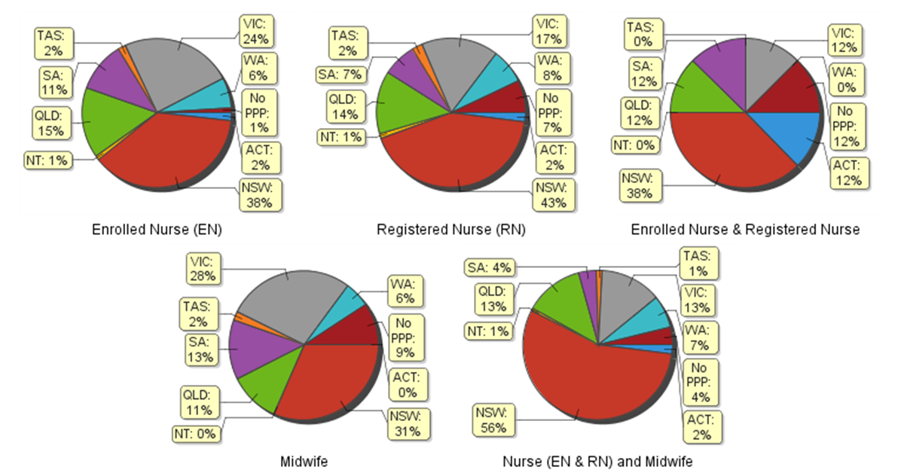
Registered Nurse and Midwife – endorsements by type
The endorsement of registration identifies registered nurses and midwives with additional qualifications and specific expertise. The NMBA endorsements for registered nurses are:
- Nurse Practitioner – includes prescribing scheduled medicines
- Registered Nurse - supply scheduled medicines (rural and isolated practice)
The NMBA endorsements for midwives are:
- Eligible Midwife – prescribe scheduled medicines
- Midwife Practitioner – refer Position-Statement Midwife Practitioners (7 April 2011)

 |  | Principal place of practice
Profession | Endorsement type | ACT | NSW | NT | QLD |  | SA |  | TAS |  | VIC |  | WA |  | No PPP |  | Total
Nurse | Nurse Practitioner | 36 | 273 | 19 | 321 |  | 108 |  | 25 |  | 224 |  | 196 |  | 12 |  | 1,214
Nurse | Scheduled Medicines - Rural and isolated practice | 3 | 35 | 10 | 771 |  | 7 |  | 5 |  | 108 |  | 13 |  | 5 |  | 957
Midwife | Scheduled Medicines- Eligible Midwife | 2 | 30 | 1 | 57 |  | 14 |  | 3 |  | 33 |  | 29 |  |  |  | 169
 | Midwife Practitioner |  | 1 |  |  |  |  |  |  |  |  |  |  |  |  |  | 1

Registered Nurse Notation
Registered Nurses with a sole qualification in mental health nursing or paediatric nursing or disability nursing.
To ensure national consistency, registered nurses with a sole qualification in mental health nursing or paediatric nursing or disability nursing - rather than a qualification in general nursing - are identified on the national register with a notation, which states: Solely qualified in the area of Disability Nursing / Mental Health Nursing / Paediatric Nursing.
Registered Nurse |  | Principal place of practice
Notation | ACT |  | NSW | NT | QLD | SA | TAS | VIC | WA | No PPP | Total
Disability Nursing | 1 |  | 22 | 3 | 10 | 4 |  | 12 | 19 | 8 | 79
Mental Health nursing | 5 |  | 222 | 27 | 61 | 56 | 4 | 173 | 1,169 | 87 | 1,804
Paediatric Nursing | 3 |  | 114 | 3 | 31 | 11 |  | 49 | 148 | 32 | 391
Total | 9 |  | 358 | 33 | 102 | 71 | 4 | 234 | 1,336 | 127 | 2,274

The NMBA also recognises those midwives that meet the requirements of the Eligible Midwife registration standard with a notation on their registration.
The notation states:
Eligible midwife competent to provide pregnancy, labour, birth and post natal care and qualified to provide the associated services and order diagnostic investigations required for midwifery practice, in accordance with relevant State and Territory legislation.
An Eligible midwife, may be qualified to obtain endorsement under section 94 to prescribe Schedule 2, 3, 4 & 8 medicines (required for midwifery practice in accordance with state and territory legislation), when they have completed a NMBA-approved program of study for prescribing midwifery medicines.
Midwife | Principal place of practice
Notation | ACT | NSW | NT | QLD | SA | TAS | VIC | WA | Total
Eligible midwife | 2 | 53 | 3 | 114 | 19 | 7 | 55 | 39 | 292
This counts in the above table includes notated and endorsed eligible midwives
Nurse and Midwife – general registration by age group
Nurse and Midwife | Nurse |  |  | Nurse & Midwife |  |  | Midwife
Age group | Enrolled Nurse (EN) | Registered Nurse (RN) | Enrolled Nurse & Registered Nurse | Enrolled Nurse (EN) | Registered Nurse (RN) | Enrolled Nurse & Registered Nurse | Midwife | Total |  | % by Age Group
U - 25 | 3,425 | 10,273 | 328 | 1 | 336 | 7 | 282 | 14,652 |  | 4.03%
25 - 29 | 4,886 | 30,524 | 1,373 | 20 | 1,389 | 13 | 643 | 38,848 |  | 10.69%
30 - 34 | 4,866 | 33,314 | 917 | 8 | 1,830 | 12 | 552 | 41,499 |  | 11.42%
35 - 39 | 4,275 | 29,064 | 624 | 6 | 1,731 | 4 | 466 | 36,170 |  | 9.95%
40 - 44 | 5,578 | 33,478 | 577 | 11 | 2,408 | 7 | 532 | 42,591 |  | 11.72%
45 - 49 | 7,589 | 31,428 | 624 | 7 | 3,386 | 4 | 447 | 43,485 |  | 11.96%
50 - 54 | 9,590 | 30,604 | 560 | 4 | 5,384 | 7 | 263 | 46,412 |  | 12.77%
55 - 59 | 10,378 | 31,139 | 311 | 3 | 6,358 | 1 | 199 | 48,389 |  | 13.31%
60 - 64 | 6,745 | 21,577 | 122 | 1 | 4,560 | 1 | 117 | 33,123 |  | 9.11%
65 - 69 | 2,469 | 9,989 | 28 |  | 1,885 |  | 64 | 14,435 |  | 3.97%
70 - 74 | 442 | 2,307 | 2 |  | 428 |  | 21 | 3,200 |  | 0.88%
75 - 79 | 56 | 461 | 1 |  | 78 |  | 1 | 597 |  | 0.16%
80+ | 7 | 80 |  |  | 13 |  |  | 100 |  | 0.03%
Total | 60,306 | 264,238 | 5,467 | 61 | 29,786 | 56 | 3,587 | 363,501 |  | 100.00%
Nurse and Midwife – general registration by age group
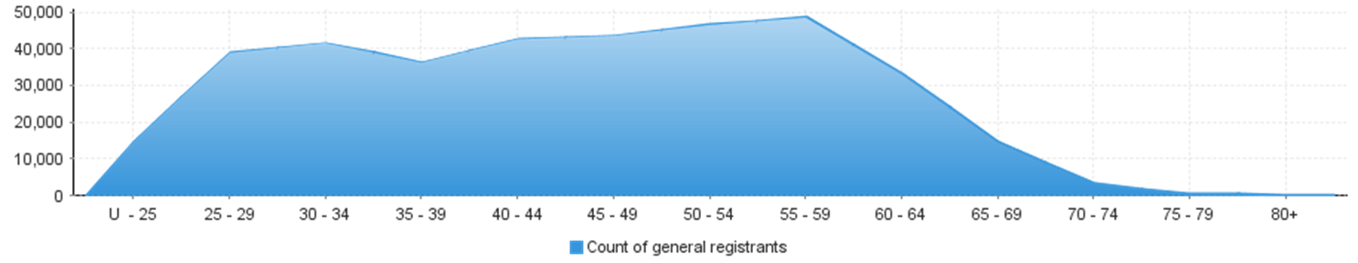
Nurse and Midwife – non-practising registration by age group
Nurse and Midwife | Nurse |  |  | Nurse & Midwife |  |  | Midwife
Age group | Enrolled Nurse (EN) | Registered Nurse (RN) | Enrolled Nurse & Registered Nurse | Enrolled Nurse (EN) | Registered Nurse (RN) | Enrolled Nurse & Registered Nurse | Midwife | Total |  | % by Age Group
U - 25 | 15 | 13 |  |  |  |  |  | 28 |  | 0.61%
25 - 29 | 52 | 163 | 1 |  | 5 |  | 10 | 231 |  | 5.04%
30 - 34 | 49 | 292 | 1 | 1 | 16 |  | 9 | 368 |  | 8.02%
35 - 39 | 57 | 297 |  |  | 17 |  | 7 | 378 |  | 8.24%
40 - 44 | 69 | 359 |  |  | 36 |  | 4 | 468 |  | 10.20%
45 - 49 | 95 | 343 |  |  | 42 |  | 7 | 487 |  | 10.62%
50 - 54 | 140 | 347 | 4 |  | 70 |  | 4 | 565 |  | 12.32%
55 - 59 | 162 | 443 |  |  | 102 |  | 6 | 713 |  | 15.55%
60 - 64 | 117 | 423 |  |  | 131 |  | 5 | 676 |  | 14.74%
65 - 69 | 38 | 302 | 1 |  | 98 |  | 1 | 440 |  | 9.59%
70 - 74 | 6 | 116 |  |  | 42 |  | 1 | 165 |  | 3.60%
75 - 79 |  | 35 | 1 |  | 13 |  |  | 49 |  | 1.07%
80+ |  | 12 |  |  | 6 |  |  | 18 |  | 0.39%
Total | 800 | 3,145 | 8 | 1 | 578 |  | 54 | 4,586 |  | 100.00%
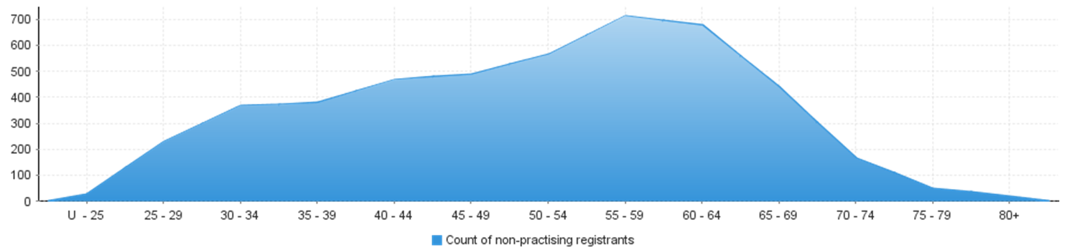
Nurse and Midwife – non-practising registration by age group

Nurse and Midwife – general registration by gender
Nurse and Midwife |  |  | Principal place of practice
Profession | Gender | Divisions | ACT | NSW | NT | QLD | SA | TAS | VIC | WA | No PPP | Total
Nurse | Female | Enrolled Nurse (EN) | 613 | 11,696 | 337 | 10,582 | 7,047 | 1,299 | 18,021 | 4,933 | 61 | 54,589
Nurse | Female | Registered Nurse (RN) | 3,811 | 66,152 | 2,709 | 44,874 | 19,224 | 5,637 | 58,342 | 25,287 | 7,033 | 233,069
Nurse | Female | Enrolled Nurse & Registered Nurse | 46 | 899 | 49 | 953 | 523 | 45 | 1,742 | 423 | 17 | 4,697
Nurse | Female Nurse Total |  | 4,470 | 78,747 | 3,095 | 56,409 | 26,794 | 6,981 | 78,105 | 30,643 | 7,111 | 292,355
Nurse | Male | Enrolled Nurse (EN) | 65 | 1,492 | 69 | 1,114 | 688 | 127 | 1,813 | 344 | 5 | 5,717
Nurse | Male | Registered Nurse (RN) | 523 | 9,968 | 498 | 5,682 | 2,630 | 792 | 7,154 | 2,757 | 1,165 | 31,169
Nurse | Male | Enrolled Nurse & Registered Nurse | 8 | 177 | 5 | 143 | 92 | 2 | 296 | 46 | 1 | 770
Nurse | Male Nurse Total |  | 596 | 11,637 | 572 | 6,939 | 3,410 | 921 | 9,263 | 3,147 | 1,171 | 37,656
Nurse Total |  |  | 5,066 | 90,384 | 3,667 | 63,348 | 30,204 | 7,902 | 87,368 | 33,790 | 8,282 | 330,011
Nurse & Midwife | Female | Enrolled Nurse (EN) & Midwife | 4 | 5 |  | 11 | 3 |  | 37 |  |  | 60
Nurse & Midwife | Female | Registered Nurse (RN) & Midwife | 551 | 8,637 | 492 | 5,927 | 2,120 | 624 | 7,726 | 2,952 | 222 | 29,251
Nurse & Midwife |  | Enrolled Nurse & Registered Nurse & Midwife | 1 | 7 |  | 1 | 3 |  | 35 | 8 |  | 55
Nurse & Midwife | Female Nurse & Midwife Total |  | 556 | 8,649 | 492 | 5,939 | 2,126 | 624 | 7,798 | 2,960 | 222 | 29,366
Nurse & Midwife |  | Enrolled Nurse (EN) & Midwife |  |  |  | 1 |  |  |  |  |  | 1
Nurse & Midwife | Male | Registered Nurse (RN) & Midwife | 13 | 185 | 26 | 114 | 51 | 15 | 78 | 48 | 5 | 535
Nurse & Midwife |  | Enrolled Nurse & Registered Nurse & Midwife |  | 1 |  |  |  |  |  |  |  | 1
Nurse & Midwife | Male Nurse & Midwife Total |  | 13 | 186 | 26 | 115 | 51 | 15 | 78 | 48 | 5 | 537
Nurse & Midwife Total |  |  | 569 | 8,835 | 518 | 6,054 | 2,177 | 639 | 7,876 | 3,008 | 227 | 29,903
Midwife | Female |  | 100 | 797 | 58 | 626 | 494 | 15 | 1,049 | 342 | 91 | 3,572
Midwife | Male |  |  | 5 | 1 | 2 | 1 | 1 | 3 |  | 2 | 15
Midwife Total |  |  | 100 | 802 | 59 | 628 | 495 | 16 | 1,052 | 342 | 93 | 3,587
Grand Total |  |  | 5,735 | 100,021 | 4,244 | 70,030 | 32,876 | 8,557 | 96,296 | 37,140 | 8,602 | 363,501

Nurse and Midwife – total general registration by gender
 | Principal place of practice
General | ACT | NSW | NT | QLD | SA | TAS | VIC | WA | No PPP | Total
Female | 5,126 | 88,193 | 3,645 | 62,974 | 29,414 | 7,620 | 86,952 | 33,945 | 7,424 | 325,293
Male | 609 | 11,828 | 599 | 7,056 | 3,462 | 937 | 9,344 | 3,195 | 1,178 | 38,208

Nurse and Midwife – general registration by gender percentages
 | Principal place of practice
General | ACT | NSW | NT | QLD | SA | TAS | VIC | WA | No PPP | Total
Female | 89.38% | 88.17% | 85.89% | 89.92% | 89.47% | 89.05% | 90.30% | 91.40% | 86.31% | 89.52%
Male | 10.62% | 11.83% | 14.11% | 10.08% | 10.53% | 10.95% | 9.70% | 8.60% | 13.69% | 10.48%

Nurse and Midwife – non-practising registration by gender
Nurse and Midwife |  |  | Principal place of practice
Profession | Gender | Divisions | ACT | NSW | NT | QLD | SA | TAS | VIC | WA | No PPP | Total
Nurse | Female | Enrolled Nurse (EN) | 12 | 277 | 8 | 118 | 81 | 14 | 181 | 51 | 7 | 749
Nurse | Female | Registered Nurse (RN) | 48 | 1,216 | 25 | 394 | 195 | 67 | 483 | 220 | 203 | 2,851
Nurse | Female | Enrolled Nurse & Registered Nurse |  | 3 |  | 1 |  |  | 1 |  | 1 | 6
Nurse | Female Nurse Total |  | 60 | 1,496 | 33 | 513 | 276 | 81 | 665 | 271 | 211 | 3,606
Nurse | Male | Enrolled Nurse (EN) | 1 | 24 |  | 5 | 5 | 1 | 12 | 1 | 2 | 51
Nurse | Male | Registered Nurse (RN) | 9 | 129 | 2 | 35 | 32 | 5 | 46 | 16 | 20 | 294
Nurse | Male | Enrolled Nurse & Registered Nurse | 1 |  |  |  | 1 |  |  |  |  | 2
Nurse | Male Nurse Total |  | 11 | 153 | 2 | 40 | 38 | 6 | 58 | 17 | 22 | 347
Nurse Total |  |  | 71 | 1,649 | 35 | 553 | 314 | 87 | 723 | 288 | 233 | 3,953
Nurse & Midwife | Female | Enrolled Nurse (EN) & Midwife |  |  |  |  |  |  | 1 |  |  | 1
Nurse & Midwife | Female | Registered Nurse (RN) & Midwife | 11 | 316 | 3 | 72 | 22 | 7 | 75 | 41 | 21 | 568
Nurse & Midwife |  | Enrolled Nurse & Registered Nurse & Midwife
Nurse & Midwife | Female Nurse & Midwife Total |  | 11 | 316 | 3 | 72 | 22 | 7 | 76 | 41 | 21 | 569
Nurse & Midwife |  | Enrolled Nurse (EN) & Midwife
Nurse & Midwife | Male | Registered Nurse (RN) & Midwife |  | 7 |  | 1 |  | 1 |  |  | 1 | 10
Nurse & Midwife |  | Enrolled Nurse & Registered Nurse & Midwife
Nurse & Midwife | Male Nurse & Midwife Total |  |  | 6 |  | 1 |  | 1 |  |  | 1 | 9
Nurse & Midwife Total |  |  | 11 | 323 | 3 | 73 | 22 | 8 | 76 | 41 | 22 | 579
Midwife | Female |  |  | 17 |  | 6 | 7 | 1 | 15 | 3 | 5 | 54
Midwife | Male
Midwife Total |  |  |  | 17 |  | 6 | 7 | 1 | 15 | 3 | 5 | 54
Grand Total |  |  | 82 | 1,989 | 38 | 632 | 343 | 96 | 814 | 332 | 260 | 4,586

Nurse and Midwife – total non-practising totals by gender
 | Principal place of practice
General | ACT | NSW | NT | QLD | SA | TAS | VIC | WA | No PPP | Total
Female | 71 | 1,829 | 36 | 591 | 305 | 89 | 756 | 315 | 237 | 4,229
Male | 11 | 160 | 2 | 41 | 38 | 7 | 58 | 17 | 23 | 357

Nurse and Midwife – non-practising registration by gender percentages
 | Principal place of practice
General | ACT | NSW | NT | QLD | SA | TAS | VIC | WA | No PPP | Total
Female | 86.59% | 91.96% | 94.74% | 93.51% | 88.92% | 92.71% | 92.87% | 94.88% | 91.15% | 89.52%
Male | 13.41% | 8.04% | 5.26% | 6.49% | 11.08% | 7.29% | 7.13% | 5.12% | 8.85% | 10.48%

Note that the data for dual registration in the tables and diagrams includes where a nurse or a midwife may be non-practising in one category, for example enrolled nurse (non-practising) & registered nurse (practising) or nurse (non-practising) & midwife (practising).
Note that No principal place of practice (PPP) will include nurses and midwives with an overseas address.

