

Nursing and Midwifery Board of Australia

Registrant Data

Reporting period: December 2015

Table of contents
Introduction 3
Principal Place of Practice 4
1. Registration Type 4
2. General Registration 5
3. Non-practising Registration 6
4. Endorsements by Type 7
5. Notations 7
Age Group 8
6. General Registration 8
7. Non-practising Registration 9
Gender 10
8. General Registration 10
9. Non-practising Registration 12

Introduction
This report contains registration information about nurses and midwives registered with the Nursing and Midwifery Board of Australia (NMBA).
The functions of the NMBA are defined under the National Law, and include:
- Registering nurses, midwives and students of nursing and midwifery
- Determining national registration requirements
- Developing professional codes, standards, guidelines and position statements to guide the practice of nurses and midwives
- Managing notifications, investigations and panel hearings
- Overseeing the assessment of internationally qualified nurses and midwives who wish to register in Australia
- Approving national accreditation standards and accredited programs of study leading to registration and endorsement
- Delegating to state and territory boards and committees of the NMBA, and AHPRA staff, the power to determine individual applications for registration and notification of a nurse’s or midwife’s health, performance and/or conduct, and a student’s health or criminal history
*Co-regulatory models apply in New South Wales (NSW) and Queensland (QLD). In NSW, notifications are managed separately by the Nursing and Midwifery Council of NSW; the NSW Board of the NMBA only manages registration matters. In QLD, notifications are received by the Office of the Health Ombudsman (OHO), who determines which notifications should be managed by the NMBA.
The NMBA’s functions are supported by the Australian Health Practitioner Regulation Agency (AHPRA). For information about legislation governing the NMBA and AHPRA, see AHPRA's Legislation & Publications at www.ahpra.gov.au/Legislation-and-Publications.aspx
AHPRA has analysed the NMBA’s registration data and produced a number of statistical tables about registrants to share with the professions and community. This report is updated on a quarterly basis.
For more information on nursing and midwifery registration, please see the NMBA’s website: www.nursingmidwiferyboard.gov.au/Registration-and-Endorsement.aspx

Principal Place of Practice
- Registration Type
  - Registration Type by Principal Place of Practice*
Profession | Registration Type | Divisions | ACT | NSW | NT | QLD | SA | TAS | VIC | WA | No PPP | Total
Nurse | General | Enrolled Nurse (EN) | 666 | 13,155 | 384 | 11,957 | 7,708 | 1,431 | 19,738 | 5,247 | 92 | 60,378
Nurse | General | Registered Nurse (RN) | 4,404 | 76,142 | 3,188 | 51,488 | 21,645 | 6,416 | 66,021 | 28,105 | 8,812 | 266,221
Nurse | General | EN & RN | 62 | 1,064 | 57 | 1,132 | 617 | 57 | 2,033 | 490 | 26 | 5,538
Nurse | Total General Nurse |  | 5,132 | 90,361 | 3,629 | 64,577 | 29,970 | 7,904 | 87,792 | 33,842 | 8,930 | 332,137
Nurse | Non-practising | Enrolled Nurse (EN) | 16 | 302 | 10 | 161 | 106 | 19 | 216 | 74 | 8 | 912
Nurse | Non-practising | Registered Nurse (RN) | 53 | 1,421 | 27 | 497 | 259 | 87 | 600 | 283 | 314 | 3,541
Nurse | Non-practising | EN & RN |  | 3 |  | 3 | 3 |  | 5 | 1 | 1 | 16
Nurse | Total Non-practising Nurse |  | 69 | 1,726 | 37 | 661 | 368 | 106 | 821 | 358 | 323 | 4,469
Total Nurse |  |  | 5,201 | 92,087 | 3,666 | 65,238 | 30,338 | 8,010 | 88,613 | 34,200 | 9,253 | 336,606
Nurse & Midwife | General | EN & Midwife | 3 | 4 |  | 13 | 3 |  | 35 |  |  | 58
Nurse & Midwife | General | RN & Midwife | 549 | 8,344 | 527 | 5,820 | 2,078 | 634 | 7,534 | 2,921 | 297 | 28,704
Nurse & Midwife | General | EN & RN & Midwife | 1 | 10 | 1 | 3 | 2 |  | 28 | 9 |  | 54
Nurse & Midwife | Total General NMW |  | 553 | 8,358 | 528 | 5,836 | 2,083 | 634 | 7,597 | 2,930 | 297 | 28,816
Nurse & Midwife | Non-practising | EN & Midwife |  |  |  |  |  |  | 1 |  |  | 1
Nurse & Midwife | Non-practising | RN & Midwife | 16 | 305 | 1 | 82 | 31 | 7 | 84 | 37 | 27 | 590
Nurse & Midwife | Total Non-practising NMW |  | 16 | 305 | 1 | 82 | 31 | 7 | 85 | 37 | 27 | 591
Total NMW |  |  | 569 | 8663 | 529 | 5918 | 2114 | 641 | 7682 | 2967 | 324 | 29407
Midwife | General |  | 103 | 853 | 64 | 711 | 483 | 20 | 1,089 | 362 | 112 | 3,797
Midwife | Non-practising |  |  | 14 |  | 4 | 9 | 1 | 15 | 5 | 7 | 55
Total Midwife |  |  | 103 | 867 | 64 | 715 | 492 | 21 | 1,104 | 367 | 119 | 3,852
Total |  |  | 5,873 | 101,617 | 4,259 | 71,871 | 32,944 | 8,672 | 97,399 | 37,534 | 9,696 | 369,865
* The Nursing and Midwifery Board introduced Provisional Registration for Nurses and Midwives in September 2015. Data about the number of provisional registrants is being captured around and will be reported in the near future.

- General Registration
  - Totals for practitioners with general registration as Nurse and/or Midwife
 | ACT | NSW | NT | QLD | SA | TAS | VIC | WA | No PPP | Total
Enrolled Nurse (EN) | 666 | 13,155 | 384 | 11,957 | 7,708 | 1,431 | 19,738 | 5,247 | 92 | 60,378
Registered Nurse (RN) | 4,404 | 76,142 | 3,188 | 51,488 | 21,645 | 6,416 | 66,021 | 28,105 | 8,812 | 266,221
EN & RN | 62 | 1,064 | 57 | 1,132 | 617 | 57 | 2,033 | 490 | 26 | 5,538
Midwife | 103 | 853 | 64 | 711 | 483 | 20 | 1,089 | 362 | 112 | 3,797
Nurse (EN & RN) and Midwife* | 553 | 8,357 | 528 | 5,836 | 2,083 | 634 | 7,597 | 2,930 | 297 | 28,815
* Practitioners with a Nurse and Midwife registration may be hold registration as an EN and Midwife, RN and Midwife, or EN and RN and Midwife.

  - Percentage of General Registration by Principal Place of Practice
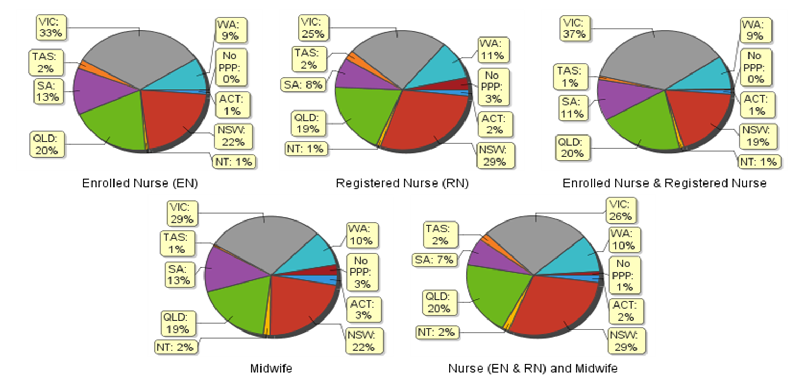

- Non-practising Registration
  - Totals for practitioners with non-practising registration as Nurse and/or Midwife
 | ACT | NSW | NT | QLD | SA | TAS | VIC | WA | No PPP | Total
Enrolled Nurse (EN) | 16 | 302 | 10 | 161 | 106 | 19 | 216 | 74 | 8 | 912
Registered Nurse (RN) | 53 | 1,421 | 27 | 497 | 259 | 87 | 600 | 283 | 314 | 3,541
EN & RN |  | 3 |  | 3 | 3 |  | 5 | 1 | 1 | 16
Midwife |  | 14 |  | 4 | 9 | 1 | 15 | 5 | 7 | 55
Nurse (EN & RN) and Midwife* | 16 | 305 | 1 | 82 | 31 | 7 | 85 | 37 | 27 | 591
* Practitioners with a Nurse and Midwife registration may be hold registration as an EN and Midwife, RN and Midwife, or EN and RN and Midwife.

  - Percentage of non-practising Registration by Principal Place of Practice
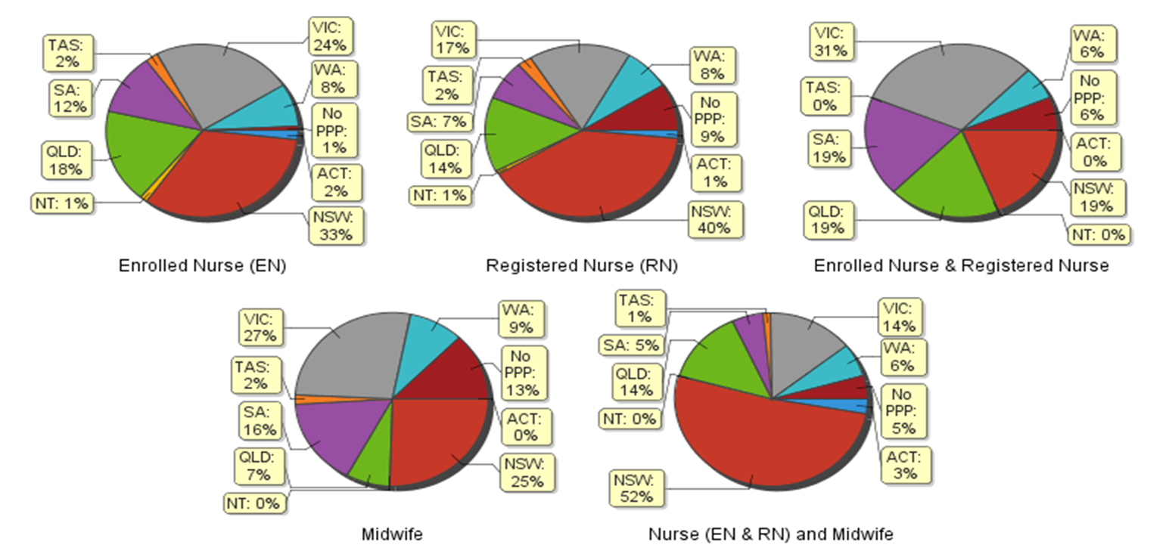
- Endorsements by Type
The NMBA endorsements for registered nurses are:
- Nurse Practitioner – includes prescribing scheduled medicines
- Registered Nurse - supply scheduled medicines (rural and isolated practice)
The NMBA endorsements for midwives are:
- Midwife – scheduled medicines
- Midwife Practitioner – refer Position-Statement Midwife Practitioners (7 April 2011)
  - Registered Nurse and Midwife – Endorsements by Type
Profession | Endorsement | ACT | NSW | NT | QLD | SA | TAS | VIC | WA | No PPP | Total
Nurse | Nurse Practitioner | 37 | 285 | 21 | 342 | 119 | 28 | 247 | 226 | 14 | 1,319
Nurse | Scheduled Medicines - Rural and isolated practice | 5 | 38 | 15 | 809 | 6 | 6 | 138 | 15 | 9 | 1,041
Midwife | Scheduled Medicines* | 2 | 34 | 2 | 81 | 22 | 3 | 43 | 34 |  | 221
Midwife | Midwife Practitioner |  | 1 |  |  |  |  |  |  |  | 1
* The above numbers under ‘Midwife Scheduled Medicines’ reflect those midwives who have met the NMBA Registration standard for endorsement for scheduled medicines for midwives they are also eligible for the Eligible midwife notation.
- Notations
Registered nurses with a sole qualification in mental health nursing or paediatric nursing or disability nursing - rather than a qualification in general nursing - are identified on the national register with a notation, which states: Solely qualified in the area of Disability Nursing / Mental Health Nursing / Paediatric Nursing.
  - Registered Nurse Notations
Notation | ACT | NSW | NT | QLD | SA | TAS | VIC | WA | No PPP | Total
Disability Nursing | 1 | 24 | 3 | 9 | 6 | 0 | 13 | 18 | 7 | 81
Mental Health nursing | 7 | 227 | 31 | 138 | 243 | 10 | 234 | 1,124 | 97 | 2,111
Paediatric Nursing | 5 | 128 | 3 | 56 | 18 | 2 | 60 | 152 | 41 | 465
Total | 13 | 379 | 37 | 203 | 267 | 12 | 307 | 1,294 | 145 | 2,657

The NMBA also recognises midwives that meet the requirements of the Eligible Midwife registration standard with a notation on their registration.
The notation states:
Eligible midwife competent to provide pregnancy, labour, birth and post natal care and qualified to provide the associated services and order diagnostic investigations required for midwifery practice, in accordance with relevant State and Territory legislation.
  - Midwife Notations
Notation | ACT | NSW | NT | QLD | SA | TAS | VIC | WA | No PPP | Total
Eligible Midwife* | 1 | 24 | 2 | 57 | 6 | 4 | 25 | 11 |  | 130
* The above numbers reflect those midwives with the Eligible midwife notation only. An Eligible midwife, may be qualified to apply for endorsement for scheduled medicines for midwives under section 94 to prescribe Schedule 2, 3, 4 & 8 medicines when they have completed a NMBA-approved program of study and meet the requirements of the NMBA Registration standard for endorsement for scheduled medicines for midwives.

Age Group
- General Registration
  - General Registration by Age Group
 | Nurse |  |  | Nurse & Midwife |  |  | Midwife
Age Group | EN | RN | EN & RN | EN | RN | EN & RN |  | Total | %
U - 25 | 4,385 | 13,187 | 395 | 1 | 472 | 6 | 361 | 18,807 | 5.16%
25 - 29 | 5,162 | 32,454 | 1,337 | 18 | 1,492 | 15 | 690 | 41,168 | 11.29%
30 - 34 | 5,025 | 33,838 | 946 | 7 | 1,865 | 10 | 603 | 42,294 | 11.60%
35 - 39 | 4,455 | 29,239 | 624 | 6 | 1,760 | 2 | 488 | 36,574 | 10.03%
40 - 44 | 5,635 | 33,634 | 598 | 12 | 2,407 | 7 | 548 | 42,841 | 11.75%
45 - 49 | 7,553 | 31,446 | 631 | 6 | 3,309 | 5 | 446 | 43,396 | 11.90%
50 - 54 | 9,479 | 30,501 | 574 | 4 | 5,231 | 7 | 275 | 46,071 | 12.63%
55 - 59 | 10,096 | 30,684 | 294 | 3 | 6,078 | 1 | 200 | 47,356 | 12.98%
60 - 64 | 6,206 | 20,486 | 112 | 1 | 4,140 | 1 | 114 | 31,060 | 8.52%
65 - 69 | 2,002 | 8,490 | 25 |  | 1,544 |  | 56 | 12,117 | 3.32%
70 - 74 | 340 | 1,842 | 1 |  | 338 |  | 13 | 2,534 | 0.69%
75 - 79 | 35 | 362 | 1 |  | 57 |  | 3 | 458 | 0.13%
80+ | 5 | 58 |  |  | 10 |  |  | 73 | 0.02%
Total | 60,378 | 266,221 | 5,538 | 58 | 28,703 | 54 | 3,797 | 364,749 | 100%

  - General Registration by Age Group
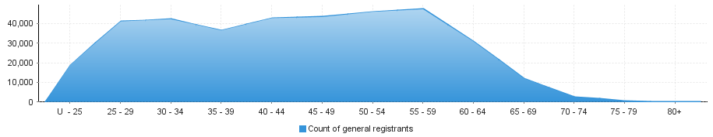

- Non-practising Registration
  - Non-practising Registration by Age Group
 | Nurse |  |  | Nurse & Midwife |  |  | Midwife
Age Group | EN | RN | EN & RN | EN | RN | EN & RN |  | Total | %
U - 25 | 24 | 46 | 1 |  |  |  |  | 71 | 1.39%
25 - 29 | 60 | 198 | 5 |  | 7 |  | 9 | 279 | 5.45%
30 - 34 | 56 | 328 | 1 | 1 | 18 |  | 8 | 412 | 8.05%
35 - 39 | 61 | 346 |  |  | 13 |  | 9 | 429 | 8.39%
40 - 44 | 82 | 374 |  |  | 40 |  | 4 | 500 | 9.78%
45 - 49 | 102 | 359 | 1 |  | 45 |  | 7 | 514 | 10.05%
50 - 54 | 157 | 391 | 5 |  | 68 |  | 5 | 626 | 12.24%
55 - 59 | 182 | 498 | 2 |  | 113 |  | 5 | 800 | 15.64%
60 - 64 | 136 | 501 |  |  | 138 |  | 5 | 780 | 15.25%
65 - 69 | 43 | 337 |  |  | 98 |  | 1 | 479 | 9.36%
70 - 74 | 9 | 116 |  |  | 36 |  | 2 | 163 | 3.19%
75 - 79 |  | 37 | 1 |  | 8 |  |  | 46 | 0.90%
80+ |  | 10 |  |  | 6 |  |  | 16 | 0.31%
Total | 912 | 3,541 | 16 | 1 | 590 | 0 | 55 | 5,115 | 100%

  - Non-practising Registration by Age Group
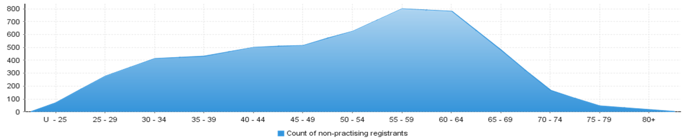
Gender
- General Registration
  - General Registration by Gender
Profession | Gender | Divisions | ACT | NSW | NT | QLD | SA | TAS | VIC | WA | No PPP | Total
Nurse | Female | Enrolled Nurse (EN) | 605 | 11,662 | 315 | 10,790 | 7,007 | 1,304 | 17,959 | 4,894 | 75 | 54,611
Nurse | Female | Registered Nurse (RN) | 3,851 | 66,128 | 2,697 | 45,621 | 19,047 | 5,624 | 58,762 | 25,352 | 7,554 | 234,636
Nurse | Female | EN & RN | 52 | 893 | 52 | 986 | 520 | 54 | 1,735 | 443 | 26 | 4,761
Nurse | Total Female General Nurse |  | 4,508 | 78,683 | 3,064 | 57,397 | 26,574 | 6,982 | 78,456 | 30,689 | 7,655 | 294,008
Nurse | Male | Enrolled Nurse (EN) | 61 | 1,493 | 69 | 1,167 | 701 | 127 | 1,779 | 353 | 17 | 5,767
Nurse | Male | Registered Nurse (RN) | 553 | 10,014 | 491 | 5,867 | 2,598 | 792 | 7,259 | 2,753 | 1,258 | 31,585
Nurse | Male | EN & RN | 10 | 171 | 5 | 146 | 97 | 3 | 298 | 47 |  | 777
Nurse | Total Male General Nurse |  | 624 | 11,678 | 565 | 7,180 | 3,396 | 922 | 9,336 | 3,153 | 1,275 | 38,129
Total General Nurse |  |  | 5,132 | 90,361 | 3,629 | 64,577 | 29,970 | 7,904 | 87,792 | 33,842 | 8,930 | 332,137
Nurse & Midwife* | Female | EN & Midwife | 3 | 4 |  | 12 | 3 |  | 35 |  |  | 57
Nurse & Midwife* | Female | RN & Midwife | 537 | 8,167 | 501 | 5,722 | 2,032 | 619 | 7,456 | 2,878 | 289 | 28,201
Nurse & Midwife* | Female | EN & RN & Midwife | 1 | 9 | 1 | 3 | 2 |  | 28 | 9 |  | 53
Nurse & Midwife* | Total Female General NMW |  | 541 | 8,180 | 502 | 5,737 | 2,037 | 619 | 7,519 | 2,887 | 289 | 28,311
Nurse & Midwife* | Male | EN & Midwife |  |  |  | 1 |  |  |  |  |  | 1
Nurse & Midwife* | Male | RN & Midwife | 12 | 176 | 26 | 98 | 46 | 15 | 78 | 43 | 8 | 502
Nurse & Midwife* | Male | EN & RN & Midwife |  | 1 |  |  |  |  |  |  |  | 1
Nurse & Midwife* | Total Male General NMW |  | 12 | 177 | 26 | 99 | 46 | 15 | 78 | 43 | 8 | 504
Total General NMW |  |  | 553 | 8,357 | 528 | 5,836 | 2,083 | 634 | 7,597 | 2,930 | 297 | 28,815
Midwife | Female |  | 102 | 848 | 63 | 709 | 482 | 19 | 1,086 | 362 | 111 | 3,782
Midwife | Male |  | 1 | 5 | 1 | 2 | 1 | 1 | 3 |  | 1 | 15
Total General Midwife |  |  | 103 | 853 | 64 | 711 | 483 | 20 | 1,089 | 362 | 112 | 3,797
Total |  |  | 5,788 | 99,571 | 4,221 | 71,124 | 32,536 | 8,558 | 96,478 | 37,134 | 9,339 | 364,749
* Practitioners with a Nurse and Midwife registration may be hold registration as an EN and Midwife, RN and Midwife, or EN and RN and Midwife.

  - Total General Registration by Gender
Gender | ACT | NSW | NT | QLD | SA | TAS | VIC | WA | No PPP | Total
Female | 5,151 | 87,711 | 3,629 | 63,843 | 29,093 | 7,620 | 87,061 | 33,938 | 8,055 | 326,101
Male | 637 | 11,860 | 592 | 7,281 | 3,443 | 938 | 9,417 | 3,196 | 1,284 | 38,648

  - Total General Registration by Gender Percentages
Gender | ACT | NSW | NT | QLD | SA | TAS | VIC | WA | No PPP | Total
Female | 88.99% | 88.09% | 85.97% | 89.76% | 89.42% | 89.04% | 90.24% | 91.39% | 86.25% | 89.45%
Male | 11.01% | 11.91% | 14.03% | 10.24% | 10.58% | 10.96% | 9.76% | 8.61% | 13.75% | 10.55%

- Non-practising Registration
  - Non-practising Registration by Gender
Profession | Gender | Divisions | ACT | NSW | NT | QLD | SA | TAS | VIC | WA | No PPP | Total
Nurse | Female | Enrolled Nurse (EN) | 15 | 279 | 10 | 154 | 100 | 17 | 201 | 74 | 6 | 856
Nurse | Female | Registered Nurse (RN) | 46 | 1,287 | 27 | 457 | 229 | 79 | 557 | 263 | 288 | 3,233
Nurse | Female | EN & RN |  | 3 |  | 2 | 2 |  | 5 | 1 | 1 | 14
Nurse | Total Female Non-practising Nurse |  | 61 | 1,569 | 37 | 613 | 331 | 96 | 763 | 338 | 295 | 4,103
Nurse | Male | Enrolled Nurse (EN) | 1 | 23 |  | 7 | 6 | 2 | 15 |  | 2 | 56
Nurse | Male | Registered Nurse (RN) | 7 | 134 |  | 40 | 30 | 8 | 43 | 20 | 26 | 308
Nurse | Male | EN & RN |  |  |  | 1 | 1 |  |  |  |  | 2
Nurse | Total Male Non-practising Nurse |  | 8 | 157 |  | 48 | 37 | 10 | 58 | 20 | 28 | 366
Total Non-practising Nurse |  |  | 69 | 1,726 | 37 | 661 | 368 | 106 | 821 | 358 | 323 | 4,469
Nurse & Midwife | Female | EN & Midwife |  |  |  |  |  |  | 1 |  |  | 1
Nurse & Midwife | Female | RN & Midwife | 16 | 300 | 1 | 81 | 31 | 6 | 84 | 36 | 26 | 581
Nurse & Midwife | Total Female Non-practising NMW |  | 16 | 300 | 1 | 81 | 31 | 6 | 85 | 36 | 26 | 582
Nurse & Midwife | Male | RN & Midwife |  | 5 |  | 1 |  | 1 |  | 1 | 1 | 9
Nurse & Midwife | Total Male Non-practising NMW |  |  | 5 |  | 1 |  | 1 |  | 1 | 1 | 9
Total Non-practising NMW |  |  | 16 | 305 | 1 | 82 | 31 | 7 | 85 | 37 | 27 | 591
Midwife | Female |  |  | 14 |  | 4 | 9 | 1 | 15 | 5 | 7 | 55
Midwife | Male |  |  |  |  |  |  |  |  |  |  | 0
Total Non-practising Midwife |  |  |  | 14 |  | 4 | 9 | 1 | 15 | 5 | 7 | 55
Total |  |  | 85 | 2,045 | 38 | 747 | 408 | 114 | 921 | 400 | 357 | 5,115

  - Total Non-practising Registration by Gender
Gender | ACT | NSW | NT | QLD | SA | TAS | VIC | WA | No PPP | Total
Female | 77 | 1,883 | 38 | 698 | 371 | 103 | 863 | 379 | 328 | 4,740
Male | 8 | 162 | 0 | 49 | 37 | 11 | 58 | 21 | 29 | 375

  - Total Non-practising Registration by Gender Percentages
Gender | ACT | NSW | NT | QLD | SA | TAS | VIC | WA | No PPP | Total
Female | 90.59% | 92.08% | 100.00% | 93.44% | 90.93% | 90.35% | 93.70% | 94.75% | 91.88% | 89.45%
Male | 9.41% | 7.92% | 0.00% | 6.56% | 9.07% | 9.65% | 6.30% | 5.25% | 8.12% | 10.55%

Note that the data for dual registration in the tables and diagrams includes where a nurse or a midwife may be non-practising in one category, for example enrolled nurse (non-practising) & registered nurse (practising) or nurse (non-practising) & midwife (practising).

