

Nursing and Midwifery Board of Australia

Registrant data

Reporting period: 1 April 2018 – 30 June 2018

Table of contents
Introduction 3
Introduction 4
Principal place of practice 5
1. Registration type 5
2. General Registration 7
3. Non-practising Registration 8
4. Provisional Registration 9
5. Notations 10
Age group 11
6. General registration 11
7. Non-practising registration 12
8. Provisional registration 13
Gender 14
9. General Registration 14
10. Non-practising Registration 16
11. Provisional Registration 18

Introduction
This report contains registration information about nurses and midwives registered with the Nursing and Midwifery Board of Australia (NMBA).
The functions of the NMBA are defined under the National Law, and include:
- Registering nurses, midwives and students of nursing and midwifery
- Determining national registration requirements
- Developing professional codes, standards, guidelines and position statements to guide the practice of nurses and midwives
- Managing notifications, investigations and panel hearings
- Overseeing the assessment of internationally qualified nurses and midwives who wish to register in Australia
- Approving national accreditation standards and accredited programs of study leading to registration and endorsement
- Delegating to state and territory boards and committees of the NMBA, and AHPRA staff, the power to determine individual applications for registration and notification of a nurse’s or midwife’s health, performance and/or conduct, and a student’s health or criminal history

*Co-regulatory models apply in New South Wales (NSW) and Queensland (QLD). In NSW, notifications are managed separately by the Nursing and Midwifery Council of NSW; the NSW Board of the NMBA only manages registration matters. In QLD, notifications are received by the Office of the Health Ombudsman (OHO), who determines which notifications should be managed by the NMBA.
The NMBA’s functions are supported by the Australian Health Practitioner Regulation Agency (AHPRA). For information about legislation governing the NMBA and AHPRA, see AHPRA's Legislation & Publications at www.ahpra.gov.au/Legislation-and-Publications.aspx
AHPRA has analysed the NMBA’s registration data and produced a number of statistical tables about registrants to share with the professions and community. This report is updated on a quarterly basis.
For more information on nursing and midwifery registration, please see the NMBA’s website: www.nursingmidwiferyboard.gov.au/Registration-and-Endorsement.aspx

Principal place of practice
- Registration type
Registration type by principal place of practice*
Profession | Registration type | Divisions |  | ACT | NSW | NT | QLD | SA | TAS | VIC | WA | No PPP | Total
Nurse | General | Enrolled Nurse (EN) |  | 708 | 13,833 | 429 | 13,515 | 7,933 | 1,589 | 20,966 | 5,533 | 124 | 64,630
Nurse | General | Registered Nurse (RN) |  | 4,980 | 83,585 | 3,526 | 58,211 | 22,335 | 7,080 | 72,974 | 29,552 | 9,821 | 292,064
Nurse | General | EN & RN |  | 88 | 1,432 | 64 | 1,645 | 826 | 81 | 2,999 | 730 | 33 | 7,898
Nurse | Total General Nurse |  |  | 5,776 | 98,850 | 4,019 | 73,371 | 31,094 | 8,750 | 96,939 | 35,815 | 9,978 | 364,592
Nurse | Non-practising | Enrolled Nurse (EN) |  | 18 | 317 | 8 | 212 | 145 | 25 | 283 | 88 | 16 | 1,112
Nurse | Non-practising | Registered Nurse (RN) |  | 77 | 1,518 | 24 | 710 | 341 | 111 | 777 | 341 | 482 | 4,381
Nurse | Non-practising | EN & RN |  |  | 5 |  | 7 | 4 | 1 | 10 | 1 | 5 | 33
Nurse | Total Non-practising Nurse |  |  | 95 | 1,840 | 32 | 929 | 490 | 137 | 1,070 | 430 | 503 | 5,526
Nurse | Provisional |  | Enrolled Nurse (EN) | 3 | 6 |  | 8 | 4 | 2 | 17 | 7 |  | 47
Nurse |  |  | Registered Nurse (RN) | 2 | 38 |  | 30 | 16 | 6 | 35 | 26 | 1 | 154
Nurse | Total Provisional Nurse |  |  | 5 | 44 | 0 | 38 | 20 | 8 | 52 | 33 | 1 | 201
Total Nurse |  |  |  | 5,876 | 100,734 | 4,051 | 74,338 | 31,604 | 8,895 | 98,061 | 36,278 | 10,482 | 370,319
Table 1.1 (continued from page 4)
Profession | Registration type | Divisions |  | ACT | NSW | NT | QLD | SA | TAS | VIC | WA | No PPP | Total
Nurse & Midwife | General | EN & Midwife |  | 1 | 8 | 3 | 26 | 8 |  | 33 | 2 |  | 81
Nurse & Midwife | General | RN & Midwife |  | 507 | 7,705 | 486 | 5,697 | 1,863 | 627 | 7,432 | 2,824 | 307 | 27,448
Nurse & Midwife | General | EN & RN & Midwife |  |  | 19 | 2 | 7 | 2 | 2 | 34 | 13 |  | 79
Nurse & Midwife | Total General NMW |  |  | 508 | 7,732 | 491 | 5,730 | 1,873 | 629 | 7,499 | 2,839 | 307 | 27,608
Nurse & Midwife | Non-practising | EN & Midwife |  |  |  |  |  |  |  | 1 |  |  | 1
Nurse & Midwife | Non-practising | RN & Midwife |  | 20 | 290 |  | 95 | 41 | 10 | 128 | 46 | 29 | 659
Nurse & Midwife | Total Non-practising NMW |  |  | 20 | 290 | 0 | 95 | 41 | 10 | 129 | 46 | 29 | 660
Nurse & Midwife | Provisional |  | Registered Nurse (RN) |  | 2 |  | 5 |  |  | 1 | 1 |  | 9
Nurse & Midwife | Total Provisional NMW |  |  | 0 | 2 | 0 | 5 | 0 | 0 | 1 | 1 | 0 | 9
Total NMW |  |  |  | 528 | 8,024 | 491 | 5,830 | 1,914 | 639 | 7,629 | 2,886 | 336 | 28,277
Midwife | General |  |  | 168 | 1,179 | 86 | 1,048 | 633 | 34 | 1,351 | 431 | 198 | 5,128
Midwife | Non-practising |  |  |  | 19 | 1 | 9 | 9 |  | 24 | 7 | 8 | 77
Midwife | Provisional |  |  |  | 1 |  |  | 1 |  | 2 |  |  | 4
Total Midwife |  |  |  | 168 | 1,199 | 87 | 1,057 | 643 | 34 | 1,377 | 438 | 206 | 5,209
Total |  |  |  | 6,572 | 109,957 | 4,629 | 81,225 | 34,161 | 9,568 | 107,067 | 39,602 | 11,024 | 403,805
* The Nursing and Midwifery Board introduced Provisional Registration for Nurses and Midwives in September 2015. Data about the number of provisional registrants is included in this June 2018 report.

- General Registration
Table 2.1 Totals for practitioners with general registration as Nurse and/or Midwife
 | ACT | NSW | NT | QLD | SA | TAS | VIC | WA | No PPP | Total
Enrolled Nurse (EN) | 708 | 13,833 | 429 | 13,515 | 7,933 | 1,589 | 20,966 | 5,533 | 124 | 64,630
Registered Nurse (RN) | 4,980 | 83,585 | 3,526 | 58,211 | 22,335 | 7,080 | 72,974 | 29,552 | 9,821 | 292,064
EN & RN | 88 | 1,432 | 64 | 1,645 | 826 | 81 | 2,999 | 730 | 33 | 7,898
Midwife | 168 | 1,179 | 86 | 1,048 | 633 | 34 | 1,351 | 431 | 198 | 5,128
Nurse (EN & RN) and Midwife* | 508 | 7,732 | 491 | 5,730 | 1,873 | 629 | 7,499 | 2,839 | 307 | 27,608
* Practitioners with a Nurse and Midwife registration may hold registration as an EN and Midwife, RN and Midwife, or EN and RN and Midwife.

Percentage of general registration by principal place of practice

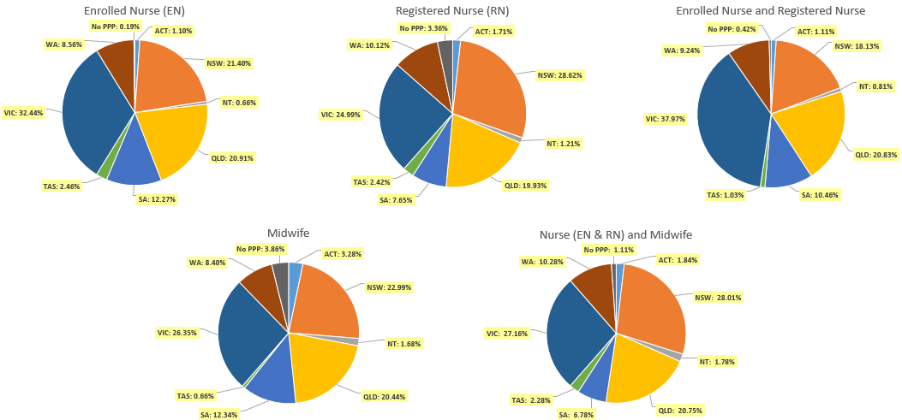

- Non-practising Registration
Totals for practitioners with non-practising registration as Nurse and/or Midwife
Division | ACT | NSW | NT | QLD | SA | TAS | VIC | WA | No PPP | Total
Enrolled Nurse (EN) | 18 | 317 | 8 | 212 | 145 | 25 | 283 | 88 | 16 | 1,112
Registered Nurse (RN) | 77 | 1,518 | 24 | 710 | 341 | 111 | 777 | 341 | 482 | 4,381
EN & RN |  | 5 |  | 7 | 4 | 1 | 10 | 1 | 5 | 33
Midwife |  | 19 | 1 | 9 | 9 |  | 24 | 7 | 8 | 77
Nurse (EN & RN) and Midwife* | 20 | 290 |  | 95 | 41 | 10 | 129 | 46 | 29 | 660
* Practitioners with a Nurse and Midwife registration may hold registration as an EN and Midwife, RN and Midwife, or EN and RN and Midwife.
Percentage of non-practising registration by principal place of practice

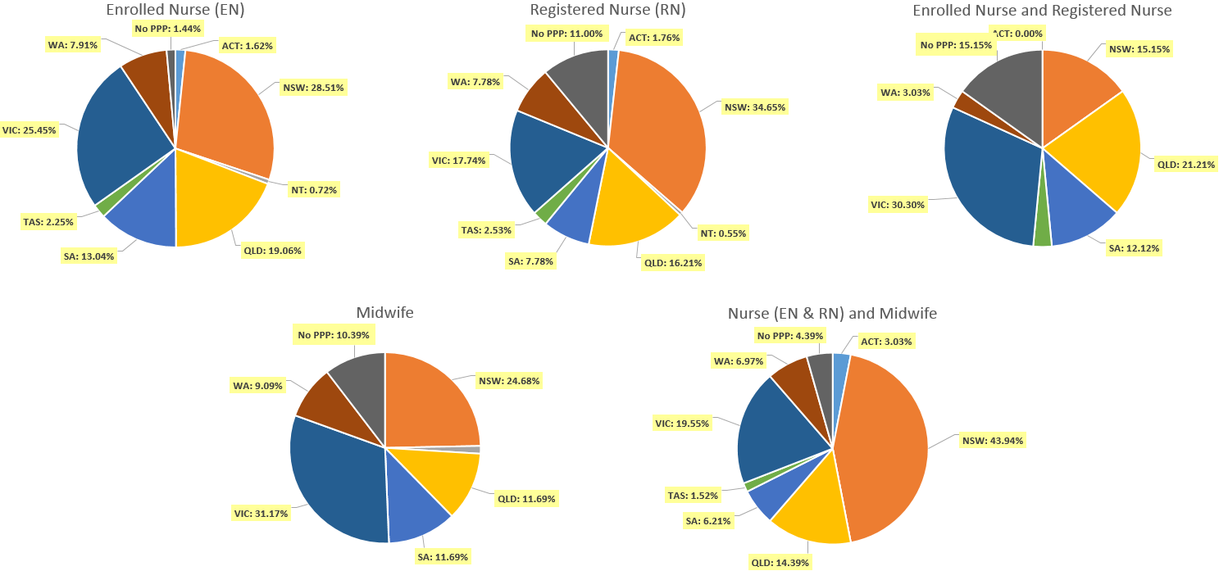

- Provisional Registration
Provisional registration is a registration type used by the NMBA for registered nurses, enrolled nurses and/or midwives who want to return to the register after an absence from practice. Provisional registration enables a registered nurse, enrolled nurse and/or midwife to complete a period of supervised practice or a NMBA-approved re-entry to practice program to be eligible for general registration.

Table 4.1 Totals for practitioners with provisional registration as Nurse and/or Midwife
Division | ACT | NSW | NT | QLD | SA | TAS | VIC | WA | No PPP | Total
Enrolled Nurse (EN) | 3 | 6 |  | 8 | 4 | 2 | 17 | 7 |  | 47
Registered Nurse (RN) | 2 | 38 |  | 30 | 16 | 6 | 35 | 26 | 1 | 154
Midwife |  | 1 |  |  | 1 |  | 2 |  |  | 4
Nurse (EN & RN) and Midwife* |  | 2 |  | 5 |  |  | 1 | 1 |  | 9
* Practitioners with a Nurse and Midwife registration may hold registration as an EN and Midwife, RN and Midwife, or EN and RN and Midwife.
Table 4.2 Percentage of provisional by principal place of practice

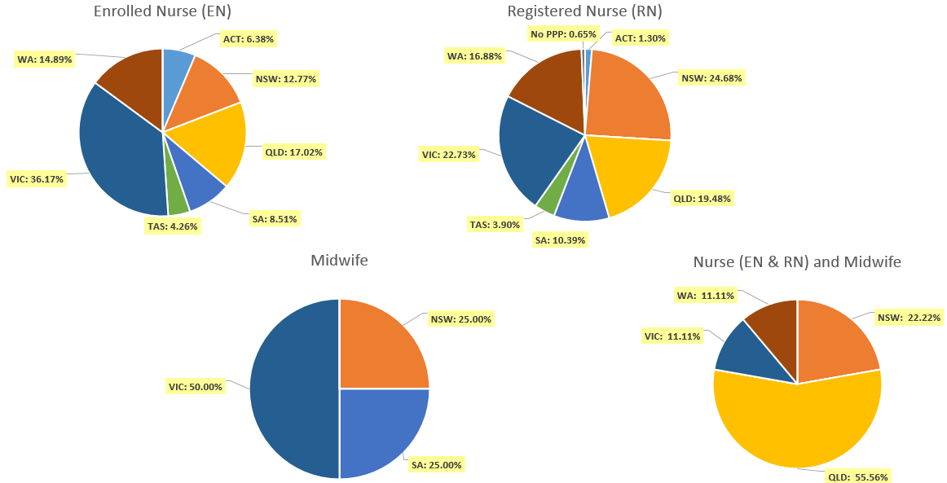

Endorsements by Type
The NMBA endorsements for registered nurses are:
- Nurse Practitioner
- Registered Nurse - scheduled medicines (rural and isolated practice)
The NMBA endorsements for midwives are:
- Midwife – scheduled medicines
- Midwife Practitioner – refer Position-Statement Midwife Practitioners (7 April 2011)
Table 5.1 Registered Nurse and Midwife – Endorsements by principal place of practice
Profession | Endorsement | ACT | NSW | NT | QLD | SA | TAS | VIC | WA | No PPP | Total
Nurse | Nurse Practitioner | 43 | 399 | 29 | 447 | 141 | 41 | 356 | 249 | 24 | 1,729
Nurse | Scheduled Medicines - Rural and isolated practice | 7 | 44 | 27 | 823 | 10 | 8 | 179 | 27 | 10 | 1,135
Midwife | Scheduled Medicines* | 4 | 65 | 5 | 156 | 41 | 11 | 76 | 70 | 1 | 429
Midwife | Midwife Practitioner |  | 1 |  |  |  |  |  |  |  | 1
Total |  | 54 | 509 | 61 | 1,426 | 192 | 60 | 611 | 346 | 35 | 3,294
* The above numbers under ‘Midwife Scheduled Medicines’ reflect those midwives who have met the NMBA Registration standard for endorsement for scheduled medicines for midwives.
- Notations
Registered nurses with a sole qualification in mental health nursing or paediatric nursing or disability nursing - rather than a qualification in general nursing - are identified on the national register with a notation, which states: Solely qualified in the area of Disability Nursing / Mental Health Nursing / Paediatric Nursing.
Table 6.1 Registered Nurse notations
Notation | ACT | NSW | NT | QLD | SA | TAS | VIC | WA | No PPP | Total
Disability Nursing |  | 40 | 2 | 10 | 5 |  | 12 | 23 | 19 | 111
Mental health nursing | 8 | 273 | 26 | 198 | 216 | 17 | 308 | 1,051 | 161 | 2,258
Paediatric Nursing | 3 | 137 | 2 | 115 | 15 | 2 | 89 | 159 | 73 | 595
Total | 11 | 450 | 30 | 323 | 236 | 19 | 409 | 1,233 | 253 | 2,964
The NMBA also recognises midwives that meet the requirements of the Eligible Midwife registration standard with a notation on their registration.
The notation states:
Eligible midwife competent to provide pregnancy, labour, birth and post-natal care and qualified to provide the associated services and order diagnostic investigations required for midwifery practice, in accordance with relevant State and Territory legislation.
Table 6.2 Midwife notations
Notation | ACT | NSW | NT | QLD | SA | TAS | VIC | WA | No PPP | Total
Eligible Midwife* | 1 | 1 |  | 4 |  |  | 2 | 2 |  | 10
* The above numbers reflect those midwives with the Eligible midwife notation only. An Eligible midwife, may be qualified to apply for endorsement for scheduled medicines for midwives under section 94 to prescribe Schedule 2, 3, 4 & 8 medicines when they have completed a NMBA-approved program of study and meet the requirements of the NMBA Registration standard for endorsement for scheduled medicines for midwives.
Age group
- General registration
Table 7.1 General registration by age group
 | Nurse |  |  | Nurse & Midwife |  |  | Midwife | Total
Age group | EN | RN | EN & RN | EN | RN | EN & RN | Midwife | Total | % age bracket
U - 25 | 4,921 | 12,226 | 414 | 2 | 447 | 2 | 380 | 18,392 | 4.6%
25 - 29 | 6,294 | 34,055 | 1,616 | 9 | 1,623 | 26 | 925 | 44,548 | 11.2%
30 - 34 | 6,104 | 43,233 | 1,653 | 21 | 1,969 | 13 | 866 | 53,859 | 13.6%
35 - 39 | 5,430 | 33,693 | 1,034 | 14 | 1,894 | 12 | 738 | 42,815 | 10.8%
40 - 44 | 5,227 | 31,954 | 845 | 11 | 2,019 | 7 | 639 | 40,702 | 10.2%
45 - 49 | 6,837 | 34,693 | 832 | 14 | 2,780 | 7 | 588 | 45,751 | 11.5%
50 - 54 | 8,286 | 29,951 | 696 | 5 | 3,702 | 6 | 417 | 43,063 | 10.8%
55 - 59 | 9,922 | 31,318 | 539 | 4 | 5,577 | 4 | 285 | 47,649 | 12.0%
60 - 64 | 7,858 | 25,275 | 200 | 1 | 4,749 | 2 | 189 | 38,274 | 9.6%
65 - 69 | 3,046 | 11,763 | 58 |  | 2,061 |  | 74 | 17,002 | 4.3%
70 - 74 | 618 | 3,225 | 9 |  | 510 |  | 24 | 4,386 | 1.1%
75 - 79 | 72 | 562 | 2 |  | 101 |  | 3 | 740 | 0.2%
80+ | 15 | 116 |  |  | 16 |  |  | 147 | <0.1%
Total | 64,630 | 292,064 | 7,898 | 81 | 27,448 | 79 | 5,128 | 397,328 | 100.0%

Table 7.2 General registration by age group
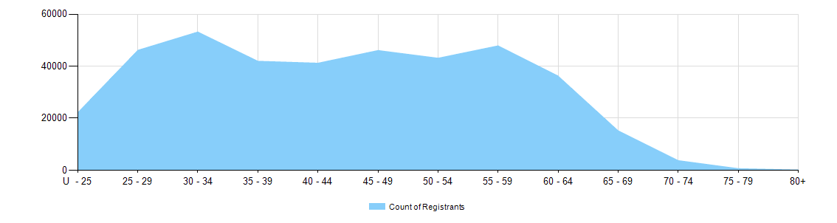

- Non-practising registration
Table 8.1 Non-practising registration by age group
 | Nurse |  |  | Nurse & Midwife
Age group | EN | RN | EN & RN | EN | RN | EN & RN | Midwife | Total | % age bracket
U - 25 | 30 | 31 |  |  |  |  | 2 | 63 | 1.0%
25 - 29 | 73 | 252 | 5 |  | 7 |  | 9 | 346 | 5.5%
30 - 34 | 67 | 355 | 7 | 1 | 11 |  | 7 | 448 | 7.2%
35 - 39 | 89 | 418 | 4 |  | 25 |  | 11 | 547 | 8.7%
40 - 44 | 78 | 376 | 2 |  | 23 |  | 10 | 489 | 7.8%
45 - 49 | 124 | 429 | 2 |  | 47 |  | 5 | 607 | 9.7%
50 - 54 | 155 | 406 | 4 |  | 38 |  | 8 | 611 | 9.8%
55 - 59 | 195 | 532 | 3 |  | 94 |  | 9 | 833 | 13.3%
60 - 64 | 186 | 733 | 3 |  | 165 |  | 11 | 1,098 | 17.5%
65 - 69 | 90 | 526 | 2 |  | 158 |  | 2 | 778 | 12.4%
70 - 74 | 19 | 225 | 1 |  | 60 |  | 2 | 307 | 4.9%
75 - 79 | 6 | 71 |  |  | 23 |  |  | 100 | 1.6%
80+ |  | 27 |  |  | 8 |  | 1 | 36 | 0.6%
Total | 1,112 | 4,381 | 33 | 1 | 659 | 0 | 77 | 6,263 | 100.0%

Table 8.2 Non-practising registration by age group

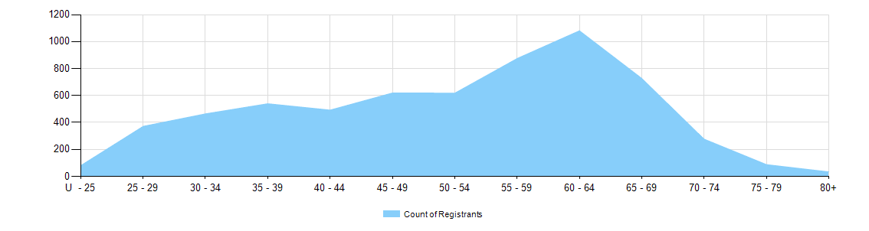
- Provisional registration
Provisional registration is a registration type used by the NMBA for registered nurses, enrolled nurses and/or midwives who want to return to the register after an absence from practice. Provisional registration enables a registered nurse, enrolled nurse and/or midwife to complete a period of supervised practice or a NMBA-approved re-entry to practice program to be eligible for general registration.

Table 9.1 Provisional registration by age group
 | Nurse |  |  | Nurse & Midwife
Age group | EN | RN | EN & RN | EN | RN | EN & RN | Midwife | Total | % age bracket
U - 25 |  |  |  |  |  |  |  | 0 | 0%
25 - 29 | 1 | 3 |  |  |  |  |  | 4 | 1.9%
30 - 34 | 7 | 18 |  |  | 2 |  |  | 27 | 12.6%
35 - 39 | 8 | 42 |  |  | 1 |  | 1 | 52 | 24.3%
40 - 44 | 7 | 28 |  |  | 2 |  | 1 | 38 | 17.8%
45 - 49 | 10 | 27 |  |  | 1 |  | 2 | 40 | 18.7%
50 - 54 | 6 | 18 |  |  | 1 |  |  | 25 | 11.7%
55 - 59 | 3 | 13 |  |  | 1 |  |  | 17 | 7.9%
60 - 64 | 4 | 2 |  |  | 1 |  |  | 7 | 3.3%
65 - 69 |  | 1 |  |  |  |  |  | 1 | 0.5%
70 - 74 | 1 | 2 |  |  |  |  |  | 3 | 1.4%
75 - 79 |  |  |  |  |  |  |  | 0 | 0%
80+ |  |  |  |  |  |  |  | 0 | 0%
Total | 47 | 154 | 0 | 0 | 9 | 0 | 4 | 214 | 100.0%

Tale 9.2 Provisional registration by age group

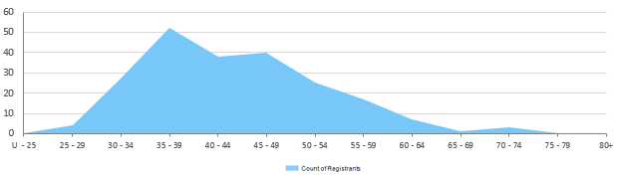

Gender
- General Registration
Table 10.1 General registration by gender
Profession | Gender | Divisions |  | ACT | NSW | NT | QLD | SA | TAS | VIC | WA | No PPP | Total
Nurse | Female | Enrolled Nurse (EN) |  | 625 | 12,249 | 354 | 12,118 | 7,185 | 1,442 | 18,958 | 5,096 | 108 | 58,135
Nurse | Female | Registered Nurse (RN) |  | 4,306 | 72,227 | 2,975 | 51,434 | 19,650 | 6,201 | 64,547 | 26,665 | 8,331 | 256,336
Nurse | Female | EN & RN |  | 73 | 1,218 | 52 | 1,435 | 670 | 75 | 2,589 | 664 | 31 | 6,807
Nurse | Total female General Nurse |  |  | 5,004 | 85,694 | 3,381 | 64,987 | 27,505 | 7,718 | 86,094 | 32,425 | 8,470 | 321,278
Nurse | Male | Enrolled Nurse (EN) |  | 83 | 1,584 | 75 | 1,397 | 748 | 147 | 2,008 | 437 | 16 | 6,495
Nurse | Male | Registered Nurse (RN) |  | 674 | 11,356 | 551 | 6,776 | 2,685 | 879 | 8,427 | 2,887 | 1,490 | 35,725
Nurse | Male | EN & RN |  | 15 | 214 | 12 | 210 | 156 | 6 | 410 | 66 | 2 | 1,091
Nurse | Total male General Nurse |  |  | 772 | 13,154 | 638 | 8,383 | 3,589 | 1,032 | 10,845 | 3,390 | 1,508 | 43,311
Nurse | Intersex or Indeterminate |  | Registered Nurse (RN) |  | 2 |  | 1 |  |  |  |  |  | 3
Total General Nurse |  |  |  | 5,776 | 98,850 | 4,019 | 73,371 | 31,094 | 8,750 | 96,939 | 35,815 | 9,978 | 364,592
Nurse & Midwife* | Female | EN & Midwife |  | 1 | 8 | 2 | 25 | 8 |  | 33 | 2 |  | 79
Nurse & Midwife* | Female | RN & Midwife |  | 499 | 7,535 | 456 | 5,609 | 1,822 | 613 | 7,364 | 2,781 | 301 | 26,980
Nurse & Midwife* | Female | EN & RN & Midwife |  |  | 18 | 2 | 7 | 2 | 2 | 34 | 13 |  | 78
Nurse & Midwife* | Total female General NMW |  |  | 500 | 7,561 | 460 | 5,641 | 1,832 | 615 | 7,431 | 2,796 | 301 | 27,137
Nurse & Midwife* | Male | EN & Midwife |  |  |  | 1 | 1 |  |  |  |  |  | 2
Nurse & Midwife* | Male | RN & Midwife |  | 8 | 170 | 30 | 88 | 41 | 14 | 68 | 43 | 6 | 468
Nurse & Midwife* | Male | EN & RN & Midwife |  |  | 1 |  |  |  |  |  |  |  | 1
Nurse & Midwife* | Total male General NMW |  |  | 8 | 171 | 31 | 89 | 41 | 14 | 68 | 43 | 6 | 471
Total General NMW |  |  |  | 508 | 7,732 | 491 | 5,730 | 1,873 | 629 | 7,499 | 2,839 | 307 | 27,608
Midwife | Female |  |  | 167 | 1,173 | 85 | 1,047 | 631 | 32 | 1,345 | 431 | 198 | 5,109
Midwife | Male |  |  | 1 | 6 | 1 | 1 | 2 | 2 | 6 |  |  | 19
Total General Midwife |  |  |  | 168 | 1,179 | 86 | 1,048 | 633 | 34 | 1,351 | 431 | 198 | 5,128
Total |  |  |  | 6,452 | 107,761 | 4,596 | 80,149 | 33,600 | 9,413 | 105,789 | 39,085 | 10,483 | 397,328
* Practitioners with a Nurse and Midwife registration may hold registration as an EN and Midwife, RN and Midwife, or EN and RN and Midwife.

Table 10.2 Total general registration by gender
Gender | ACT | NSW | NT | QLD | SA | TAS | VIC | WA | No PPP | Total
Female | 5,671 | 94,428 | 3,926 | 71,675 | 29,968 | 8,365 | 94,870 | 35,652 | 8,969 | 353,524
Male | 781 | 13,331 | 670 | 8,473 | 3,632 | 1,048 | 10,919 | 3,433 | 1,514 | 43,801
Intersex or Indeterminate |  | 2 |  | 1 |  |  |  |  |  | 3

Table 10.3 Total general registration by gender percentages
Gender | ACT | NSW | NT | QLD | SA | TAS | VIC | WA | No PPP | Total
Female | 87.9% | 87.6% | 85.4% | 89.4% | 89.2% | 88.9% | 89.7% | 91.2% | 85.6% | 89.0%
Male | 12.1% | 12.4% | 14.6% | 10.6% | 10.8% | 11.1% | 10.3% | 8.8% | 14.4% | 11.0%
Intersex or Indeterminate |  | <0.1% |  | <0.1% |  |  |  |  |  | <0.1%

- Non-practising Registration
Table 11.1 Non-practising registration by gender
Profession | Gender | Divisions |  | ACT | NSW | NT | QLD | SA | TAS | VIC | WA | No PPP | Total
Nurse | Female | Enrolled Nurse (EN) |  | 17 | 287 | 7 | 201 | 138 | 23 | 267 | 84 | 16 | 1,040
Nurse | Female | Registered Nurse (RN) |  | 67 | 1,375 | 21 | 646 | 301 | 104 | 705 | 325 | 434 | 3,978
Nurse | Female | EN & RN |  |  | 5 |  | 6 | 3 | 1 | 9 | 1 | 4 | 29
Nurse | Total Female  Non-practising Nurse |  |  | 84 | 1,667 | 28 | 853 | 442 | 128 | 981 | 410 | 454 | 5,047
Nurse | Male | Enrolled Nurse (EN) |  | 1 | 30 | 1 | 11 | 7 | 2 | 16 | 4 |  | 72
Nurse | Male | Registered Nurse (RN) |  | 10 | 143 | 3 | 64 | 40 | 7 | 72 | 16 | 48 | 403
Nurse | Male | EN & RN |  |  |  |  | 1 | 1 |  | 1 |  | 1 | 4
Nurse | Total Male  Non-practising Nurse |  |  | 11 | 173 | 4 | 76 | 48 | 9 | 89 | 20 | 49 | 479
Total Non-practising Nurse |  |  |  | 95 | 1,840 | 32 | 929 | 490 | 137 | 1,070 | 430 | 503 | 5,526
Nurse & Midwife | Female | EN & Midwife |  |  |  |  |  |  |  | 1 |  |  | 1
Nurse & Midwife | Female | RN & Midwife |  | 19 | 282 |  | 93 | 41 | 10 | 128 | 46 | 29 | 648
Nurse & Midwife | Total Female  Non-practising NMW |  |  | 19 | 282 | 0 | 93 | 41 | 10 | 129 | 46 | 29 | 649
Nurse & Midwife | Male |  | RN & Midwife | 1 | 8 |  | 2 |  |  |  |  |  | 11
Nurse & Midwife | Total Male  Non-practising NMW |  |  | 1 | 8 |  | 2 |  |  |  |  |  | 11
Total Non-practising NMW |  |  |  | 20 | 290 | 0 | 95 | 41 | 10 | 129 | 46 | 29 | 660
Midwife | Female |  |  |  | 19 | 1 | 9 | 9 |  | 24 | 7 | 8 | 77
Total Non-practising Midwife |  |  |  |  | 19 | 1 | 9 | 9 |  | 24 | 7 | 8 | 77
Total |  |  |  | 115 | 2,149 | 33 | 1,033 | 540 | 147 | 1,223 | 483 | 540 | 6,263

Table 11.2 Total non-practising registration by gender
Gender | ACT | NSW | NT | QLD | SA | TAS | VIC | WA | No PPP | Total
Female | 103 | 1,968 | 29 | 955 | 492 | 138 | 1,134 | 463 | 491 | 5,773
Male | 12 | 181 | 4 | 78 | 48 | 9 | 89 | 20 | 49 | 490

Table 11.3 Total non-practising registration by gender percentages
Gender | ACT | NSW | NT | QLD | SA | TAS | VIC | WA | No PPP | Total
Female | 89.6% | 91.6% | 87.9% | 92.4% | 91.1% | 93.9% | 92.7% | 95.9% | 90.9% | 92.2%
Male | 10.4% | 8.4% | 12.1% | 7.6% | 8.9% | 6.1% | 7.3% | 4.1% | 9.1% | 7.8%

- Provisional Registration
Provisional registration is a registration type used by the NMBA for registered nurses, enrolled nurses and/or midwives who want to return to the register after an absence from practice. Provisional registration enables a registered nurse, enrolled nurse and/or midwife to complete a period of supervised practice or a NMBA-approved re-entry to practice program to be eligible for general registration.

Table 12.1 Provisional registration by gender
Profession | Gender | Divisions | ACT | NSW | NT | QLD | SA | TAS | VIC | WA | No PPP | Total
Nurse | Female | Enrolled Nurse (EN) | 3 | 6 |  | 8 | 3 | 2 | 16 | 7 |  | 45
Nurse | Female | Registered Nurse (RN) | 2 | 34 |  | 26 | 15 | 6 | 32 | 22 | 1 | 138
Nurse | Total Female  Provisional Nurse |  | 5 | 40 | 0 | 34 | 18 | 8 | 48 | 29 | 1 | 183
Nurse | Male | Enrolled Nurse (EN) |  |  |  |  | 1 |  | 1 |  |  | 2
Nurse | Male | Registered Nurse (RN) |  | 4 |  | 4 | 1 |  | 3 | 4 |  | 16
Nurse | Total Male  Provisional Nurse |  | 0 | 4 | 0 | 4 | 2 | 0 | 4 | 4 | 0 | 18
Total Provisional Nurse |  |  | 5 | 44 | 0 | 38 | 20 | 8 | 52 | 33 | 1 | 201
Nurse & Midwife | Female | RN & Midwife |  | 2 |  | 5 |  |  | 1 | 1 |  | 9
Nurse & Midwife | Total Female  Provisional NMW |  | 0 | 2 | 0 | 5 | 0 | 0 | 1 | 1 | 0 | 9
Total Provisional NMW |  |  | 0 | 2 | 0 | 5 | 0 | 0 | 1 | 1 | 0 | 9
Midwife | Female |  |  | 1 |  |  | 1 |  | 2 |  |  | 4
Total Provisional Midwife |  |  | 0 | 1 | 0 | 0 | 1 | 0 | 2 | 0 | 0 | 4
Total |  |  | 5 | 47 | 0 | 43 | 21 | 8 | 55 | 34 | 1 | 214

Table 12.2 Provisional registration by gender
Gender | ACT | NSW | NT | QLD | SA | TAS | VIC | WA | No PPP | Total
Female | 5 | 43 |  | 39 | 19 | 8 | 51 | 30 | 1 | 196
Male |  | 4 |  | 4 | 2 |  | 4 | 4 |  | 18

Table 12.3 Provisional registration by gender percentages
Gender | ACT | NSW | NT | QLD | SA | TAS | VIC | WA | No PPP | Total
Female | 100.0% | 91.5% |  | 90.7% | 90.5% | 100.0% | 92.7% | 88.2% | 100.0% | 91.6%
Male |  | 8.5% |  | 9.3% | 9.5% |  | 7.3% | 11.8% |  | 8.4%

Note that the data for dual registration in the tables and diagrams includes where a nurse or a midwife may be non-practising in one category, for example enrolled nurse (non-practising) & registered nurse (practising) or nurse (non-practising) & midwife (practising).

